**Overview of Electrical Hardware present in the car as of 20/9/24**

**Mikkel W. Jensen, electrical lead 2022-2025.**

May be subject to changes and may not be up to date for when the reader receives this information – Pictures, PCBs and descriptions should be (hopefully) updated concurrently by the present team in order to help future members of Vikings understand the intricacies of the car.

**Definitions**  
The car’s electrical hardware has been partitioned into different sections to make an overview simpler. The *cockpit* revolves around anything that is present inside where the driver sits. The *Tractive-System Container* (“TSC”) involves anything that is placed inside the crate at the back of the car alongside the inverter box. The *accumulator* is anything that is present inside the tractive-system accumulator-container (“TSAC”). Lastly, the *miscellaneous* section includes anything that does not fit within the aforementioned categories.

Table of Contents

Cockpit **Fejl! Bogmærke er ikke defineret.**

X90 Master Controller 4

X90 Interface PCB 6

Live-view ethernet module 9

Dashboard 10

Steering Wheel 12

Inertia Switch 13

Break-Over-Travel-Switch (BOTS) 14

Tractive System Container (TSC) 16

Inverters 16

TSC HV PCB 20

TSC LV PCB 24

Tractive System Active Light (TSAL) 27

Brake System Plausibility Device (BSPD) 30

High-Voltage-Disconnect (HVD) 34

Accumulator Container (TSAC) 38

Accumulator overview & specs **Fejl! Bogmærke er ikke defineret.**

Orion BMS 2 41

Orion BMS Expansion PCB 44

ACCU HV PCB 51

IMD 58

Battery cells 39

Cell connection PCB 40

Cell connection addon PCB 41

Other 59

Accumulator Container (OLD) 62

Accumulator overview & specs 62

ACCU HV PCB 64

AMS 69

AMS Slaves 76

Battery Cells 79

Cell Connection PCB 79

Cell connection addon PCB 79

Accumulator Isolation Relays 80

Others 81

Tractive-System Master Panel (TSMP) 81

Charger 82

Cooling Pump 84

3 Emergency Buttons 85

Brake light 85

RTDS 86

Sensor Network 87

Low-Voltage Battery 87

Mechanical Hardware 94

Simulators, testbenches and others 101

Major Electrical Circuits 103

# 

# Cockpit

## X90 Master Controller

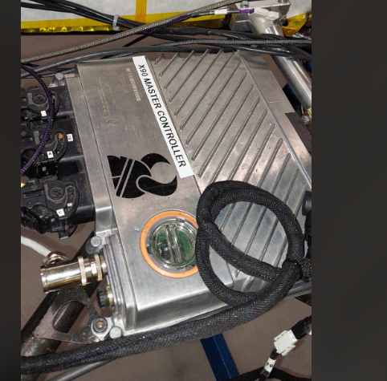

*Figure: The X90 PLC with the Vikings logo on it.*

**Placement in Vehicle**

* On the floor of the cockpit between the seat and the pedals

**Purpose & Relevant Rules**

* The Master controller functions as the overall brains of the car. The master controller consists of the main X90 PLC from B&R along with four optional expansion boards, which add additional I/O to the system.
* Error checks are being performed on the System critical signals to determine if the data is safe to use and to follow rule T11.9.
* The following sensors are connected to the master controller; two torque pedal position sensors, brake pressure sensor front and rear and Steering angle sensor.
* To identify and locate errors in the shutdown circuit a measurement point has been added between most of the elements of the circuit. (See Shutdown Circuit Overview in workshop).
* Controls the Status LED’s on the dashboard.
* Alarm Management System, to keep track of potential problems with the car during operation and for debugging.
* LV Battery charge monitoring
* Actuators / output signals to Brake-light, Ready-To-Drive-Sound and cooling pump.
* The master controller uses different Communication protocols for various devices on the car. (Ethernet = liveview, Powerlink = reserved, USB = datalogging, CAN = inverter, AMS, dashboard, sensor network, FS datalogger; RS-232 = INS (internal navigation system).
* 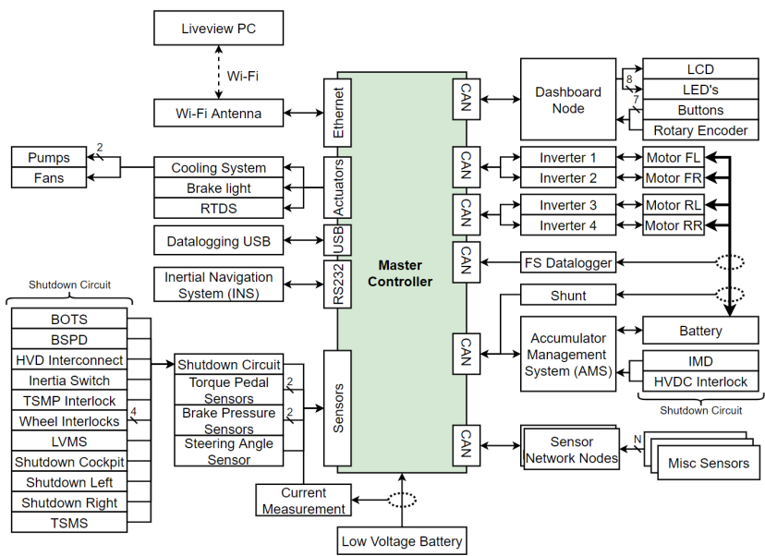

*Figure: overview of the master controller connections*

**Circuitry Explanation**

* Not made in-house: bought unit. Code can be found on GitHub

**Connections**

* (Direct ethernet connection)
* X90 Interface PCB
* TSC LV PCB via J9 (TSC LV PCB, 35 pins).

## X90 Interface PCB

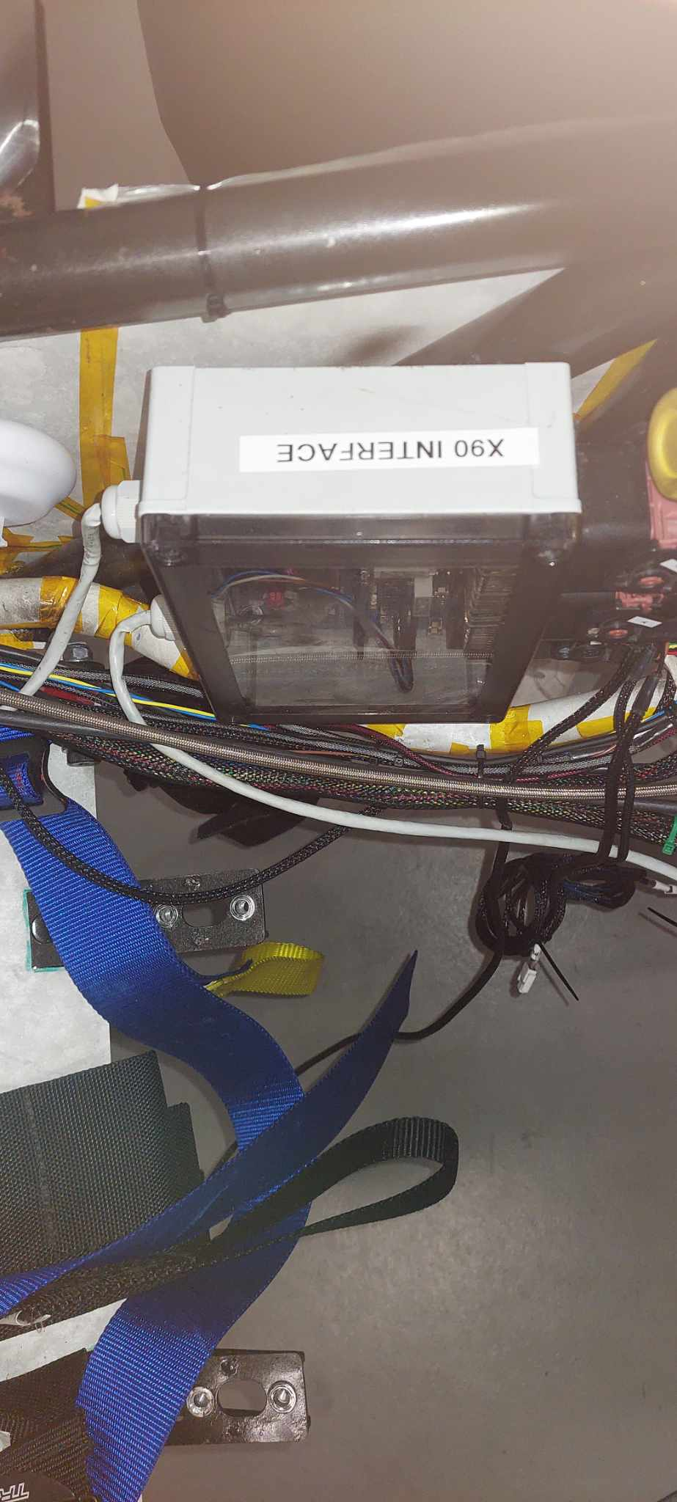

*Figure: The X90 Interface PCB placed inside the plastic box.*

**Placement in Vehicle**

* Left side of vehicle’s inner-wall in a plastic box (seen from driver’s POV).

**Purpose & Relevant Rules**

* Interface for the X90.
  + It communicates directly with the X90 And sends signals / power to it from the rest of the car.
* It supplies most LV circuits with the LV in the fashion:
  + LV Battery > LVMS > X90 Interface PCB > X PCB.

**Circuitry Explanation**

* LV Input
  + Current sensor to measure the LV current and send the result to the master controller.
  + LED D12 signals if LV is present in the x90 interface pcb AFTER the current sensor
* Accumulator
  + Acc_can on the x90 interface is equivalent to car_can on the AMS and that is where the connection goes.
  + LV supplied to the AMS is supplied via the X90 interface PCB, through a 5A fuse, and not directly via the battery.
* Dashboard
  + CAN communication between X90 and Dashboard
  + LV supply to the dashboard.
* Power over ethernet
  + Enables liveView for monitoring of car stats and configuration.
* Test LEDs
  + Used to verify if the following signals go out from the X90;
    - Brake light
    - RTDS
    - Cooling pump 1
    - Cooling pump 2 (Not used anymore)
    - Cooling Fan 1 (Not used anymore)
    - Cooling Fan 2 (Not used anymore)
* RTDS
  + Ready to drive sound
* Sensor Network
  + Converts LV to 9V.
  + Gets CAN from the sensor network
* Sensors
  + Torque_pedals to x90
    - Two Torque pedal position sensors
    - Two Torque pedals
  + Brake_pressure to x90
    - 1 rear sensor
    - 1 front sensor
  + Steering_angle to x90
* Brake Light
  + LV Supply when needed (via master controller).
* Cooling System
  + Controlled by the X90 by triggering a relay that enables the LV to flow to the cooling pump based on the cooling_temperature_sensor’s feedback.
* CAN Connectors
  + Sensor Network supply + CAN to X90
  + Inverter12 CAN to X90
  + Inverter34 CAN to X90
  + Datalogger CAN to X90
  + Accumulator CAN to X90
  + Dashboard CAN to X90
* X90 Power
  + Power to the X90 + Sensors.
* TS Container
  + LV-supply to the TSC.
  + Enable/disable CAN connection between HIGH/LOW for Inv12 and inv34 and datalogger
* **Shutdown Circuit**
  + **SDC is a big safety chain which controls if high voltage from the accumulator is “allowed” to enter the rest of the vehicle systems.**
  + **See relevant section.**

**Connections**

* X90: CAN and interface
* LV battery
* AMS (supply + CAN)
* Dashboard: CAN
* Ethernet antenna (J2 / J3)
* RTDS (J1C)
* Sensor network: CAN + supply (currently, CAN er connected men supply is not connected due to the sensor network not being integrated on the car as of now.)
* Torque_pedal sensor: supply + result
* Brake_pressure sensor: supply + result
* Steering_angle sensor: supply + result
* Brake Light: supply
* Cooling Pump: supply
* Cooling Temperature Sensor: supply + result
* Data logger: diagnostics
* Inverter: CAN
* 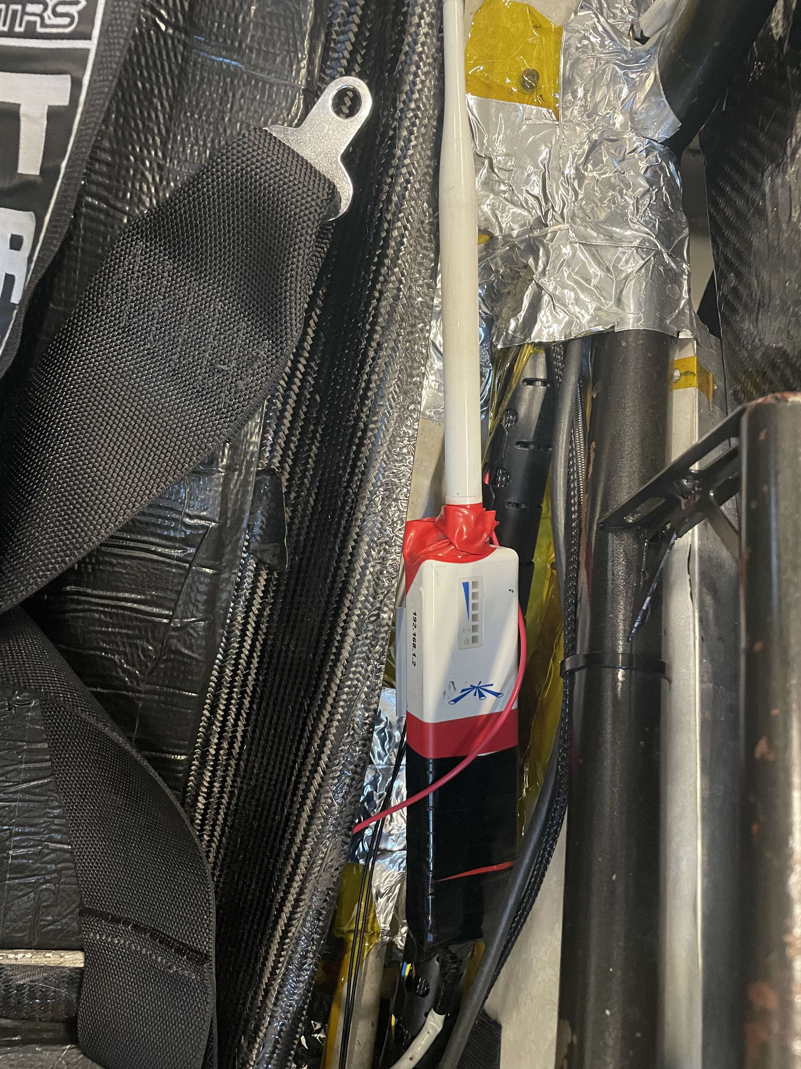TSC LV PCB: LV Supply via J9 on the TSC LV PCB and J1B on the X90 interface PCB
* Cooling fan: supply
* BOTS: SDC
* Inertia switch: SDC
* Emergency buttons: SDC
* TSMS: SDC

## Live-View Ethernet Module

*Figure: The liveview antenna.*

**Placement in Vehicle**

* Placed on the inner wall on the left side of the vehicle (seen from driver’s POV)

**Purpose & Relevant Rules**

* The wifi-antenna is a Ubiquiti Picostation M2
* Used for monitoring and configuration of car.
* **A6.13.3:** All team telemetry must be transmitted on a 2.4Ghz frequency. Teams must not transmit on a 5Ghz or any other frequency.

**Circuitry explanation**

* Bought module.

**Connections**

* Connected to X90 Interface PCB & X90 Master Controller via the X90 Interface PCB – box.
* Another WIFI-Module is connected to the PC for displaying Liveview.

## Dashboard

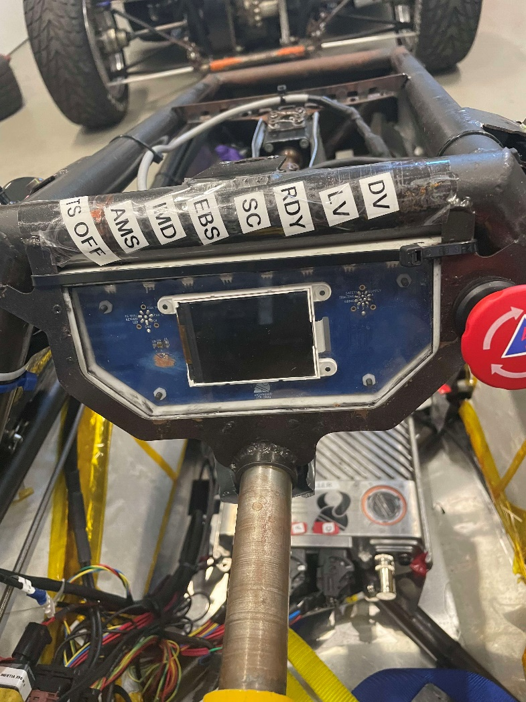

*Figure: The Dashboard PCB with the LCD mounted on it inside a plastic casing.*

**Placement in Vehicle**

* In front of the driver behind steering wheel

**Purpose & Relevant Rules**

* To help the driver navigate the vehicle & give visual indicators for different areas of the car.
* When the car is turned on it instructs the driver to press certain buttons to start:
  + ‘Safety’ à ‘traction’ à 'brake pedal + ‘drive’
* If the Shutdown circuit is not closed it will be displayed on the screen.
* The dashboard shows Battery Status, Speed, Cooling Systems Status, an Alarm and a Range estimation.
* If the X90 Master controller sends error messages and this changes the state of the dashboard to “STATE_ERROR”. In this state the active errors should be displayed as shown below.

**Circuitry Explanation**

* Humidity, pressure and temperature sensor
* CAN bus to the X90 (interface)
* DCDC converter: from LV to 5V and 3v3
* Steering Wheel
  + Buttons, encoder & supply are all from/to the steering wheel via dashboard.
* Programmed with a TIVA MCU.
* Includes status LEDs and LCD.
  + Status LEDs displaying state of TS, AMS, IMD, ERS, SC, RDY, LV, DV.
  + Status LEDs are adapted dynamically to the ambient light via ambient light sensor.
* Has a Bluetooth Module for wireless flashing
* Has LED-lightning for indicating Driverless.

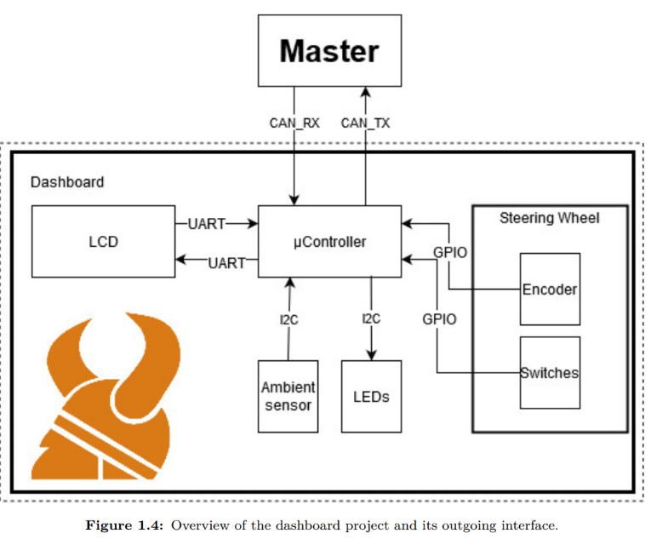

*Figure: overview of the dashboard PCB*

**Connections**

* + J1: Steering wheel + encoder PCB (placed on steering wheel).
  + J2: programmer (has a cap on it, when not in use).
  + J3: DB_can & LV_supply to/from X90 interface PCB + TS_OFF_LED (TS_ON_LED) to/from TSC LV PCB for the TSAL.

## Steering Wheel

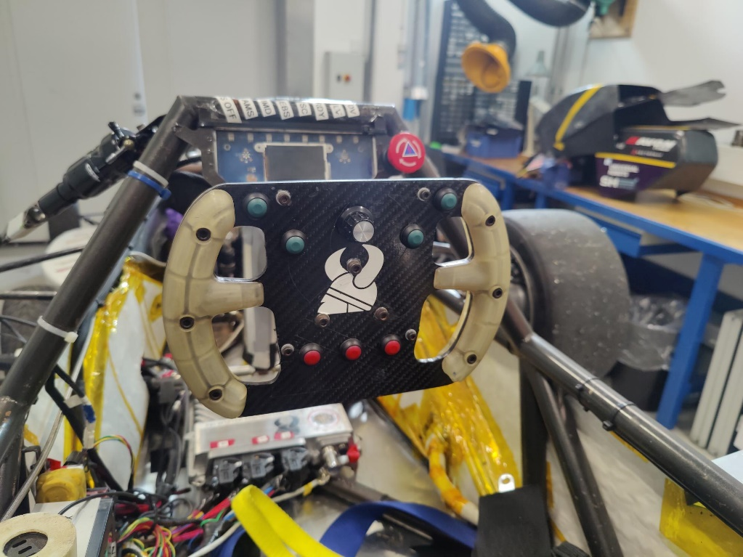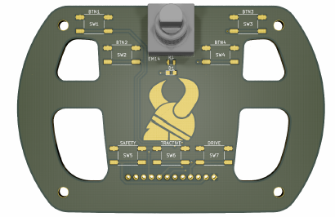

*Figure (left): the steering wheel in the front with the dashboard in the back. Figure (right): the steering wheel simulator for testing the dashboard PCB.*

**Placement in Vehicle**

* In front of the driver and in front of the Dashboard

**Purpose & Relevant Rules**

* The purpose is to steer the car.
* Navigation of menus and error messages on Dashboard.
* Encoder: Used to navigate Dashboard menus.
* Tractive button to comply with rule EV4.11.2: “The driver must be able to activate and deactivate the TS from within the cockpit without the assistance of any other person.”
* Safety button pressed to enable shutdown circuit.
* Drive button to comply with rule EV 4.11.7: “After the TS has been activated, additional actions must be required by the driver to set the vehicle to R2D mode, e.g. pressing a dedicated start button. The transition to R2D mode must only be possible during the actuation of the mechanical brakes and a simultaneous dedicated additional action.”

**Circuitry Explanation**

* 7 buttons and a rotary encoder
* Buttons 1-4 (GREEN) have no defined function
* Buttons 5-7 (RED) are pre-assigned to the startup sequence.
* Connected to Dashboard (J1 on dashboard).

**Relevant files**

* A wiring diagram of the steering wheel’s wiring can be found on teams.

## Inertia Switch

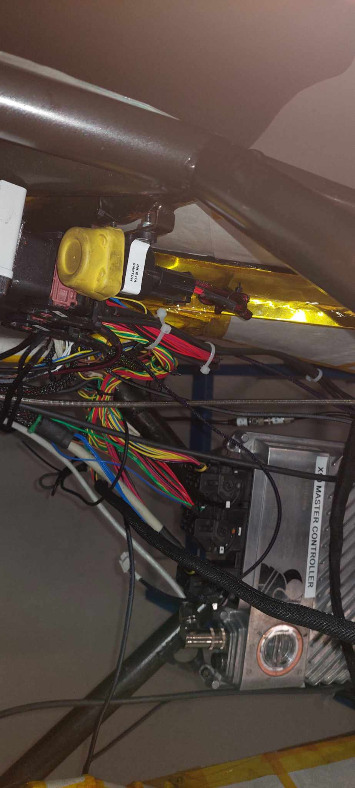

*Figure: The yellow inertia switch mounted to the chassis.*

**Placement in Vehicle**

* Located on the left side of the cockpit (seen from driver’s POV).

**Purpose & Relevant Rules**

* Part of the SDC. Is a switch that triggers if a G-force above a certain amount (i.e. a crash) occurs. You can reset it by pressing the button.
* Button used to manually reset the inertia switch
* “must be part of the SDC, see CV4.1 and EV6.1, such that an impact will result in the SDC being opened. The inertia switch must latch until manually reset.”

**Circuitry explanation**

* Part of the SDC

**Connections**

* Connected to the X90 interface PCB.

## Brake-Overtravel-Switch (BOTS)

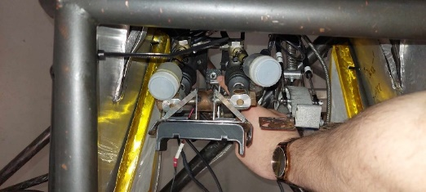 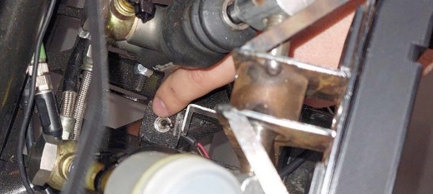

*Figure: The small BOTS-switch placed behind the brake pedal.*

**Placement on Vehicle**

* Small toggle-switch behind brake-pedal as per the rules.

**Purpose & Relevant Rules**

* Part of the SDC. Is a toggle-switch that has its “head” positioned towards the brakes, so that, in the event of brake failure and it over-travelling, it will toggle (thus facing away from the brake) and it will have to be reset manually before being able to close this part of the shutdown circuit.
* “Switch must be installed so that in the event of a failure in at least one of the brake circuits the brake pedal over-travel will result in the SDC being opened”

**Circuitry Explanation**

* Part of the SDC.

**Connections**

* Connected to the X90 interface PCB

# Tractive System Container (TSC)

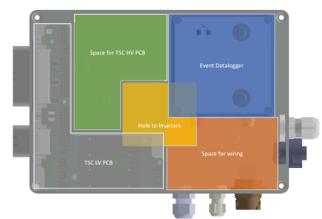

*Figure: an (outdated) overview of the various hardware inside the TSC.*

The TSC is composed of the inverter (box) and the electrical crates on top. It has a lid that must be sealed whenever the car is turned on, since high-voltage is present (and not isolated) inside the container. The **inverters** are responsible for converting the direct current from the accumulator to alternating current for our synchronous servo motors. They are bought from AMK alongside the motors, whereas everything inside the top-containers has several proprietary hardware.

**TSC LV PCB** – interfacing to the high-voltage system from the X90 Master Controller.

**TSC HV PCB** – contains the discharge circuit, TSMP circuit, datalogger interface, TSAL calculation & HV interface between the accumulator (DC) to the inverters (AC).

**TSAL Controller** – outputs logic signals to check if the car is safe to be around to the TSAL LED PCB & Master Controller.

Although ‘technically’ not a part of the TSC, the following hardware is also mentioned in this section:

**Brake-System-Plausibility-Device** (BSPD) – circuit verifying you are not pressing the speeder whilst also hard-braking.

**High-Voltage Disconnect (HVD)** – big jumper that allows anybody to easily disconnect the TS in emergencies.

**Energy** **Meter** – given out at the competition to measure the TS system.

## Inverters

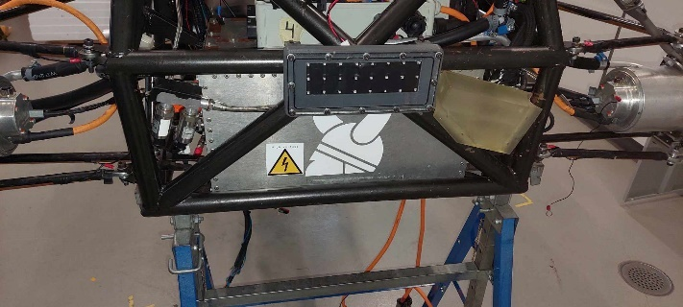

*Figure: The AMK inverter box with the Vikings logo, placed below the TSC and behind the brake light.*

**Placement on Vehicle**

* Part of the TSC. Located below the openable small box-part of it / behind brake light.

**Purpose & Relevant Rules**

* The AMK A2370DD racing kit is a package of permanent magnet synchronous motors running on AC. Therefore, a conversion of DC to AC is required in order to drive the motors. The inverters are the “driving force” for each of the four hub motors. The inverter package consists of four individual inverters located in a self-developed enclosure.

**Circuitry Explanation**

* At the front of the inverter lies the DC link directly connecting to the DC terminals of the accumulator when the TS is on/active. The DC link serves the purpose of being an immediate energy storage for the inverters along with mitigating harmonics (noise) produced by long wires between the accumulator and the inverter. Charging the DC link from 0 V to the accumulator voltage (DC link capacitance of 4x 75 uF from datasheet) is done using a precharge circuit which serves to lower the inrush current thus preventing damage. The precharge circuit is located on the ACCU HV PCB.
  + As an uncharged capacitor being connected to a DC source has an effective resistance of 0, the current is only limited by the small resistance of the connecting wires, thus a precharge circuit is required.
* Discharging the DC link is done when TS is off/deactivated. This is done to remove the risk of shock stemming from touching the two terminals of the DC link.
  + A discharge resistor, not to be confused with the precharge resistor, is added for this purpose (see discharge circuit on the TSC HV PCB).

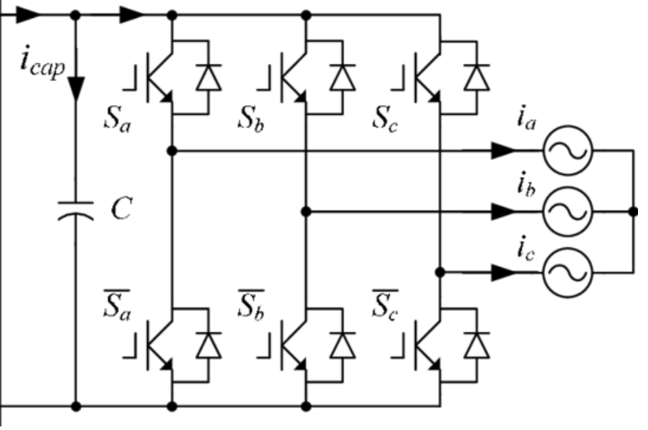

*Figure: The exact topology of the inverter is not known.*

* The enclosure is sealed around all edges and mechanically held together by rivets and screws. The wiring from the inverters come out at the top, directly into the TSC.

**Connections**

* HV cable: The cable used is a 1 - 1.2 cm thick orange cable with all three wires being despite the colors usually indicating neutral (blue) and ground (yellow and green). The cables are rated to carry 600V AC to the motors from the inverters. The cable can withstand up to 180C°.
* Mechanical’s Cooling Loop
* Motors (HV Cables + Encoder): The HV cables are colored orange and protrude from the sides of the inverters and connect to the motors. The rear HV cables connect directly with rear wheels but interface through a motor connection box for the front wheels. This is to make maintenance easier for situations where the front wheels have to be disconnected separated from the back wheels.

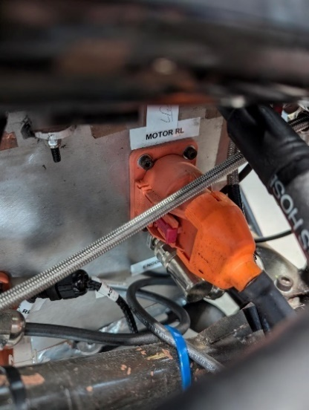 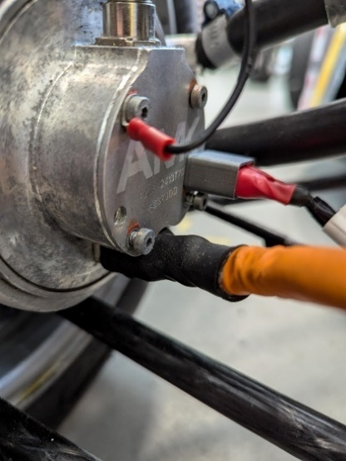 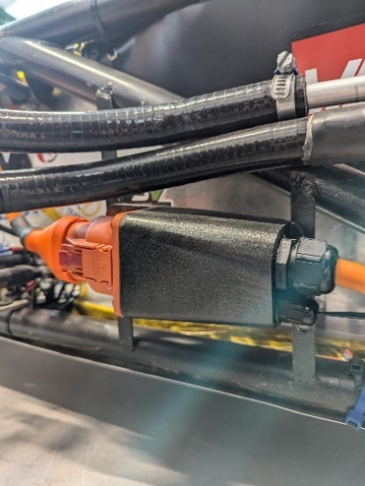

*Figure 1: HV cable connection at inverter; Figure 2: HV cable connection at motor; Figure 3: Motor connection box for front motor.*

The encoder and temperature wires also protrude from the same sides as the HV cables with metallic connectors. At the wheels, the encoder and temperature wires are attached with green connectors. The encoder and temperature wires are not connected through the motor connector box. This is because the connector at the motor is easily disconnected.

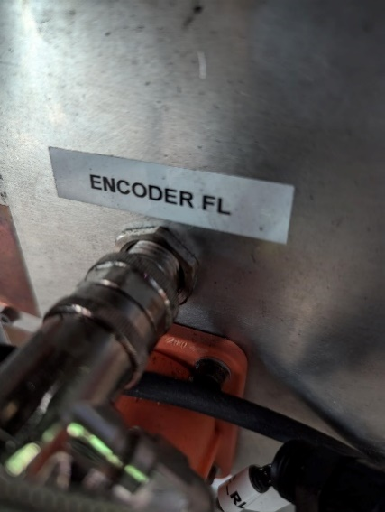 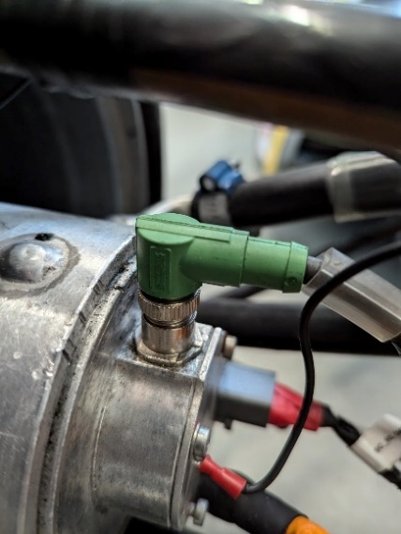

*Figure 1: Encoder/Temp. connection at inverter; Figure 2: Encoder/Temp. connection at motor.*

* HVD: Is the quick connect box for the tractive system wire. Is there to give a visual representation, that tractive system can’t be used. See section later on for further description.
* TSC HV PCB (TS+ & TS- HV connections, 5 total, whereas the last goes the TSMP)

## TSC HV PCB

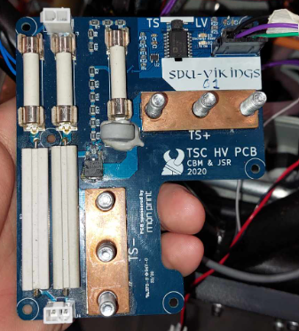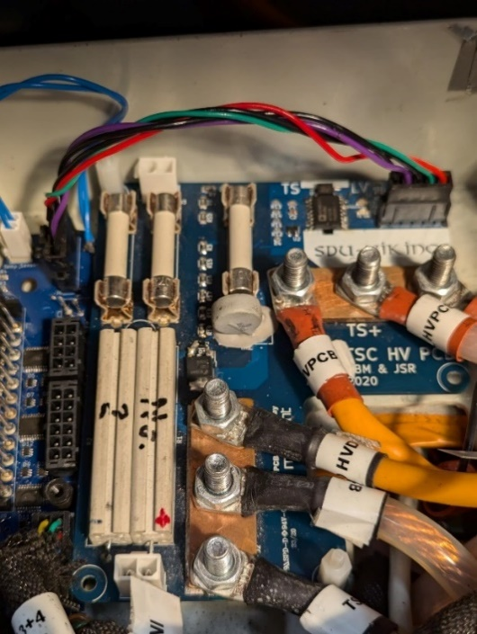

*Figure 1: the TSC HV PCB not mounted. Figure 2: the TSC HV PCB mounted inside the TSC with the HV cables.*

**Placement on Vehicle**

* Inside the TSC’s top container at the back of the vehicle.

**Purpose & Relevant Rules**

* Not to be confused with the “ACCU HV PCB” in the accumulator container!
* Discharge circuit: Used to discharge the DC-link capacitors from the inverters in the car, such that it can quickly be rid of High-voltage when TS is off.
  + From the rules: EV6.1.5: *If the SDC is opened the TS must be shut down by opening all AIRs and the voltage in the TS must drop to below 60 VDC an+d 50 VACRMS in less than 5 s. All accumulator current flow must stop immediately.*
  + If the discharge resistor open circuits/breaks, the internal capacitor in the inverters will discharge slowly, leaving an active TS Voltage in the Inverters. The TSAL will therefore not turn off, when exiting TS Active mode à signaling that a failure has happened, and the car is unsafe.
* From the plot of the discharge voltage (found in ESF), the capacitance (i.e. vehicle-side voltage) is discharged to below 60 V in under 5 seconds, even when it is discharged three times within 15 seconds.

**Circuitry Explanation**

* The TSC HV PCB is connected to the external circuitry through three signal connectors and two HV copper-busbars. The first signal connector is J3 going to the competition’s datalogger, the second is J4 going to the TSMPs, and the third is J5 which connects to the TSC LV PCB. The two busbars are TS+ and TS-.
* J3: This connector has two pins with one 1 A fuse located on each pin. The opposite side of each fuse connects to the TS+ and TS- busbars. This is supposed to be connected to the datalogger given at competition.

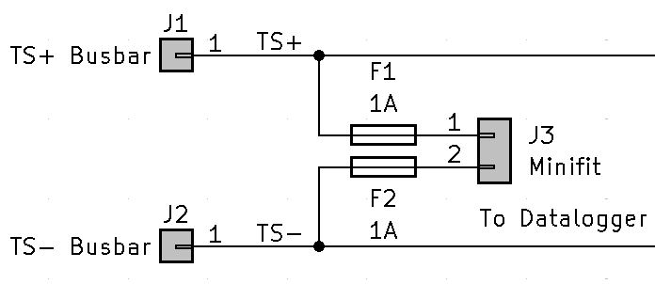

*Figure: the J3 connector (datalogger)*

* J4: This connector also has two pins and is used to connect to the TSMPs on the right side of the car. One 15k resistor connects between each pin and TS+ and TS- busbars. The use of the TSMPs is to be able to measure the insulation between TS+, TS- and GND. When the accumulator is fully charged and has roughly 600 V, then equation for heat dissipation in the 15k resistors will be the following: 600V^2 / 30000 ohm = 11 W. The power resistors are chosen accordingly.

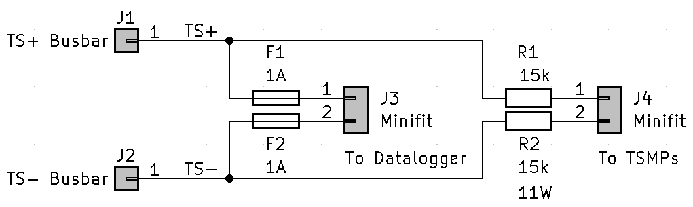

*Figure: the J4 connector (TSMP)*

* J5: This connector goes to the TSC LV PCB to provides power to the LV side of the TSC HV PCB alongside the “Discharge+” & “Discharge-“ signals. Discharge+ is the end of the SDC (from inside the accumulator on the Orion Expansion PCB), and Discharge- is the LV GND (car’s chassis). TSAL_CAR_TS_ON is used to indicate when the voltage on the tractive system is higher than 60 V, which is sent to the TSAL controller.
  + 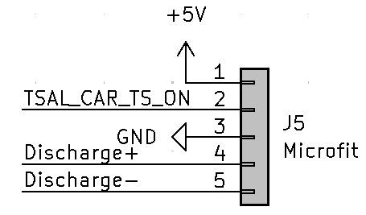

*Figure: J5 connector*

* + When the Discharge+ signal is HIGH, then that means the SDC is complete/ closed (there is LV present at the end of the SDC). This disables the discharging of the inverter DC-link via the optocoupler as pictured below.
  + 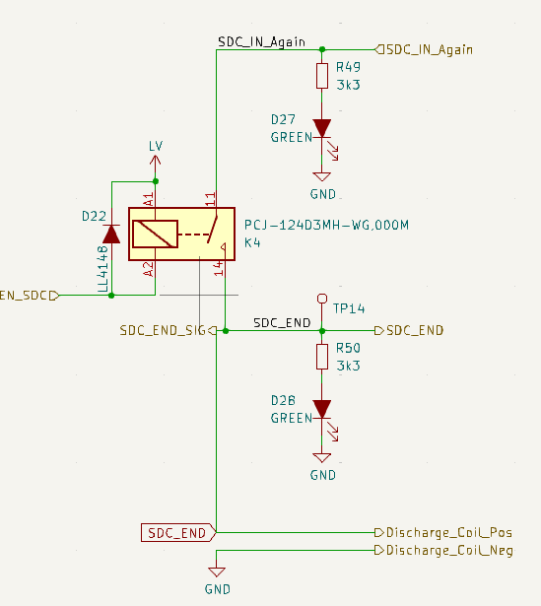

*Figure: the end of the SDC from the Orion Expansion PCB: “Discharge+” & “Discharge-“*

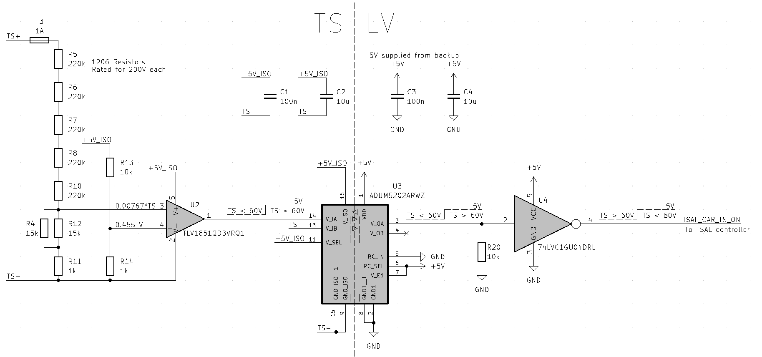

*figure 2: Voltage measurement circuit for TSAL_CAR_TS_ON. U3 is used to isolate the HV-side from the LV side for safety. The discrete resistors R4 to R12 are used due to the voltage of each component being lower.*

* TS+: All cables going to this busbar come from the internals of the inverter.
* TS-: All cables going to this busbar, except one, also come from the internals of the inverter. The last one goes to the HVD.
* Discharge circuit:
  + The stored energy in the inverter capacitors is discharged through the discharge ‘resistor’ (TH1, PTC thermistor) which limits the current and regulates its resistance according to temperature (higher resistance with higher temperature) meaning less current due to it being a PTC thermistor & less power (heat) loss.
  + If the SDC is completed, then the optocoupler U1 connects the gate of the MOSFET Q1 to GND, and thus no discharging can occur through the thermistor TH1 whilst the car has a completed SDC. However, if the SDC is not complete (i.e. error or the car is turned off), then the gate is set to 15 V via the voltage divider (R3, R15-R19 & D1) and the discharge can begin.

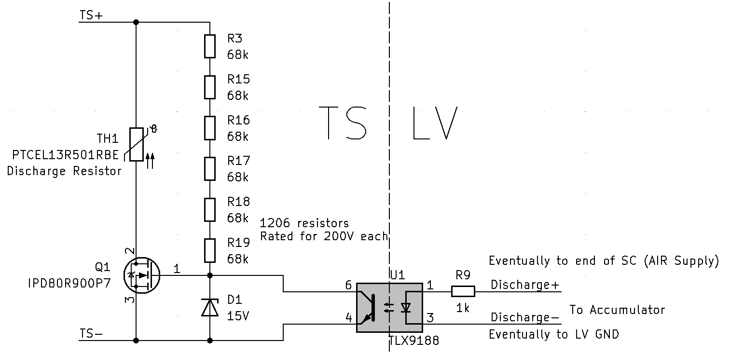

*Figure: The discharge circuit for the DC link capacitance on the inverters.*

**Connections**

* TSMP: Banana plugs on the right side of the car so that insulation between TS+, TS- and GND can be measured.
* J1 and J2 are copper busbars for interfacing between the DC input to the inverter and to the data logger, TSMP and TSAL. (Cables coming up from the inverter into the TSC). From TS- a cable goes to the HVD. There are six cables attaching to the busbars in total.
* From J5 on the TSC HV PCB a connection is made by five wires to J8 on the TSC LV PCB.
* AMS: The discharge-connector (j21) (on the PDF-version) is connected to Dicharge_coil on the Orion Expansion PCB, which controls if Q1 is open or not.

## TSC LV PCB

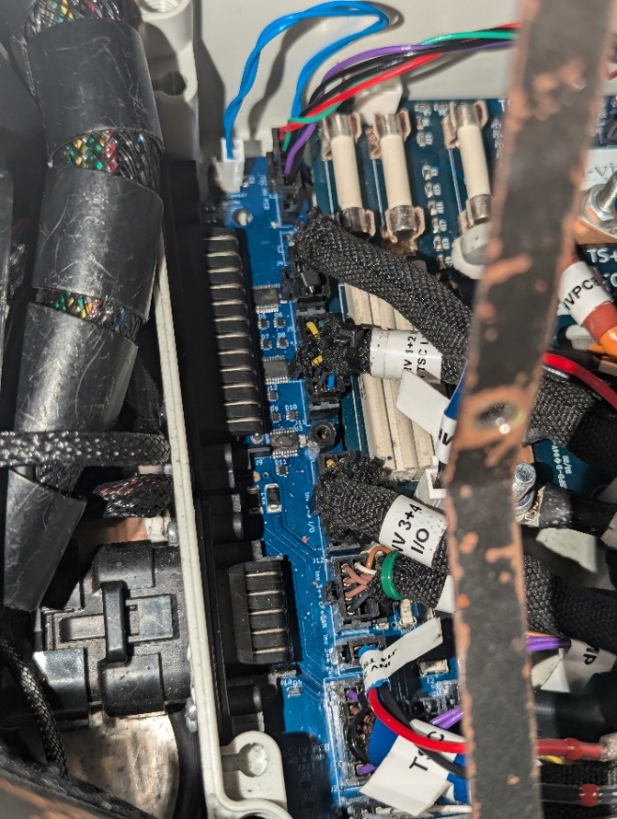 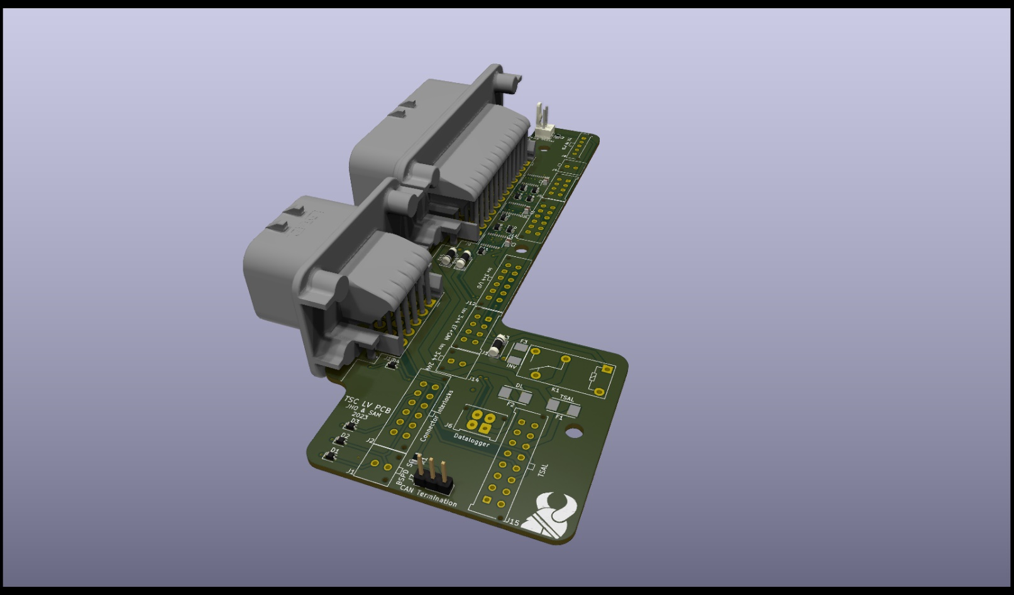

*figure: Voltage measurement circuit for TSAL_CAR_TS_ON. U3 is used to isolate the HV-side from the LV side for safety. The discrete resistors R4 to R12 are used due to the voltage of each component being lower.*

**Placement on Vehicle**

* At the left side in the TSC at the back of the vehicle, on top of the inverters.

**Purpose & Relevant Rules**

* Interface between TSAL, X90 Interface, TSC HV PCB & inverters.

**Circuitry Explanation**

* TSAL: is supplied and given signals from the LV PCB via J3. The TSAL then gives back the logic calculations to the LV PCB via J15, which then outputs the LED-settings via J10 to the TSAL LED PCB.
* Inverters 1, 2 & 3, 4:
  + Connectors for inverters 1,2: J4, J5, J11
  + Connectors for inverters 3,4: J12, J13, J14
    - CAN
    - BE (Digital Input) and BA (Binary Output).
* Discharge (J8): the hardwired signal from the AMS to the TSC HV PCB (that controls the discharge MOSFET) is sent via the TSC LV PCB.
* Datalogger (J6):
  + CAN
* X90 Master Controller
  + J9 (big connector, 35 pins)) connects the master controller and the TSC HV PCB. This means:
    - Datalogger and Inverter CAN busses
    - TSAL BACKUP disable & charge status
    - Inverter BA & BE (BA = Binary output, BE = Digital input)
    - EF12 & EF34 (Power output stage enable)
    - SC for: BSPD, TSC_IN, TSMP, HVD,
    - Discharge circuit’s temperature
    - LV supply
    - 12V
  + J10 (“smaller” connector, 14 pins) connects to the AMS and TSAL LEDs.
    - The TSAL’s LEDs are connected via 4 pins
    - The 2 dashboard pins, to see when the TS is ON, is sent to the master controller to then be sent to the dashboard. (yellow / blue wire as of this writing)
    - 6 pins are connected to the AMS.
    - Lastly, 2 the SC pins are connected to the AMS.
* ”To BSPD and interlocks in the SC”
  + M1, M2, M3, M4 = Motor [number] interlock, “IL” is for interlock.
  + J2 is a connector that short-circuits if all interlocks (HVD, Motors & TSMP) are connected thus allowing the SDC to progress through.
    - Via D3 the SDC signals if the HVD is in.
    - Via D4 the SDC signals if the motors and TSMP interlocks are in.
    - The TSMP-interlock is connected from the TSMP to the right side of the TSC (seen from the back of the vehicle) and into the TSC LV PCB. From the ESF:
      * *“A four pin Binder 693 series connector is used to connect the TSMPs to the TS Container. Only two pins are used for TSMPs, while the two remaining pins are looped over to be used as an interlock.”*
  + J1 is also connected to J2, but this connector is to the BSPD
    - the BSPD’s SDC status is sent from here to the master controller.

**Connections**

* TSC HV PCB via J8 on the TSC LV PCB and J5 on the TSC HV PCB.
* TSAL: J3 (signals from TSC LV PCB to TSAL) & J15 ((signals from TSAL to TSC LV PCB) + TSAL LEDs via J10
* X90 Interface PCB: LV Supply (+3-5 other wires) placed in a grey cable. Connects to the TSC LV PCB via J9 on the TSC LV PCB and J1B on the X90 interface PCB
* Inverters CAN + BE & BA via J4, J5, J11, J12, J13, J14
* Datalogger via J6
* Master Controller via J9 (35 pins) (alongside the X90 interface PCB).
* AMS via J10 (alongside TSAL LEDs) & board
  + The SC signal is sent to the motor connector interlocks, to check if everything is correct. If the signal is correct, the signal is sent to the TSMP interlock. If that signal responds correct the signal is sent to AMS
* BSPD via J2 (on TSC LV PCB) to J4/J1 (on BSPD)
* HVD via J2.

## Tractive System Active Light (TSAL)

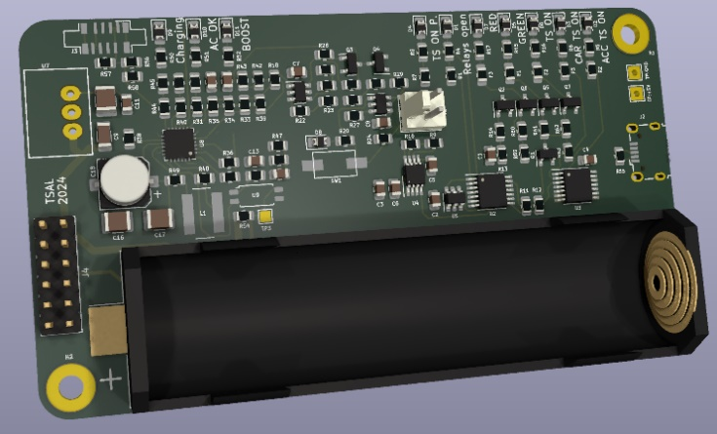 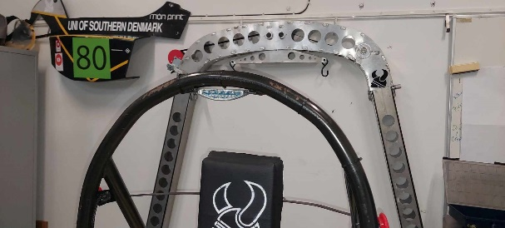

*Figure (left): the TSAL PCB with the connector for the battery. Figure (right): the TSAL LEDs mounted at the top of the hoop.*

**Placement in Vehicle**

* In 2 places:
  + TSAL Controller PCB is placed in the TSC (in the back of the car)
  + The TSAL (LEDs) are placed inside the main hoop of the car (above driver’s head)

**Purpose & Relevant Rules**

* Safety mechanism for indicating whether the car is safe to be around (green), unsafe (flashing red) or uncertain, meaning unsafe (NO LIGHT).
  + If the TS (i.e. HV) is active the TSAL flashes red. If the TS is deactivated the TSAL is continually illuminated with green.
  + The TS is deemed active if any AIR or precharge relay is closed OR the voltage on the car side of the AIRs is over 60V DC.

**Circuitry Explained (Control board)**

* The TSAL Control board receives 3 control inputs:
  + ~(TSAL_CAR_TS_ON) - from the TSC HV PCB. HIGH (5 V) if TS < 60 V on the TSC HV PCB’s voltage comparison circuit (see TSC HV PCB).
  + ~(TSAL_ACC_TS_ON) – from the AMS (i.e. the Orion Expansion PCB’s pin 22 on J1). Same sort of check as TSAL_CAR_TS_ON, just done on the AMS instead.
  + TSAL_Relay_detection – from the AMS (i.e. the Orion Expansion PCB’s pin 21 on J1). Signal that checks if one or more contactors (AIRs & Precharge) are closed (LOW) or if all are open (HIGH).
* RED Control
  + Part of the circuit that controls the flashing RED LEDs. The U1-NAND gate reads: “if there is NOT TS-voltage on the AMS and CAR AND one or more relays are closed WHILE both ~(TSAL_ACC_TS_ON) and ~(TSAL_CAR_TS_ON) are LOW (XNOR gate U3A), then we output a logic HIGH signal (via U2D) to the 555-timer (U4) to generate a flashing RED LED.
    - This also means, that if there is a discrepancy between the calculated TS-voltages: ~(TSAL_CAR_TS_ON) and ~(TSAL_ACC_TS_ON), then the RED LEDs WON’T light up at all, and you will know an error has occurred in one of the places.
  + MOSFETs (Q2 and Q6) are used to first invert the signal and then drive the signal, since the 555-timer cannot output enough current to drive the LEDs.
* GREEN Control
  + The logic circuit reads as follows:
  + “If…
    - all contactors (relays) are open AND both ~(TSAL_ACC_TS_ON) & ~(TSAL_CAR_TS_ON) are either ON or OFF (from XNOR U3A)
    - AND
    - ~(TSAL_ACC_TS_ON) AND ~(TSAL_CAR_TS_ON) are HIGH (i.e. no TS measured from ACC or CAR circuits)
  + THEN the TS is considered NOT active (i.e. no HV on the car) and the AND-gate U2C will output HIGH”
  + This controls the MOSFETs (Q1, Q5 & Q7) to supply 5V to the TSAL GREEN LEDs & the TS_OFF LED on the dashboard (Dashboard’s U12,
* Timers
  + Has a backup battery for the TSAL operation to be “lit” for a minimum of 15 min after shutdown.
  + Also includes a battery charger (U8) for charging the 15-minute battery when the TSAL is supplied with LV, and not from the battery. “Mode” controls which power source is used.
  + The signal from U10 tells the master controller if the TSAL backup supply is charging or finished charging
  + J2 is used for charging the battery without LV but via USB
* The TSAL supplies 5V “to the AMS” (i.e. it is technically via the TSC LV PCB, but the end-source is the AMS). LV is supplied from the TSC LV PCB.

**Connections**

* TSC LV PCB via J4

**Circuitry Explained (TSAL LED PCB)**

* Has 2 connectors you can connect from either the left or right side.

## Brake System Plausibility Device (BSPD)

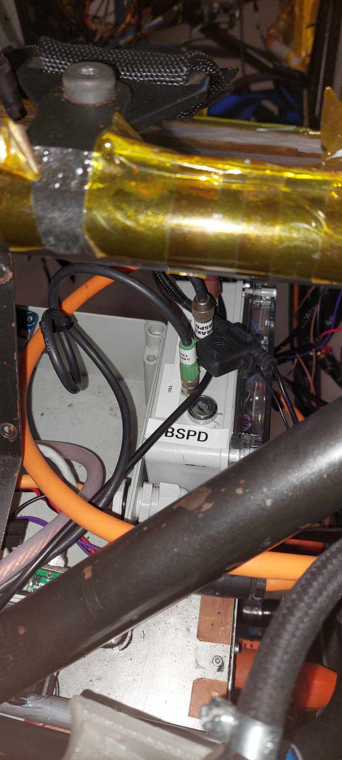

*Figure: The BSPD box.*

**Placement in Vehicle**

* Just besides the TSC to the right (when looking at the back of the vehicle).
* Includes a current sensor “HASS 50-S current sensor”, which is placed in the TSC
  + 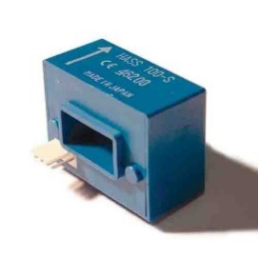

*Figure: HASS current sensor*

* + The sensor’s connector plugs connect to sockets on the BSPD container.

**Purpose & Relevant Rules**

* “*A standalone non-programmable circuit, the BSPD, must open the SDC, when hard braking occurs, whilst ≥5 kW power is delivered to the motors. The SDC must remain open until power cycling the LVMS or the BSPD may reset itself if the opening condition is no longer present for more than 10 s*”
* “*The BSPD must be directly supplied, see T1.3.1, from the LVMS*,”
* “*To detect hard braking, a brake system pressure sensor must be used. The threshold must be chosen such that there are no locked wheels and the brake pressure is ≤30 bar.*”
* “[EV ONLY] *To measure power delivery, a DC circuit current sensor only must be used. The threshold must be chosen to an equivalent of ≤5 kW for maximum TS voltage*.”
* Current sensor in the form of an open hall-effect sensor.
  + MAKE SURE TO PASS THE HV WIRE TO BE MEASURED THROUGH IT!:
* 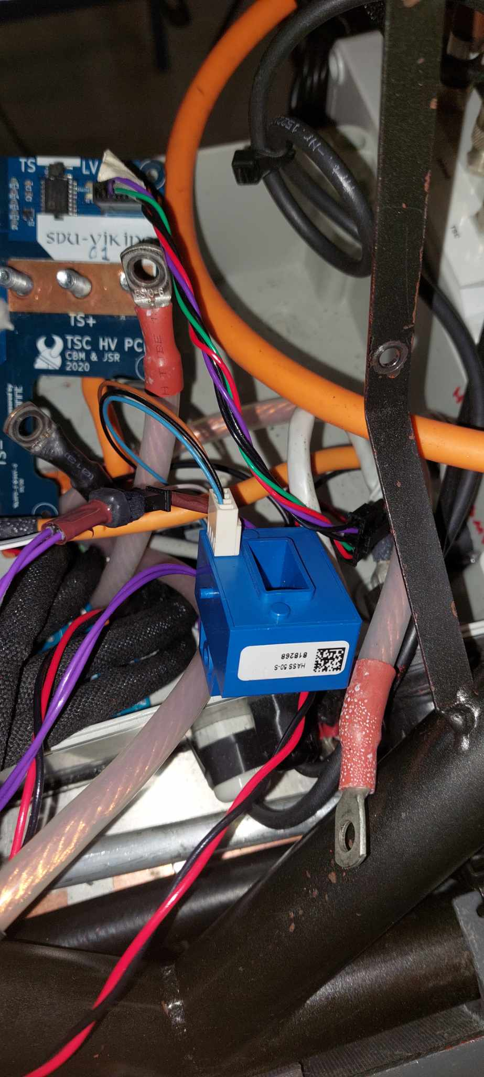

*Figure: the current sensor with the TS-wire through it.*

**Circuitry Explanation**

The BSPD Receives 4 Inputs

* Brake Sensor Input **J2** (EPT3100-H-16000-B-5-A)
* Current Sensor Input **J1** (HASS 50-S)
* +12V Input **J3**
* Shutdown Circuit in **J4**

The BSPD has 1 Output

* Shutdown Circuit Out **J4**
* The connector **J3** is fed from from the 24 V System, then fed through a 5 V DC-DC Converter U3 used to power the board.
* The brake sensor input “*brake_sense”* goes into a window comparator **U1**, where U1A sets the upper threshold and U1B sets the lower threshold using voltage dividers The same thing happens for the current sensor “*curr_sens*” using a window comparator **U2**.
* The Thresholds for the current iteration of the brake sensor are set via voltage dividers to be set to 30BAR and above for the break sensor, and 5kW for the current sensor. These thresholds are set by the FS Rules.
* The LEDs D3 & D7 are indictors for the current/brake sensor threshold being exceeded.
* When the thresholds for the Brake sensor and current sensor are met each window comparator outputs a low signal which feeds into NOR gate, **U6.**
* The NOR gate compares the two signals, If the signals are above the thresholds for more than 500 ms, then a delay block, **U8** outputs a HIGH signal to the D-latch **U5**.
* For the D-Latch, Pin1 (LE) enables the output of the OR-gate, **U4** to change the latch. For example, if the input at input Pin3 (D) is now LOW, then it is latched to LOW and vice versa.
* The D-Latch can be reset via 2 methods, Either by waiting for the signals to be below threholds for 10s using another Delay block **U10**, Or via the *“Q_inv”* Signal from a Inverter **U7**
* The Reset delay block is fed a signal from a NAND gate, **U9**. The NAND gate outputs LOW if both *latch_d* and *latch_q* are HIGH (means we have both thresholds met), otherwise it outputs HIGH. That means if we can keep either both D and Q different (e.g. LOW/HIGH) or both LOW (not excceding the threholds) for more than 10 s, then **U10** will output HIGH to OR-gate, **U4** and reset the latch.
* The D Latch latches the output Q to D if LE = 0. LE wil go high when there has gone 10 s or *Q_inv* is HIGH (i.e. a reset). This also means, that you cannot reset the BSPD until the "error" has gone away.
* The inverter **U7** inverts the latched signal from The D-Latch : if it is latched HIGH (i.e. a BSPD-error has been detected), then Q_inv is LOW, and vice versa.
* The Inverter **Q1** feeds an output to the MOSFET, **Q1**, which switches the state of the relay, **K1**, which controls the SDC. If the MOSFET switches off the relay is open, and the SDC is therefore also open, and vice versa.
* **D4** is an LED indicator for when the BSPD is CLOSED.

**Connections**

* LVMS to LV-battery via J3 “Power” -connector
* Brake Pressure sensor directly via J1 “Brake” -connector
* DC circuit current sensor directly via J2 “TSC” -connector
* Shutdown circuit via J4 “TSC”-labeled—connector
  + Antager TSC LV PCB??? (Mener det er 2 wires i alt).
* Total 3 wire-connections.
* Hall Effect sensor must wrap around TS-wire to measure current

## High-Voltage-Disconnect (HVD)

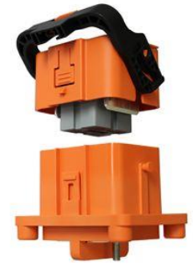 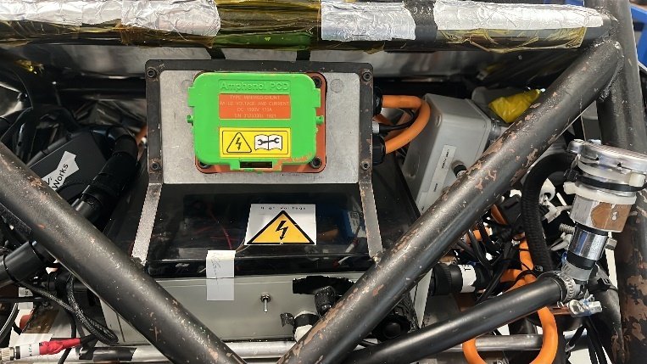

*Figure (left): the HVD female & male connector. Figure(right) the green dummy HVD mounted on the car.*

**Placement in Vehicle**

* Placed in the back of the vehicle on top of the TSC

**Purpose & Relevant Rules**

* The HVD features an interlock which is connected in series with the Shutdown Circuit (TS-voltage). If the connector is loose, the shutdown circuit will be opened, and the TS will deactivate. The failure is detected by the driver, when the vehicle is pulled out of drive state and the SDC Open LED lights up on the dashboard. [large jumper]

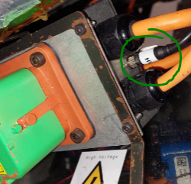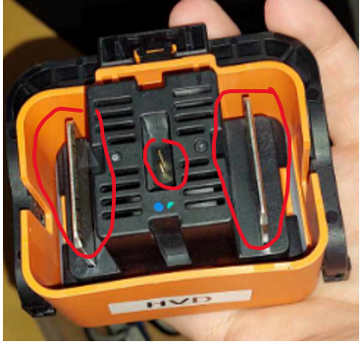

*Figure(left): showing the interlock cable; Figure(right) showing the high-voltage bus bars & the interlock in the middle.*

* A “pin-less” version of the HVD exists that is to be used to avoid accidentally closing the SDC whilst the HVD is meant to be “out”. This version has been marked in a distinguishable green colour.

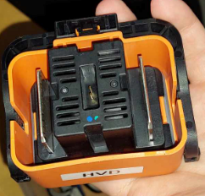 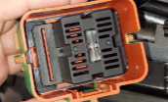

*Figure (left): real HVD with high-voltage bars; Figure(right): de-pinned green version.*

**Circuitry Explanation**

* The HVD serves as a jumper in the tractive system. If the HVD is not connected, no current may flow in the TS. A small signal interlock goes from the HVD to the TSC LV PCB and is used to determine if the HVD is connected properly or not.
  + Notice: there is an interlock going through the HVD which is part of the low-voltage SDC, but the actual “jumper”-part is NOT part of the SDC, since that is HV.

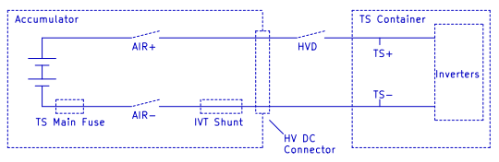 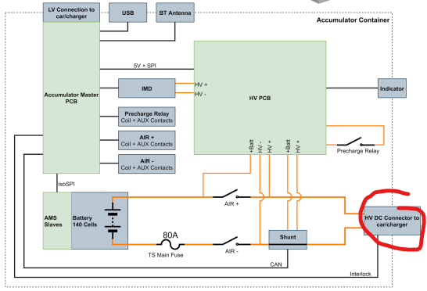

*Figure (left): Basic circuit diagram of the tractive system. The HVD is placed between the accumulator and the TSC; figure(right): Basic overview of the VIK-XI-a TSAC. On the VIK-XI-b the HVD interlock goes to the TSC LV PCB inside the TSC and not the AMS PCB inside the TSAC.*

**Connections**

* In series with the HV-connector to the accumulator & leads to TSC HV PCB’s busbars
* Third connector (small) is connected to TSC LV PCB via J2 (on the TSC LV PCB).

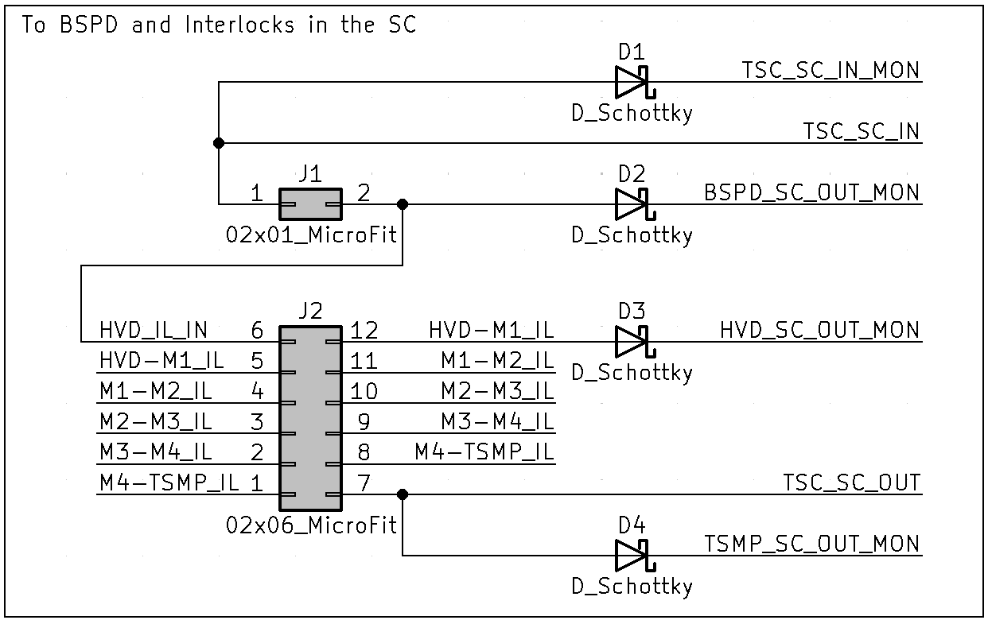

*Figure: Connection HVD to pins 5, 6 and 12 on the J2.*

**Energy Meter**

Billede af 3d figur & virkelig.

**Placement in Vehicle**

The energy meter is to be placed to the left of the HVD. This is to be done by mounting it on a 3D printed bracket attached to the chassis with zip ties.

**Purpose & Relevant Rules**

The purpose of the energy meter is for the judges at a competition to see that we comply with the upper limit for power leaving the TSAC. The meter may also be used to check the voltage level of the TSAC.

**Connections**

The energy meter connects to the TS+ busbar on the TSC HV PCB to get a reading of the TS+ voltage.

The following paragraphs which have been struck through pertains to the previous, internally developed and utilized energy meter. This is a different energy meter from the one given out at competitions

* ~~An IVT-shunt (IVT-S-100-U3-I-CAN1-12/24 digital shunt with integrated ADC and CAN) is used to measure the TS current and voltage and sends it to the AMS via CAN. It is placed inside the accumulator container next to the HV connector and AIRs.~~
* ~~From the accumulator report:  
  An energy meter is used in the car to measure the energy drawn from the batteries, this will give an view of how much energy is used around the track. The main idea with the energy meter is to measure when there is drawn to much power from the batteries, and limit the power output to make sure it is within the limit. This will help keep the power output as high as possible doing the acceleration part, while still being within the rules. It is chosen that both the voltage and current sensor will be one device placed in side the accumulator container. This sensor will be the Testco IVT-S-100, which is a current shunt with integrated ADC and CAN communication. The device also supports three voltage measurements. This sensor device is chosen over a normal current sensor circuit, because this sensor device communicate through CAN, and it is therefore possible to detect whether it is disconnected or not.~~
* ~~The function of this energy meter is to be able to dynamically limit the power drawn from the accumulator, to ensure that the team will not be disqualified due to an exceeded power limit. The measurements made by the energy meter is also used as part of the AMS.~~

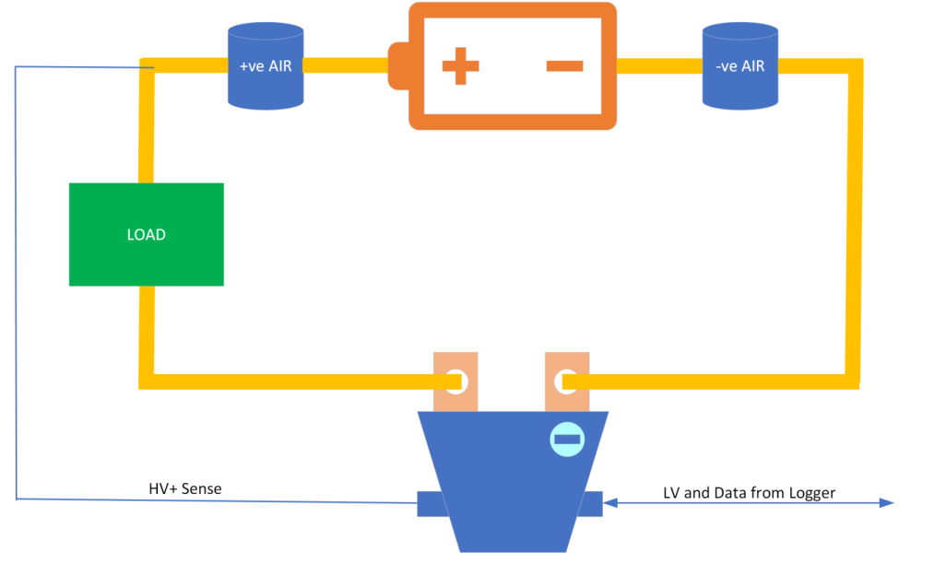

*Figure****:*** *Circuit diagram of the energy meter supplied by the organizers of FSUK24. The meter is connected as a current shunt between the load and the AIR-. A voltage measurement is made at AIR+. A data and power line goes to the data logger which is also supplied by the organizers and which is to be located in the TSC.*

# Accumulator Container (TSAC)

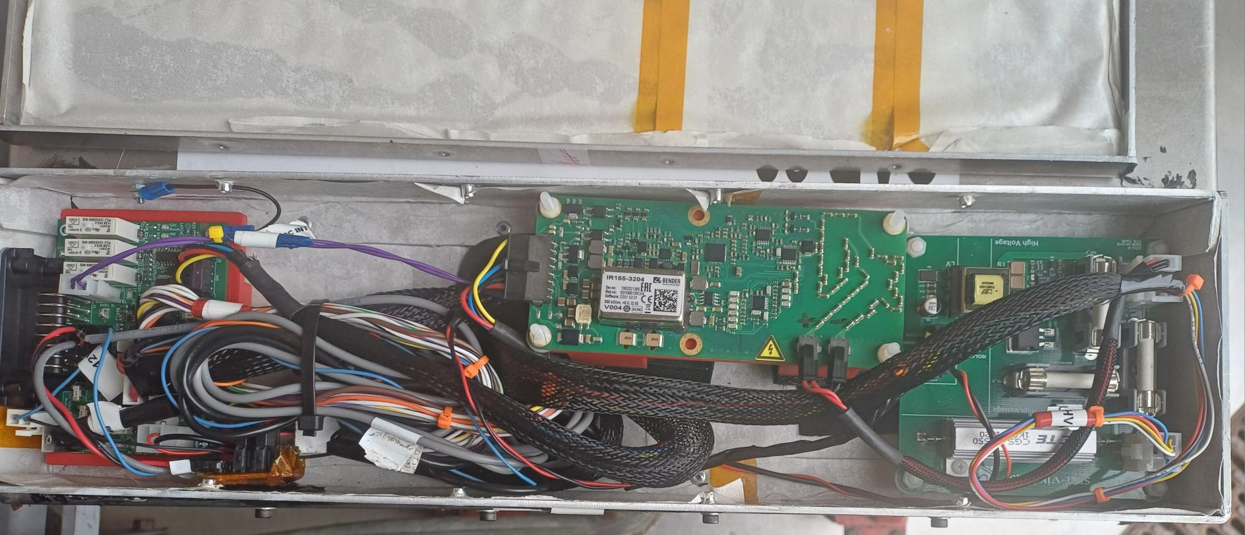

*Figure****:*** *the top container of the TSAC with the lid open. Most left is the connector to the TSC LV PCB dubbed “AMS connector”. Next to that is the Orion Expansion PCB, in the middle is the IMD and to the right is the Accu HV PCB.*

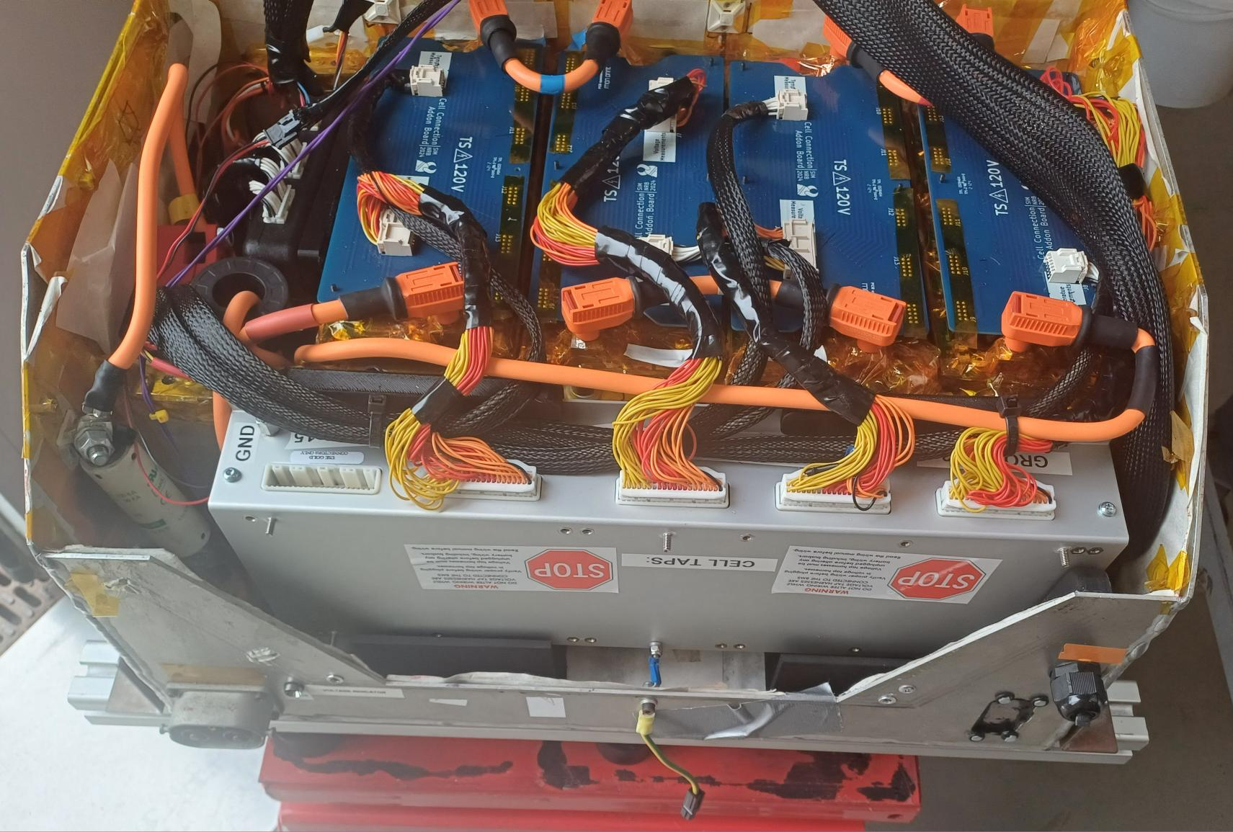

*Figure****:*** *the bottom container of the TSAC with the lid open. In the front is the Orion BMS which is connected to the blue Cell Connection Addon PCBs. To the left of the BMS is the HV-fuse. In the upper left corner is the thermistor expansion module for the BMS. Below that are the contactors (the empty area where the fifth bank was). Lastly, you can also see the hall-effect current sensor with a HV cable going through it.*

**Placement in Vehicle**

### Below the firewall of the driver’s seat. Infront of Inverter Container (TSC), and behind LV Battery.

**Purpose & Relevant Rules**

Provide power to inverters that drive the motors. Designed to have a capacity enough to complete endurance, but also deliver 80kW for acceleration, which is the max allowed.

## Battery cells

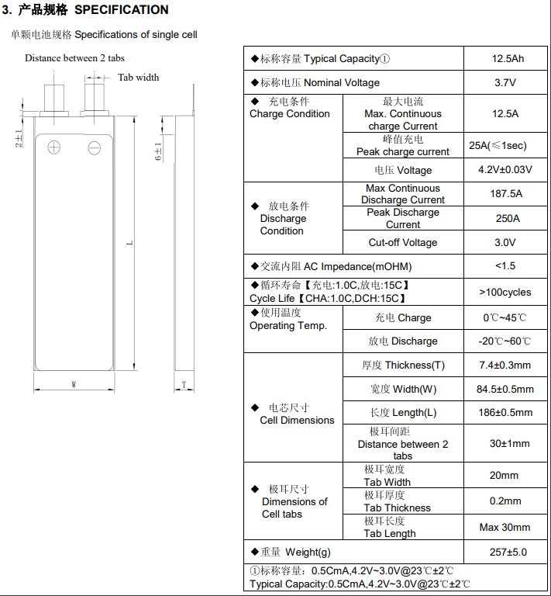

*Figure****:***  *Specifications of our battery cell chemistry.*

**Placement in vehicle**

Inside the Accumulator Container, under the cell connection PCB’s.

**Purpose & Relevant Rules**

The battery cells are LiPo pouch cells (SLPB7785186) from Melasta with 12500 mAH, 15 C, 3.7 V. LiPo puch cells are the most commonly used form of battery chemistry in EV vehicles.

We have (5) 4 Banks of 28 cells of 12.5 Ah. Whole bank has 5.18 KWh as a result. Peak current 250 A (4 seconds) and continuous current rating: of187.5 A. The cells have a nominal voltage of 3.7 V, a cutoff voltage of 3.0V and max voltage of 4.2 V. The whole accumulator’s voltage therefore ranges from 336 V to 470 V, with a nominal voltage of 414 V.

This gives the following power specifications (not taking temperature derating into account):

### Peak power of 117 kW fully charged

### Max continuous power of 88.2 kW fully charged

### Peak power of 84kW fully discharged

### Max continuous power of 63kW fully discharged

## Cell connection PCB

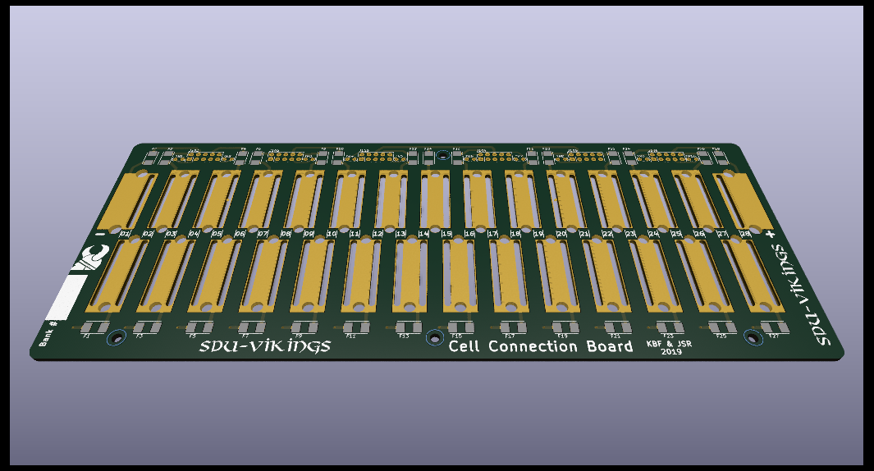

**Placement in vehicle**

Placed on top of the battery cells inside the accumulator.

**Purpose & Relevant Rules**

Used to connect all the cells in series to a total of 28 (1 bank). There are a total of (5) 4 cell connection PCBs in the accumulator totaling (5) 4 banks. It also has safety measures such as fuses and thermistors to measure the temperature of some certain cells (random sample). There are also connectors for the cell connection addon PCB. This is also the PCB with connections for the HV plugs/cables both for serial connecting all (5) 4 banks and powering the car.

## Cell connection addon PCB

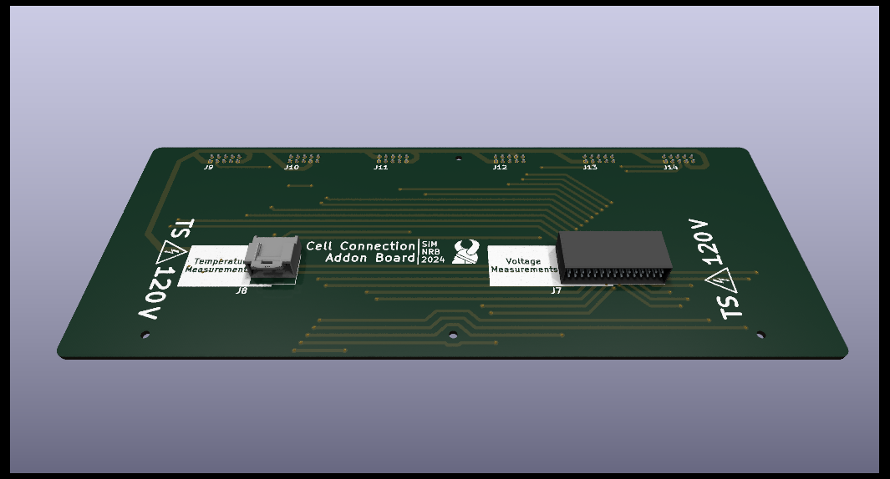

**Placement in vehicle**

The Cell connection addon PCB is placed on top of the cell connection PCB’s.

**Purpose & Relevant Rules**

The cell connection addon PCB is used to connect the cell connection PCB to the Orion BMS 2, so that it can measure the voltage on the cells. This gives the opportunity to check, if cells are underneath the critical voltage stage. Essentially it is an interface between the Orion BMS and the old Cell Connection PCBs.

## Orion BMS 2

**Placement in Vehicle**

*Figure: the TSAC open with the Orion BMS at the very front (big metal box).*

### In front of the cell banks, next to the fuse

**Purpose & Relevant Rules**

### The Orion BMS 2 is a bought AMS replacement to the old dysfunctional self-developed AMS system. Documentation of its inner workings can be found on the following page:

### [https://www.orionbms.com/products/orion-bms-standard#downloads](https://www.orionbms.com/products/orion-bms-standard" \l "downloads)

### The Orion BMS 2 serves the purpose of managing the entire battery and its banks, which involves measuring (and regulating) the following values:

### All cell voltages (112 (140), but it is capable of up to 180)

### (5)4x28 cell taps, connected to the Cell Connector Interface PCB

### Cell temperatures of at least 1/3 of the cells

### Done through the Orion BMS Thermistor expansion module; explained further below

### Measure overall current-draw and open the shutdown circuit through the Orion BMS Expansion PCB, in the case either a too high positive or negative current is being pulled. As of writing (11/09/2024), the maximum continuous discharge limit is 120A. This value will be derated for temperature. There is currently not implemented a pulse limit setting, however it should probably be the cells pulse limit, given the rest of the TS can handle it. TBD

All the voltage measurements are sent via CAN to the master controller for monitoring. The Orion BMS 2 is part of the shutdown circuit, controlling both the AMS relay, and Enable relay, all found on the Orion BMS Expansion PCB.

Connecting to the Orion BMS 2 is done through the CAN connector on the X90 interface PCB if the TSAC is connected to the car. Otherwise, it can also be connected to though the charger CAN. Here the CAN-adapter should be used in conjunction with the Orion BMS Utility software (can be downloaded [here](https://www.orionbms.com/downloads/orionbms2_utility_stable.exe)).

Connecting to the Orion BMS 2 is done through the CAN connector on the X90 interface PCB if the TSAC is connected to the car. Otherwise, it can also be connected to though the “charger CAN”. For these, the CANdapter should be used in conjunction with the Orion BMS Utility software (can be downloaded [here](https://www.orionbms.com/downloads/orionbms2_utility_stable.exe)).

The “main” (i.e. signals) connector of the Orion BMS 2 connects to the Orion BMS Expansion PCB in 3 different endings:

* 2x07 Microfit for GPIO
* 2x04 Microfit for LV (LV_charger, LV_car and GND)
* 1x03 Microfit CAN

Furthermore, it has a Thermistor connector, but it is left unused, since the thermistor expansion module takes care of this task. This module connects to all the thermistors and can then measure the temperature of all the cells required.

**Short procedure for troubleshooting (in case of AMS error):**

1. Connect to the BMS via CANdapter
2. Retrieve trouble code and diagnose
   1. Cell voltages and temperatures
      1. Unstable values might indicate a faulty connection. Previously it has been observed as problems relating to improper crimping/ crimps failing after use. Furthermore, cells at the edges of the Cell Connection PCB have a poor trace, that might get severed through rough handling.
   2. Communication errors
      1. The BMS is improperly grounded, and noise has caused an internal communication error. Determine if the BMS is grounded at its grounding points, or look into different grounding methods.
      2. Another device is not powered (Controller or Thermistor). Furthermore, having the BMS power up before another device on the CANbus, might result in a fault, that needs to be reset manually. This is an annoying problem, but not crucial, and should only appear on startup. Reboot the BMS through the BMS Utility software.
      3. EMI.
   3. Consult the troubleshooting guide for more information (On Orion BMS website)
3. Fix problems
4. Reset the fault and reboot the BMS, either power-cycling or though the BMS Utility Software.

## 

## Orion BMS Expansion PCB

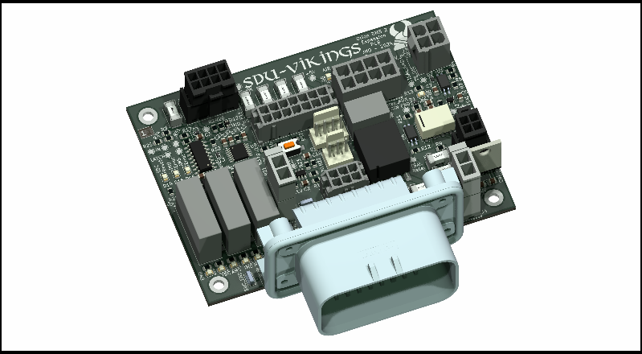

*Figure: The Orion BMX Expansion PCB in 3D rendering.*

**Placement in Vehicle**

*Figure: The top of the TSAC with the Orion Expansion PCB to the left, the IMD in the middle and the Accu HV PCB to the right.*

### In the TSAC Lid, to the left on the picture above. It connects the TSAC to the rest of the car, with a 23pin AMPSEAL connector facing out to the left. The connectors wire housing must be removed when lowering or inserting the TSAC in the car.

**Purpose & Relevant Rules**

The Orion BMS Expansion PCB was made as a replacement for the old AMS master PCB, and to integrate the Orion BMS 2 in the accumulator. While the Orion BMS 2 takes care of all the cells, this board makes sure to interface and interconnect all the other PCBs in the accumulator, notably the IMD and Accumulator HV PCB. The board has the following main functions:

1. Shutdown circuit (SDC) of the accumulator (TSAC). IMD, AMS & “SDC Enable”
2. IMD measurement points. Connecting its measurement points to the main hoop wire and TSAC container
3. Relaying signals to the TSAL regarding TS voltage & AIR status detection circuitry from the Accu HV PCB
4. Interconnect AIRs and Precharge Relays with the SDC LV-Supply and digital outputs from the Orion BMS 2. This is to open and close the contactors
5. Interface the Orion BMS 2 with the car.
6. Ease troubleshooting via status LEDs and testpoints.

**Connections explained**

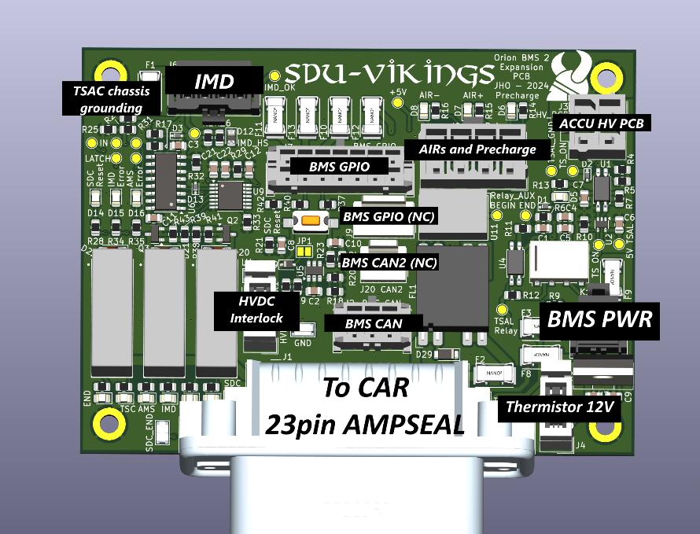

*Figure: Explanation of the Orion Expansion PCB.*

Quick rundown of the individual connectors, and their functions. To see all the connections, refer to the KiCad schematic files for this project. As of writing (11/09/2024), this is revision 3.0

1. Main TE AMPSEAL 23Pin connector; connects the TSAC to the car.
   1. SDC to the TSMS
   2. Charger current limit analog signal. (Not implemented on charger)
   3. X90 Interface CAN, LV and SDC input
   4. TSC
      1. Discharge resistor disabling when SDC is complete
      2. SDC going through the inverter motor interlocks (wires going out the inverter), and BSPD
   5. LV from the charger
   6. 5 V from TSAL to detect voltage even when LV is off
   7. SDC reset button on TSMP
   8. TSAL Relay detection and TS HV detection.
2. BMS GPIO, 2x07 Microfit
   1. Carries MP_O (MultiPurpose Output), which are open drain MOSFETs on the BMS, used for actuating the AIRs and Precharge contactor relays.
   2. MP_I lines from the BMS (MultiPurpose Input/Output). Used to reference the status of the AMS, IMD and SDC_END status.
   3. Analog charge limit, along with unused DCL_ana and SOC_ana. The unused IO are broken out in a 1x04 Molex KK-254.
3. BMS CAN, 2x03 Microfit
   1. Routes CAN1 and CAN2 from the BMS. CAN2 is not used, but broken out as a 1x03 Molex KK-254.
4. BMS PWR, 2x02 Wurth WR-MPC3 (pin compatible to Microfit)
   1. Routes Ready Power, Charge power and ground. The distinction between ready and charge power is the BMS knowing whether it is in the car, and “ready” to run, or in the charger. If the Charge Power is ever high in the car, discharging the accumulator won’t be possible.
5. IMD, 2x04 Wurth WR-MPC3
   1. IMD GND measuring point of the main hoop, and TSAC GND, which is connected to electrical ground. A grounding wire crimped in both ends is placed in the screw mounts, connecting the boards electrical ground to the inner wall of the TSAC lid.
   2. LV supply
   3. IMD OK signal, determining whether the resistance between TS and Chassis is high enough.
6. ACCU HV PCB
   1. GND reference
   2. HV detection on TS circuitry. Sent to the TSAL to activate the red light, if there is a voltage over 60V on the car side TS.
7. AIRs and Precharge
   1. Positive and negative side of the AIR+, AIR- and Precharge relay
   2. Auxiliary relays of the contractors (Normally Closed). A wire goes out and returns from a series connection of the Aux-relays. This means that if one contactor is closed, a current can no longer pass though the aux-relays, and this can be measured.
8. High Voltage DisConnect InterLock (HVDC IL)
   1. Interlock on the HV wire going out of the TSAC. SDC runs through it.

**Circuitry explained**

**Root schematic file (General IO)**

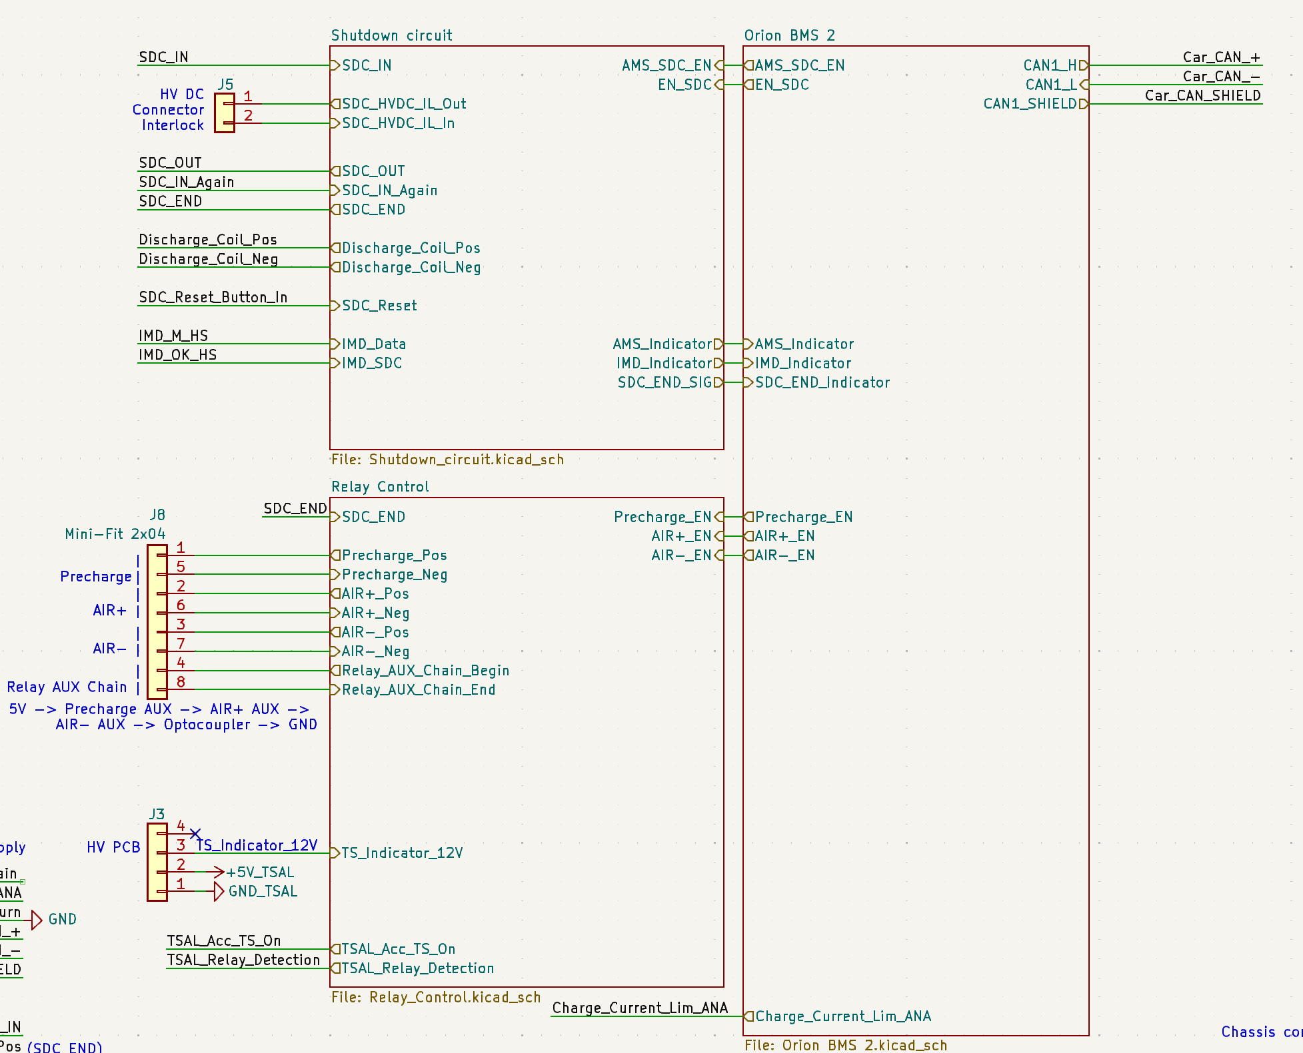 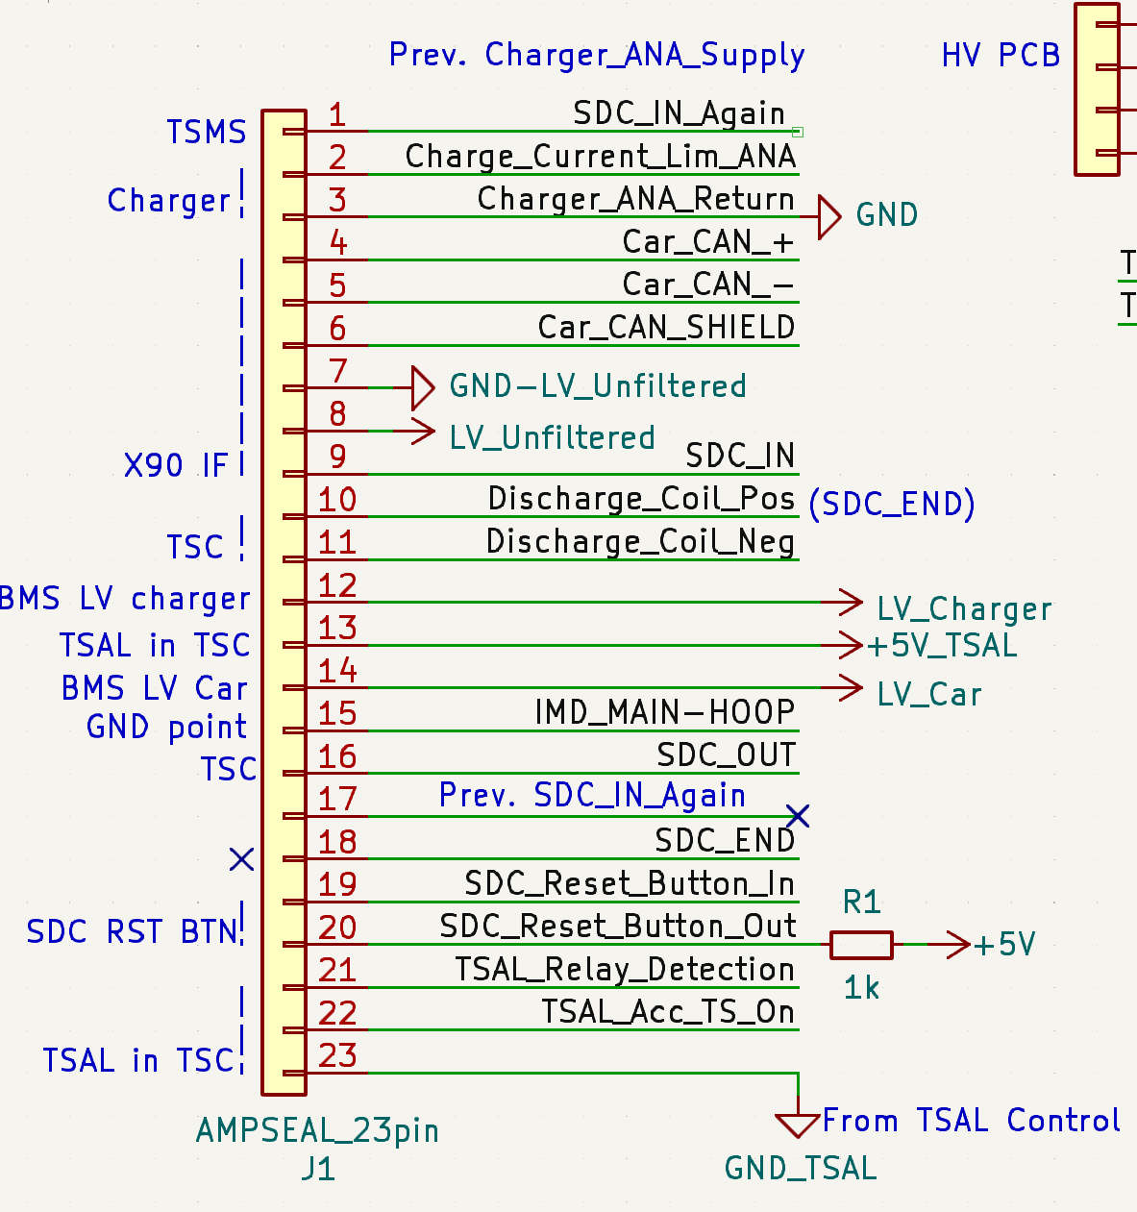

*Figure (left): The top file of the schematic. Figure (right): the AMPSeal connector.*

The schematic file is split into three main heirarchy files; Shutdown circuit, Relay control and Orion BMS 2. The shutdown circuit schematic handles the relays actuation of the SDC, and latches the IMD and AMS errors. The relay control schematic entails the circuits powering the AIRs and Precharge relay, along with determining whether a (doesn’t know which one, just one) relay is closed, and if there is HV on the TS lines. The Orion BMS 2 schematic connects the Main IO of the BMS.

**Shutdown circuit (SDC)**

* AMS Error Latch circuit:

All the BMS outputs are open drain. The error signal is a parallel wiring of the Charger_safety signal and Discharge_Enable from the BMS. Therefore the Discharge_Enable not being on during charging won’t result in an error, if the Charger_Safety is active low.

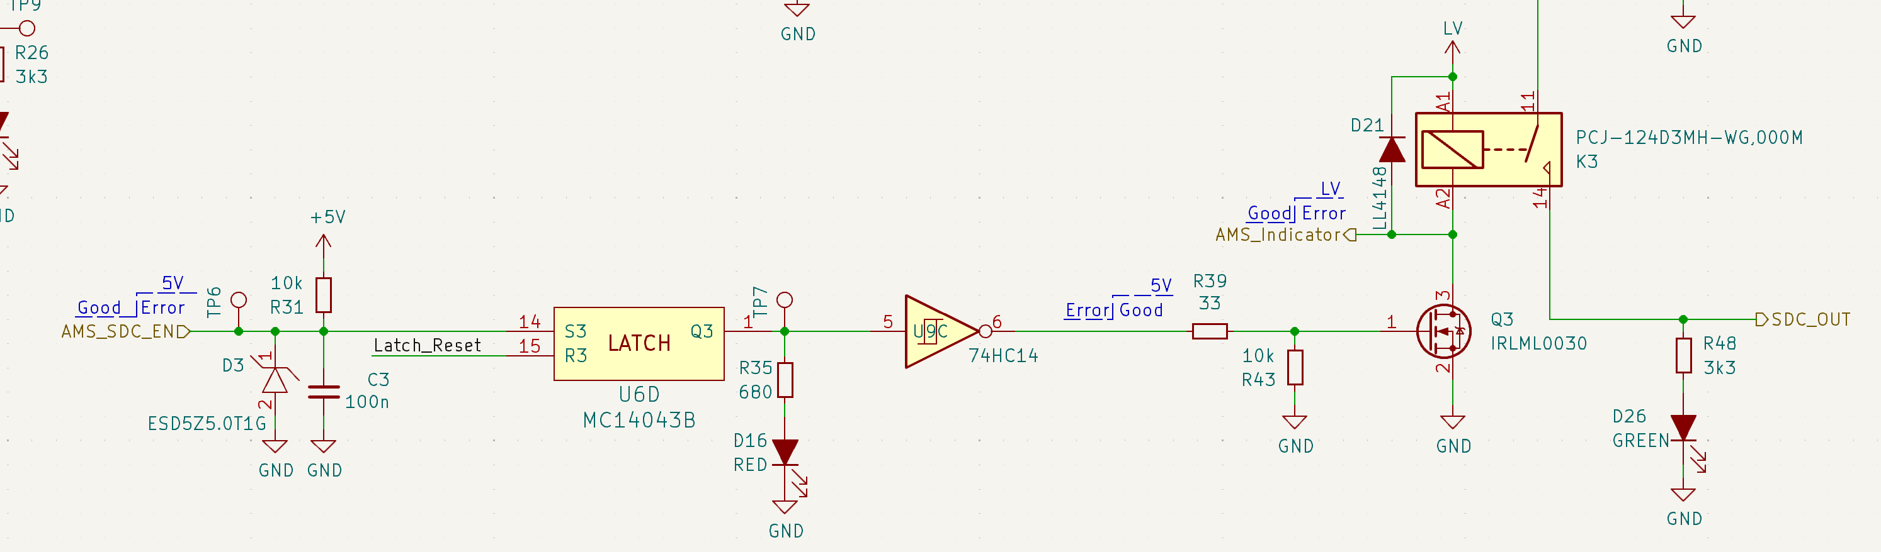

*Figure: The SDC latch circuit with a reset.*

If the AMS SDC Enable signal is not pulled low, U6D will latch the signal. This will result in U9C inverting the signal, and Q3 being turned off. This error can only be removed by manually pressing the button on the PCB, or the SDC_Reset placed on the TSMP. With Q3 not conducting anymore, K3 will also open, and the SDC being broken. Since the AIR’s are connected to the SDC, they will lose power too, and open.

The IMD stage is much similar, although this signal is active high, an inverter is placed before the latch. If any false latches are observed, look into adding additional filtering capacitors on the latch inputs.

* SDC reset on power on:

IMD/AMS both take time to start up, and to prevent startup latching, this circuit disables it for the first 3.5s after LV has been applied.

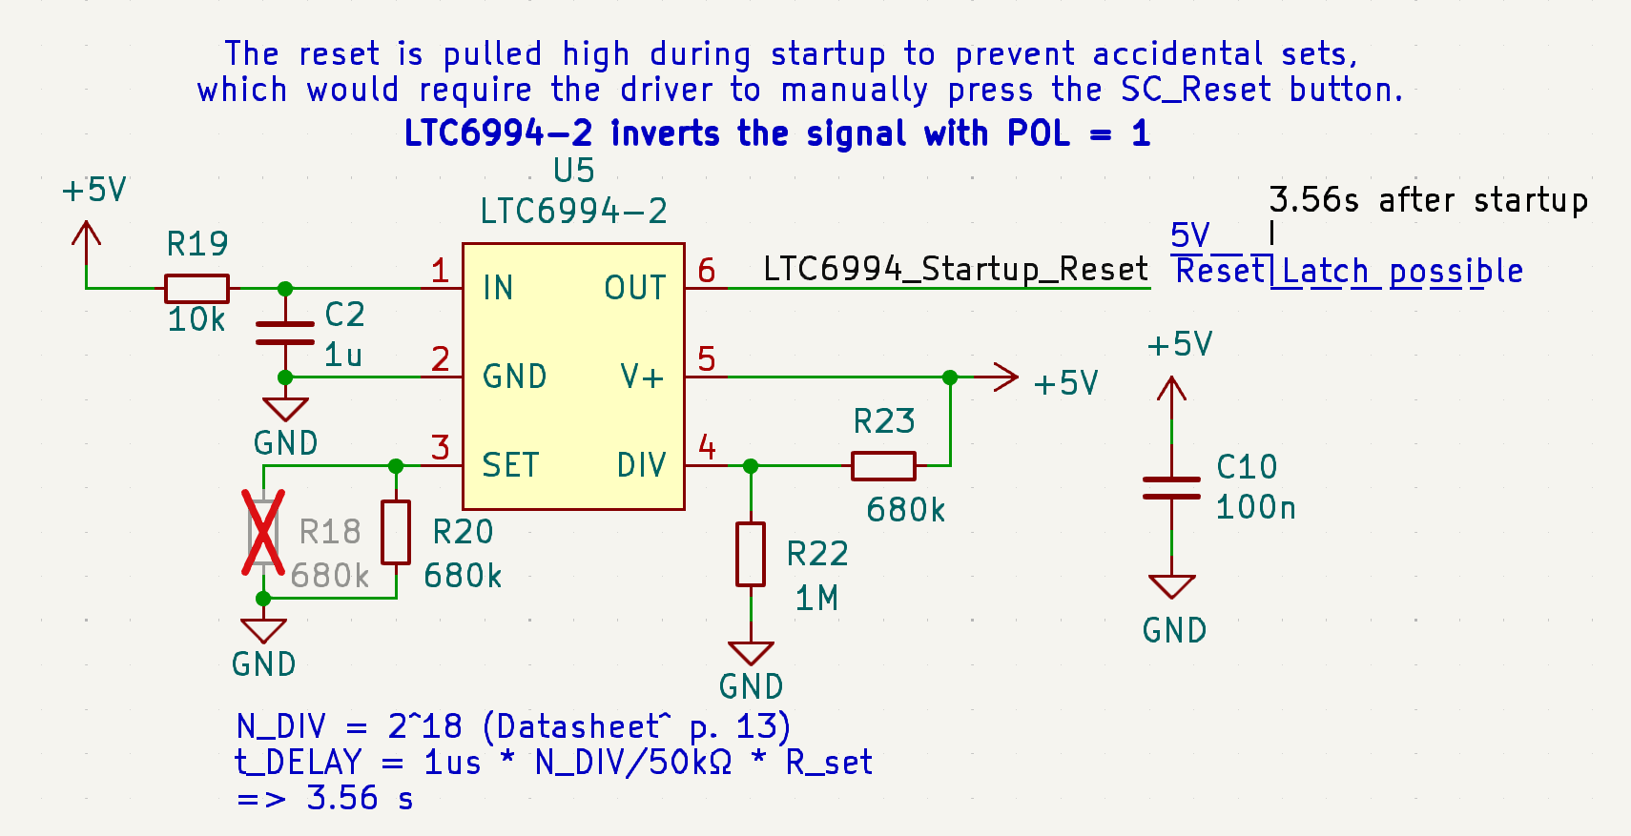

*Figure: The reset timer circuit for the AMS reset.*

**Relay control**

* Actuating the contactors (AIRs and Precharge):

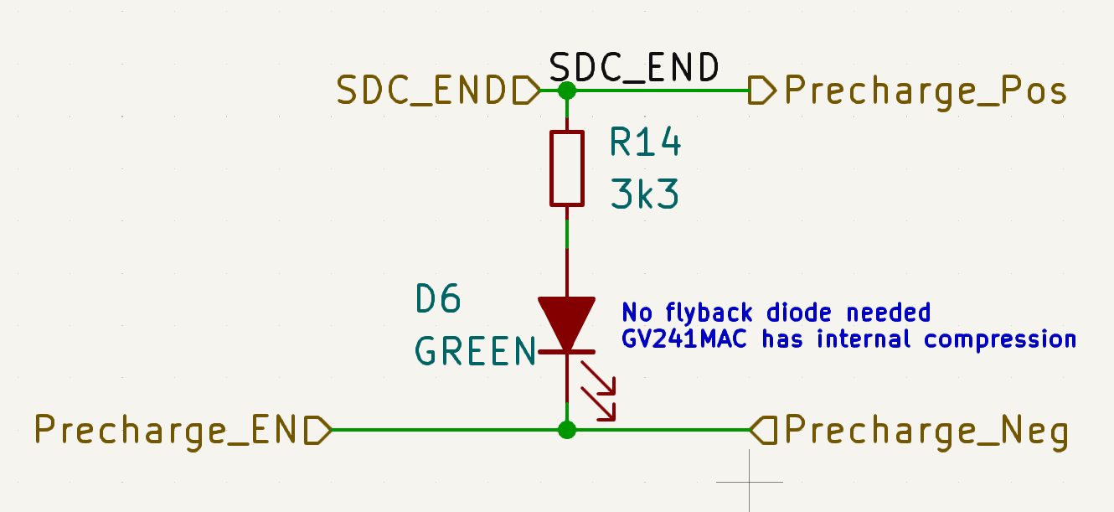

*Figure: the end of the SDC.*

The positive terminal of the contactor is connected to the SDC_END. The BMS is used directly to drive it, which saves space on the PCB. The open drain outputs of the BMS are activated to close the contactors.

* Relay status detection with auxiliary relays:

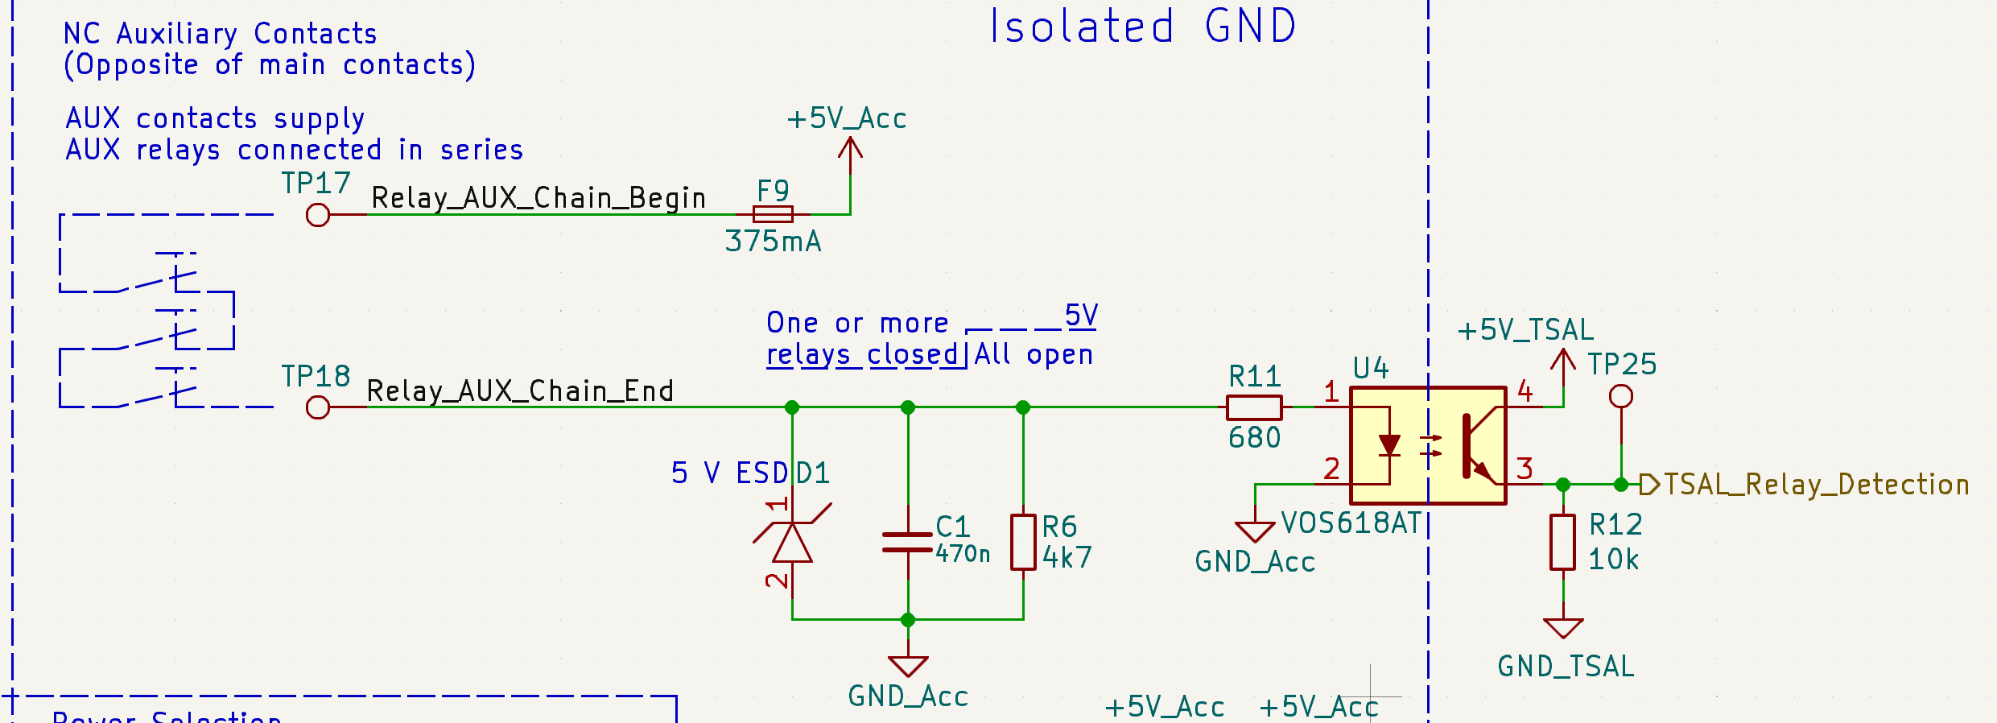

*Figure: Relay detection via aux relays.*

* Detection of HV on TS from the ACCU HV PCB:

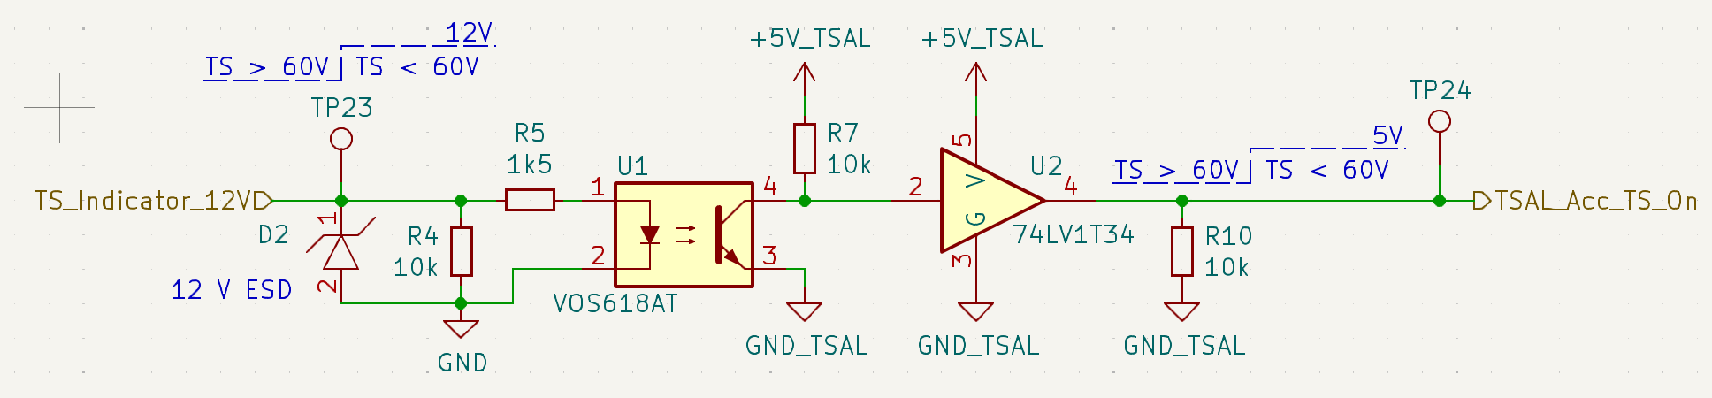

*Figure: TS indicator (via signal from the Accu HV PCB).*

## ACCU HV PCB

**Placement in Vehicle**

The ACCU HV PCB is located on the left side of the top lid of the accumulator. It is placed here due to space constraints in the main accumulator container.

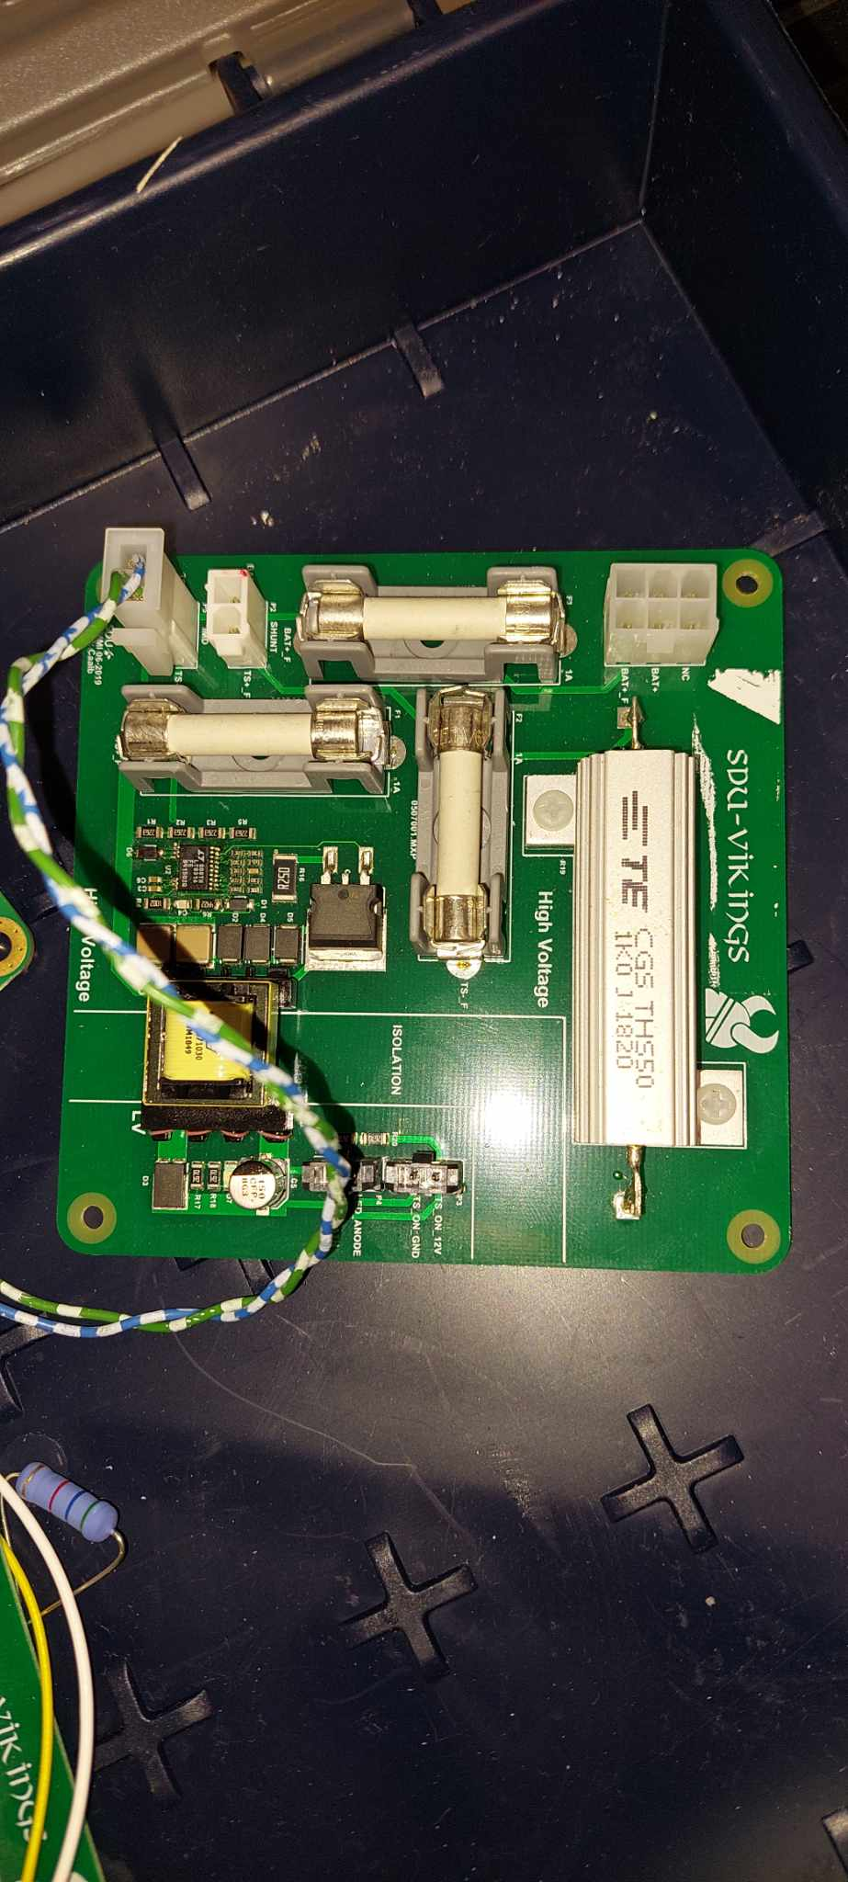

Figure: The standalone ACCU HV PCB.

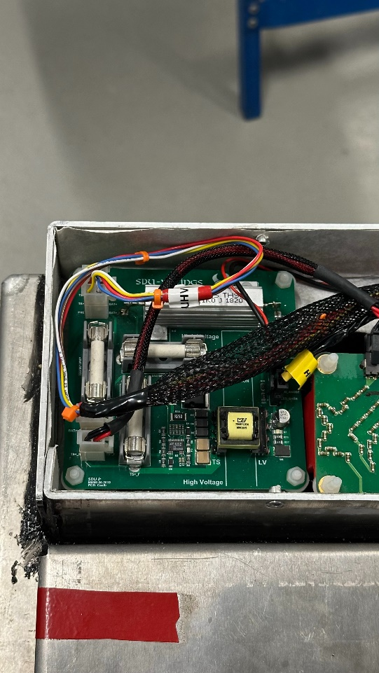 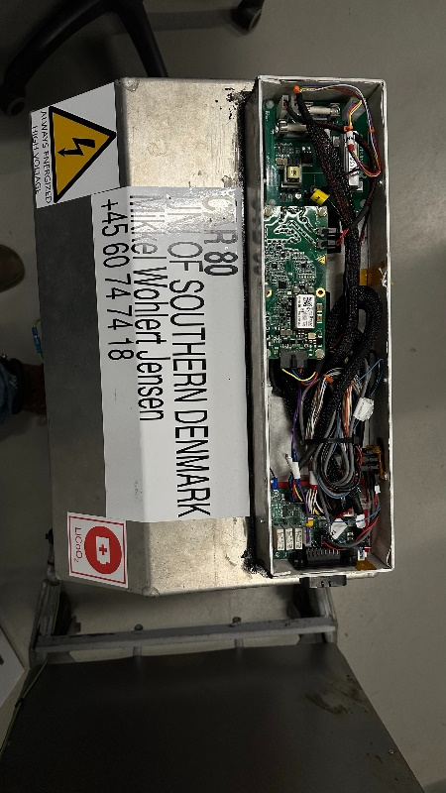

Left figure: The ACCU HV PCB in the top lid. Right figure: The ACCU HV PCB in context of the entire accumulator.

The terms for high voltage lines being used in this explanation are:

* V_BAT: This denotes the high voltage that is present at the accumulator side of the relays.
* V_TS: This denotes the high voltage present at the opposite/vehicle side of the relays.

**Purpose and Relevant Rules**

The PCB functions to handle the tasks of precharging, providing fused HV lines for the IMD and use of the TS indicator light. The 2019 report “*Accumulator for electric Formula Student racecar*” indicates that the PCB should have functionality for measuring the HV voltage from the energy meter, but the current PCB makes no hint at having this functionality, expect for having the connector to the energy meter (aka. shunt). The same goes for the temperature measurement of the precharge resistor.

Precharging:

* Refer to rule EV 5.7.
* The precharge-circuit limits the inrush current when the AIRs are closed. This is done by closing the precharge relay BEFORE the AIRs, thus “precharging” the car-side (DC-link capacitance of the inverters) of the AIRs and avoiding a large inrush current. The pre-charging sequence is performed by closing the negative AIR and the pre-charge relay, in that order. When the voltage on the car side of the AIRs reaches 90% of the maximum voltage or above, the AIR+ is allowed to close and the precharge relay opens at last.
* This task requires that the battery voltage V_Bat and the car-side voltage V_TS are known and these thus have to be measured.
* From the 2019 report “*Accumulator for electric Formula Student racecar”:* “The inverters used in the car has a total capacitance of 300µF. The equivalent load of other things connected to the tractive system is 30kΩ (measured on previous car).”
* The 1kΩ precharge power resistor is selected in order to limit the inrush current (as seen in the ESF!). By selecting a 1kΩ resistor, the time to reach 95% of maximum voltage becomes 0,9 seconds.
* This value is different than the 3.3kΩ calculated in the accumulator report from 2019. From the report: “It is desired to have an as short as possible precharge time, while still keeping the peak power dissipated in the resistor to a reasonable amount. The power rating of the resistor will most likely not be the limiting factor. Instead the voltage rating of the resistor will determine the minimum size. Hence a goal of less than three seconds of precharge is set, but it might be shorter if that can be achieved without selecting a larger resistor than minimally necessary.”
  + For future reference: maybe it would be wise to have a higher resistance to limit current spikes. It is not necessary to have as fast a pre-charge time.

Fused HV lines to IMD:

* Refer to rule EV 6.3.
* The IMD gets its measurements of TS voltage from the ACCU HV PCB. Where the IMD gets this measurement from is not important, but it has been implemented this way for ease of use.

TS indicator light:

* Refer to rules EV 5.4.8 to 5.4.10.
* The DC/DC flyback converter is used to convert the HV+ to an isolated 12 V for the LED Voltage indicator that shows whether the voltage on the vehicle side of the AIRs is higher than 60V.

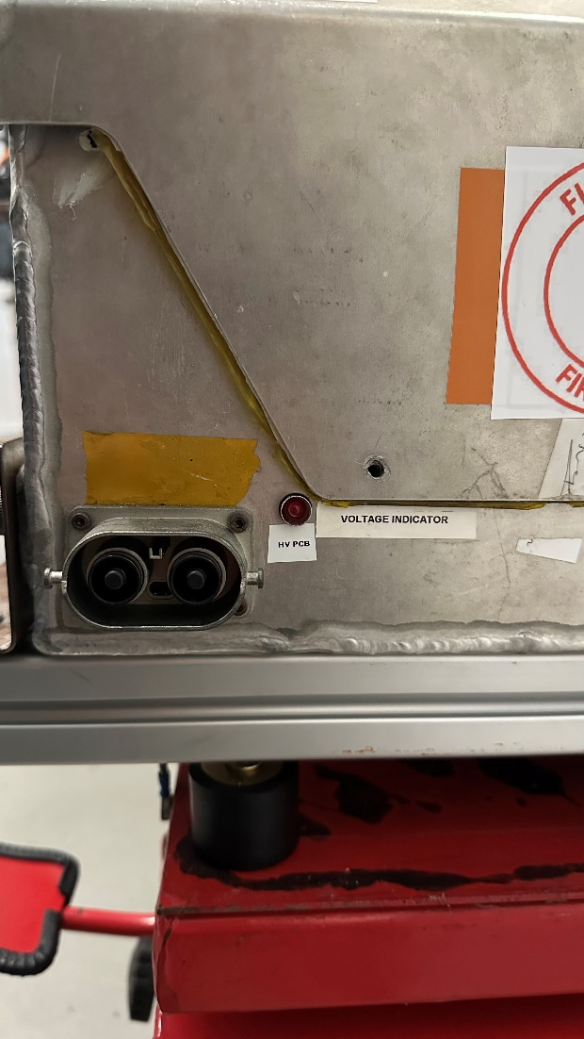

Figure: TS indicator LED seen from the front of the TSAC.

The PCB contains both HV and LV and as such must take measures to keep these separated. On this PCB it is done by making a demarcated, and easily visible, isolation area.

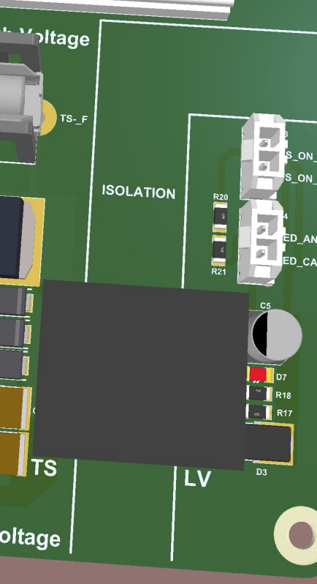

Figure: The isolation area marked across the placement of the transformer.

**Circuitry Explanation**

The explanation for the circuity of the PCB follows the same outlines as those made in the section for purpose and relevant rules.

Precharge circuit:

* The precharge resistor chosen is the A132039-ND 50 W power resistor.
* The contacts on the precharge relay are connected, by yellow and white wires, to the PCB through P1. The yellow wire connects pin 1 to the contact on the precharge relay between the relay and the precharge resistor. The white wire connects the battery side of the precharge relay to pin 4. This is called Bat+_Fused and further goes on to connect to the positive battery terminal through a fuse.

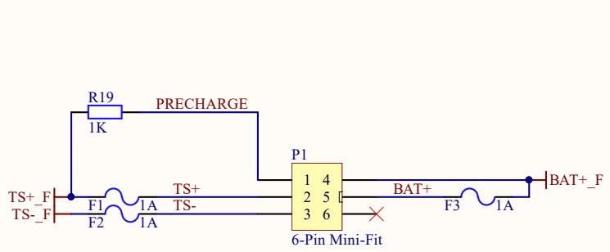



Figure: The connector P1 on the ACCU HV PCB with the precharge relay added in green to show how it connects to the relay.

Circuit for fused HV lines to IMD:

* This entire circuit consists of a connector which will be described later and two fuses.
* The component choice for all fuses on the PCB is a 1 A fuse that fits the 03540101ZXGY fuse block size.

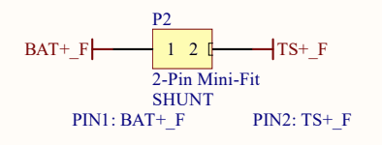

Figure: The connector to the IMD. The fusing is shown in the figure for the precharge circuit.

TS indicator light circuit:

* The DC/DC converter is made using the flyback topology and is currently set to turn on when the voltage reaches 56,34V. The major components consist of the following:
  + Controller: LT8316IFE
  + Transformer: 750871030
  + Transistor: STB13N80K5
  + Zener diodes for transistor snubber: 2 x CZRB5375B-HF
  + Feedback voltage divider: 4 x 226kΩ in series with 2 x 10kΩ

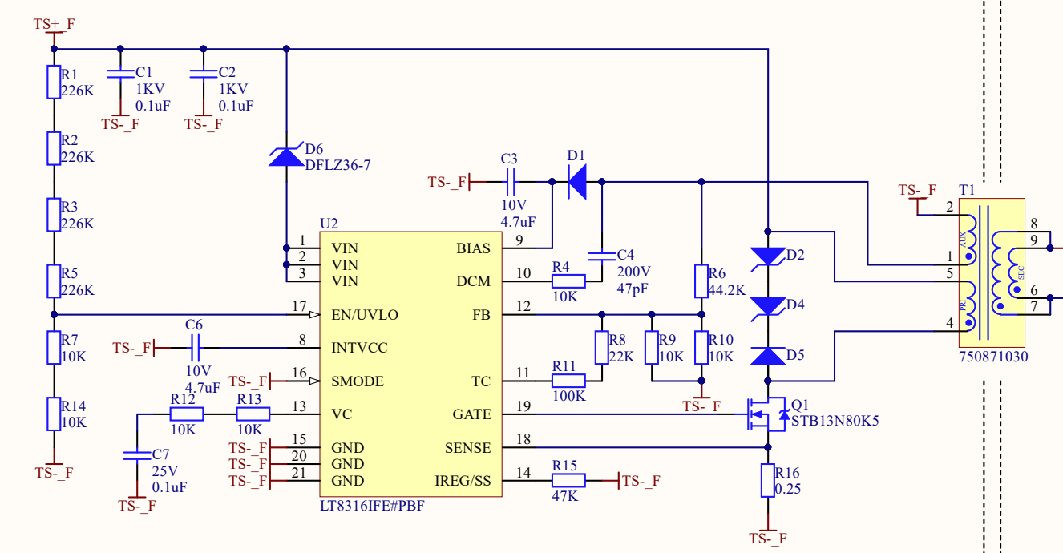

Figure: The circuit of the controller.

* The reasoning for choosing this converter and the voltage of 12V, as explained in the accumulator report, is stated as the following: “As the same buck converter is used elsewhere in the car, the output voltage is chosen to be 12V.” The converter is currently not used elsewhere in the car, and the same goes for the 12V.
* The supply for the controller is provided by the auxiliary winding on the transformer and fed into pin 9 (BIAS).
* The red LED currently in use is the same as the ones being used on the charger.

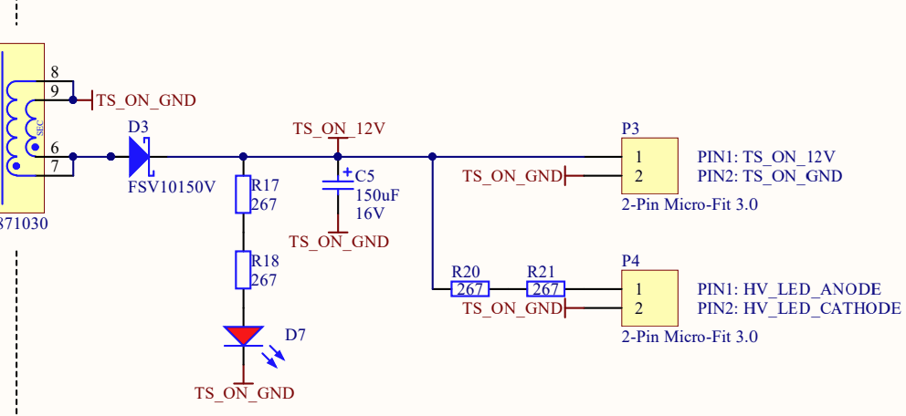

Figure: The secondary side of the transformer for the 12V and LED connectors.

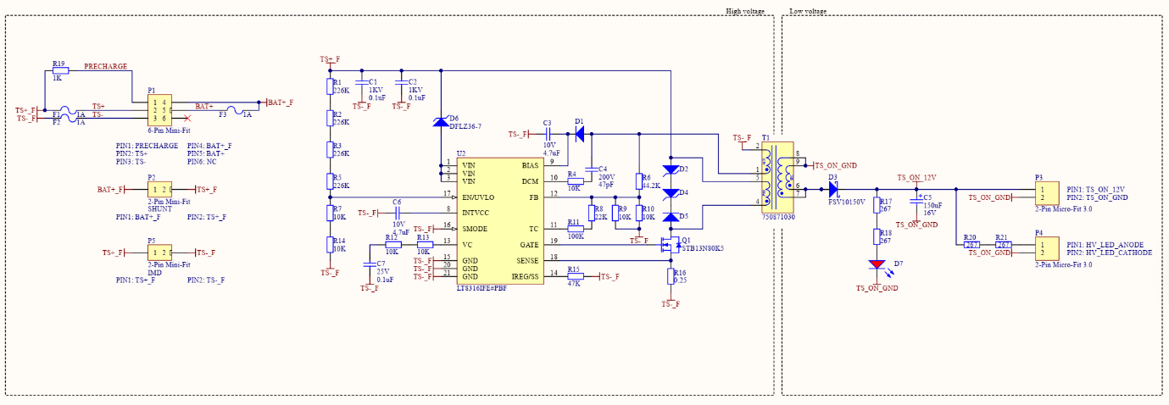

Figure: An entire schematic of the circuit.

**Connections**

P1: Connections from Battery and TS lines in ACCU container. The physical connector is a 6-Pin Molex Mini-Fit.

* Pin 1: Pre-charge, from terminal +A1 on the Pre-charge relay
* Pin 2: TS+, from terminal -A2 on AIR+
* Pin 3: TS-, from terminal -A2 on AIR-
* Pin 4: BAT+_Fused, from terminal -A2 on the Pre-charge relay
* Pin 5: BAT+,from terminal +A1 on AIR+
* Pin 6: Not Connected

P2: SHUNT Sensor. Measurements from the Shunt sensor in the ACCU container. The physical connector is a 6-Pin Molex Mini-Fit.

* Pin 1: BAT+_Fused
* Pin 2: TS+_Fused

P3: TS_ON, Connection to connector **J3** of the Orion Expansion PCB indicating if TS > 60V. The physical connector is a 2-Pin Molex Micro-Fit 3.0.

* Pin 1: TS_ON_12V
* Pin 2: TS_ON_GND

P4: Connector going to the LED on the front of the accumulator. Used for indicating >60 V on the TS lines. The physical connector is a 2-Pin Molex Micro-Fit 3.0.

* Pin 1: HV_LED_ANODE
* Pin 2: HV_LED_CATHODE

P5: sends HV+ & HV- to connectors XLA+ and XLA- (line voltage) to the IMD. The physical connector is a 2-Pin Molex Mini-Fit.

* Pin 1: TS+_F
* Pin 2: TS-_F

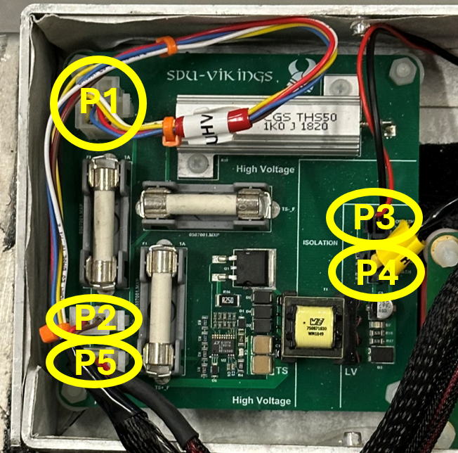

Figure: The physical placements of the connectors P1 through P5.

## IMD



*Figure: The Orion Expansion PCB is placed to the left, the IMD in the middle and the Accu HV PCB to the right.*

**Placement in Vehicle**

### In the middle of the TSAC lid

**Purpose & Relevant Rules**

*EV 6.3 Insulation Monitoring Device*

This is an out-of-house (sponsored by Bender in 2019) IMD (Bender IR155-3204) and satisfies EV 6.3.2. The IMD’s purpose is to open the SDC in the event the resistance between TS and GND is below 500 Ω/V * TS_max voltage. It must trip at atleast 235kΩ, it has been bought with this parameter set at 300kΩ. Furthermore, it is important that the undervoltage detection is disabled (I.e. equal 0V). Its datasheet can be read [here](https://www.bender.de/fileadmin/content/Products/d/e/IR155-32xx-V004_D00115_D_XXEN.pdf).

It is connected to the Orion BMS expansion board, where it receives LV and its GND measurement points. Both the electrical ground, which is connected to the TSAC enclosure, and Main-hoop-chassis measurement point. It receives TS+ and TS- sense lines from the Accu HV PCB. They are also fused here.

**Connections**

* Big connector - J106 (on Orion exp. PCB)
* HV Sense lines (2 pins) - J102 (on Accu HV PCB)

## Other

#### **Contactors**

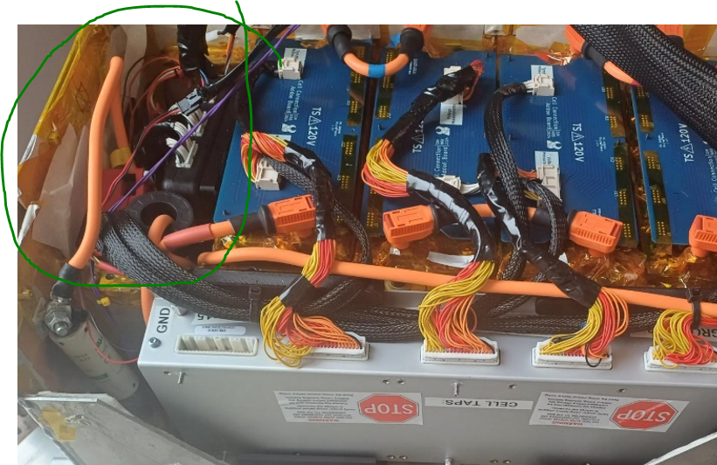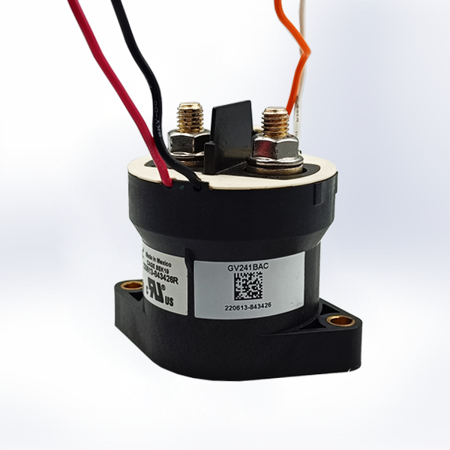

*Figure (left): The contactors are placed below the thermal expansion module on the left side of the TSAC. Figure (right) an image of the contactor-model used.*

The big “relays**”** in the TS-system (AIR+, AIR- and precharge) are called contactors. These are the GV24 series of 400+ A, 800 V_DC contactors. They have 2 main HV connection terminals (+A1 & A2-) and the controls (X2- & X1+), but it also has some auxiliary terminals that output the status of the contactor (T1 & T2)

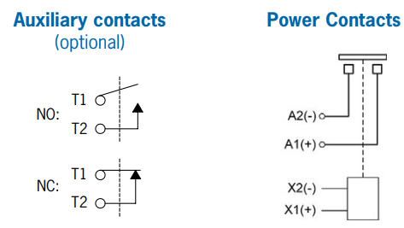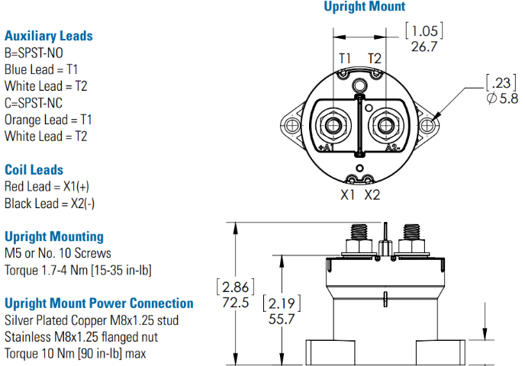

*Figures: an overview of the main power contacts and the auxiliary contacts.*

**Connections**

#### **HV Fuse**

**Connections**

#### **Orion BMS’ Hall Effect Current Sensor**

**Connections**

# Accumulator Container (OLD)

## Accumulator overview & specs

**Placement in Vehicle**

* BILLEDE AF ACCUMULATOR CONTAINER BÅDE LUKKET OG ÅBEN
* Below the firewall (driver seat).

**Purpose & Relevant Rules**

* Max 588 V
* 140 LiPo cells in series divided into 5 banks of 28 cells each.
* Maximum capacity: 6.48 KWh
  + The energy capacity is calculated using the charge capacity (Ah) and nominal voltage (V_nom) of the cells. The nominal voltage is used as it will be the voltage seen for most of the discharging of the cell. Thus is will underestimate the capacity when having discharged very little and overestimate it when having discharged a lot. In comparison, using the maximum voltage (V_max) overestimates the energy capacity at all points of discharge. This is shown in the images below.

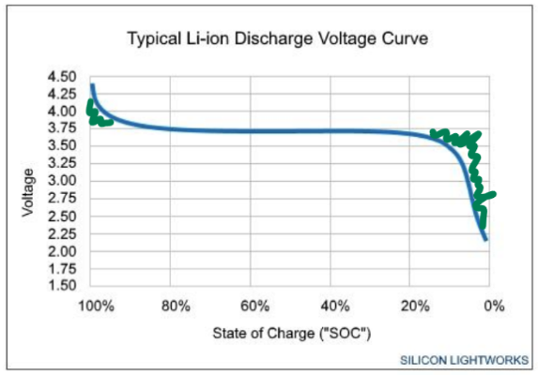 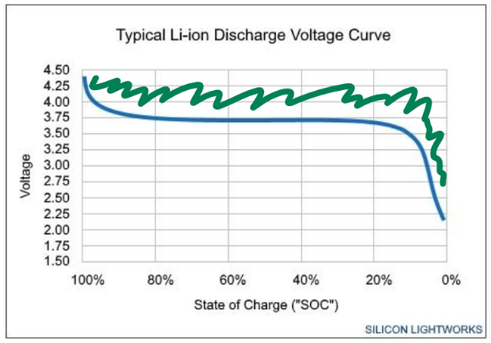

* The power output of the accumulator is software limited to 80kW. Without limitation it’s a peak of 147 kW (fully charged).
* Cells are monitored and balanced by AMS (previously self-designed via the LTC6813 IC)

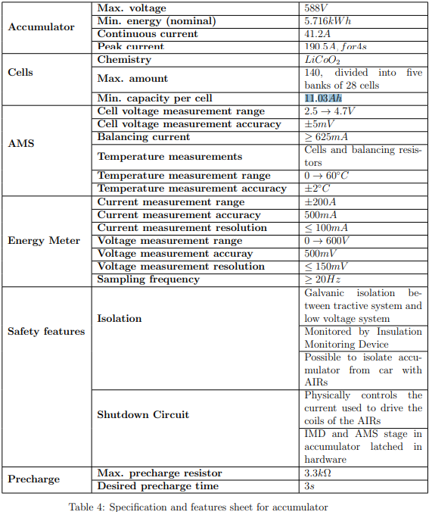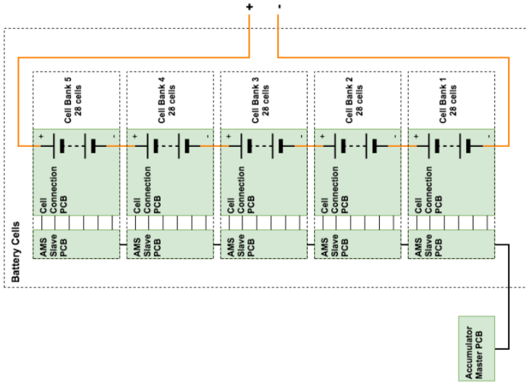

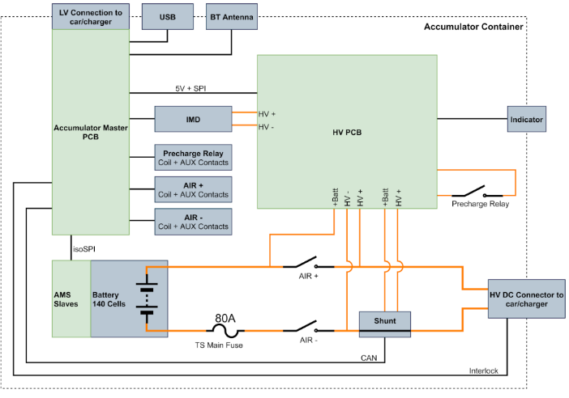

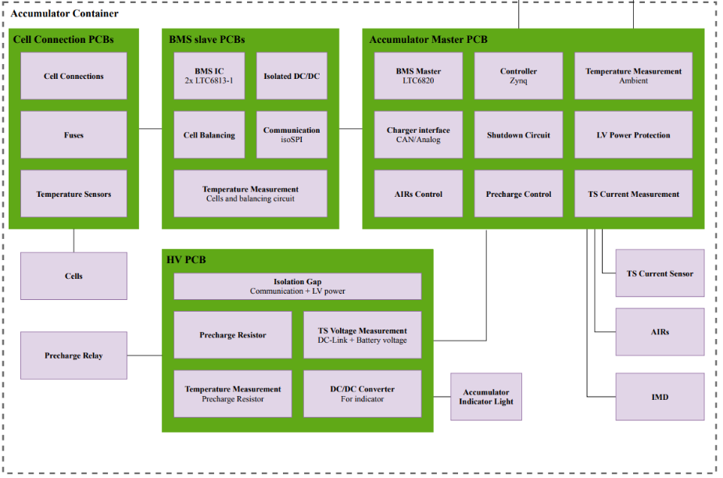

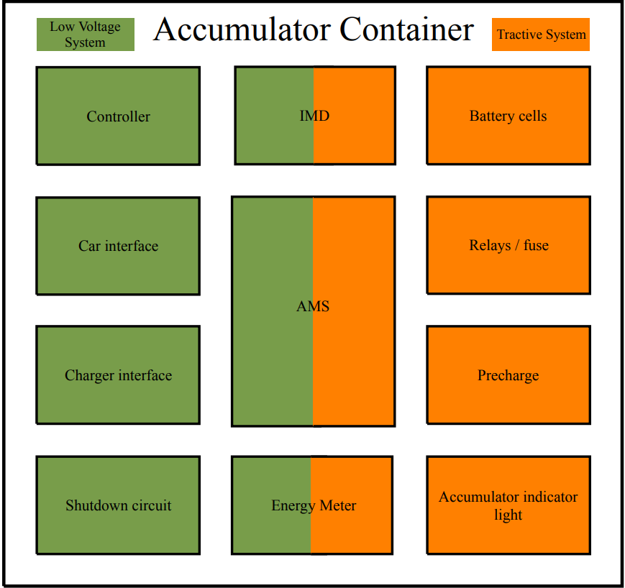

## ACCU HV PCB

**Placement in Vehicle**



* Placed inside the TSAC, in the top box. (seen from the front): the HV PCB (and IMD-PCB) are placed behind a ‘paper-wall’ to the right-side that isolates them from the AMS (previous).

**Purpose & Relevant Rules**

* 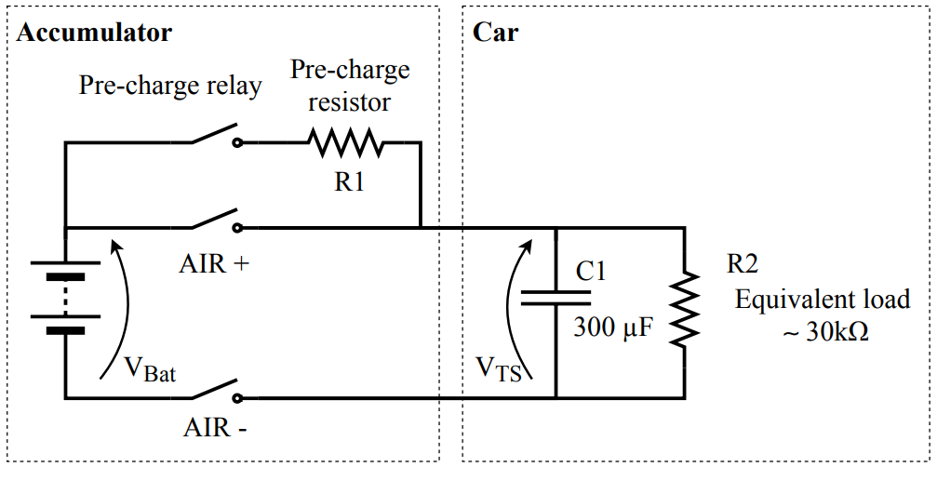
* Contains….
  + the precharge resistor (the precharge relay is placed together with the AIRs in the accumulator),
  + DCDC for accumulator voltage indicator and distributing low-current TS for the IMD
  + Voltage-measurement channels on the digital shunt. The digital shunt (IVT-S-100-U3-I-CAN1-12/24) is used to measure the TS current and voltage.
    - From the accumulator 2019 report: “*It is wished by the team to have the functionality of an energy meter* [Sic: shunt], *similar to the one used at events, in the accumulator. The function of this energy meter [sic:* shunt] *is to be able to dynamically limit the power drawn from the accumulator, to ensure that the team will not be disqualified due to an exceeded power limit. The measurements made by the energy meter is also used as part of the AMS.*”
* Precharge circuit
  + The precharge-circuit limits the inrush current when the AIRs are closed. This is done by opening the precharge relay BEFORE the AIRs, thus “precharging” the car-side (DC-link capacitance of the inverters) of the AIRs and avoiding a large inrush current. The pre-charging sequence is performed by closing the negative AIR and the pre-charge relay, in that order. At 90% or above, the AIR+ is allowed closed.
  + This also requires that the battery voltage V_Bat and the car-side voltage V_TS is known and thus measured.
  + *“The inverters used in the car has a total capacitance of 300µF. The equivalent load of other things connected to the tractive system is 30 kohm (measured on previous car).”* -from accumulator 2019 report
* The 1.0 kΩ precharge power resistor is selected in order to limit the inrush current (as seen in the ESF!). By selecting a 1kΩ resistor, the precharge time becomes 1.5 seconds. Circa 3 second precharge time.
  + This value is different than the 3.3kohm calculated in the accumulator report from 2019. From the report: “*It is desired to have an as short as possible precharge time, while still keeping the peak power dissipated in the resistor to a reasonable amount. The power rating of the resistor will most likely not be the limiting factor. In stead the voltage rating of the resistor will determine the minimum size. Hence a goal of less than three seconds of precharge is set, but it might be shorter if that can be achieved without selecting a larger resistor than minimally necessary.”*
    - For future reference: maybe it would be wise to have a higher resistance to limit current spikes. It is not necessary to have a fast pre-charge time.
* The temperature of the pre-charge resistor is monitored with a thermistor on the resistor housing. From the accumulator report: “*It is unlikely that the resistor will get too hot during normal use, and as such the temperature measurement is only used for diagnostics*.”
  + For future reference: Maybe remove this part of the circuit if it is unnecessary.
* The HV PCB also contains the….
  + DCDC for the Accumulator voltage indicator
  + TS Voltage Measurement
* 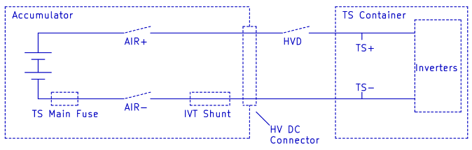

**Circuitry Explanation**

* Precharge circuit:
  + +A1 (yellow) and A2- (white) contacts on the precharge relay are connected to the HV PCB. This path has a 2A fuse.
  + Batt+ (that is the voltage of the accumulator) is sent to the precharge-resistor of 1kohm and through the precharge relay. This voltage (now called HV+ since we’re on the other side of the relay) is now (ACCORDING TO SCHEMATIC, NOT THE DIAGRAM IN THE ACCUMULATOR REPORT) sent to the IMD alongside HV- (which is just the negative terminal of the accumulator on the other side of the shunt.
    - This HV+ is also sent to AUX
    - The HV+ is also sent to the DCDC converter.
* DCDC for the Accumulator voltage indicator
  + The DCDC is used to convert the HV+ to 12v referenced to HV- and then to 3.3V for the LED Voltage indicator that shows whether the voltage on the vehicle side of the AIRs is higher than 60V.
    - (explanation from the accumulator report: “*As the same buck converter is used elsewhere in the car, the output voltage is chosen to be 12V* .”)
  + “U2” is a comparator that compares the HV+ voltage (scaled down) à if TS > 60 V, then the output is HIGH. If the output is LOW, then the CTRL-pin (on/off function) of U3 (that is the DCDC from 12V to 3.3V) will DISABLE the 3v3 and the LED Voltage indicator will NOT be lit.
  + 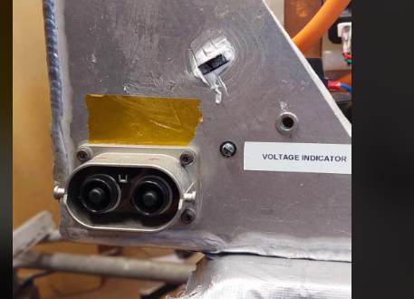
  + 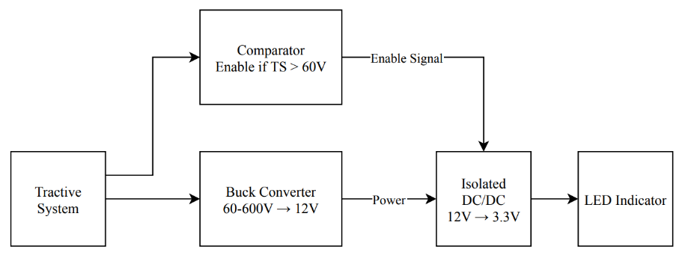
* TS Voltage Measurement
  + monitor the precharge process and ensure the DC-Link capacitors in the car is charged to at least 90% of the battery voltage before continuing.
  + calculate the power drawn from (and to) the accumulator, to ensure the power limit is not exceeded.
    - The entirety of the current supplied from the accumulator goes through this shunt.
  + The voltage is measured via voltage divider and the output here is then sent to a 14-bit ADC (ADUM142E). This ADC communicates with the AMS via SPI… The lines sent to the AMS are….Abnd his is..
  + 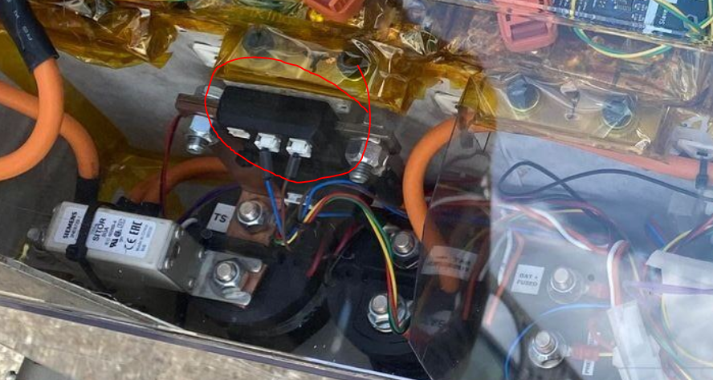
    - In series with the TS.
* TSAL_VOLTAGE_MEASUREMENT
* 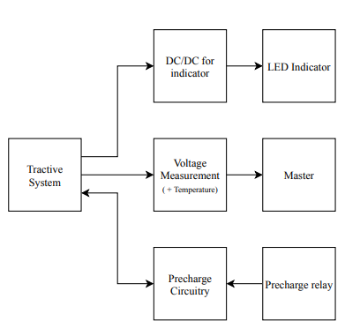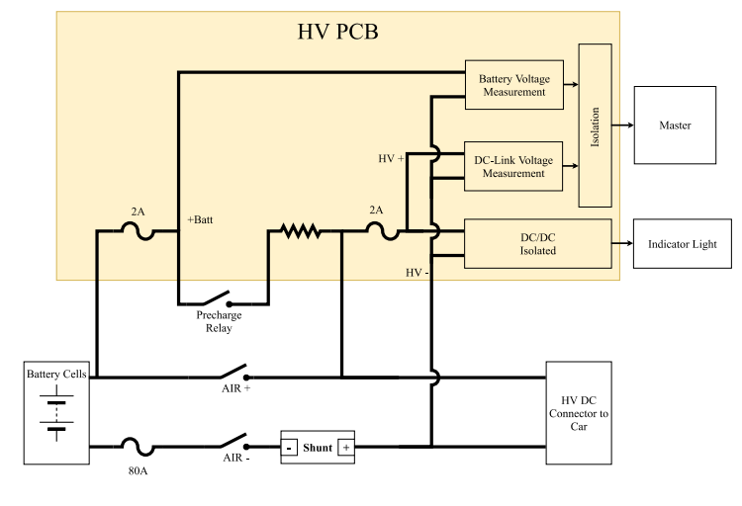

**Connections**

* AMS
* AUX via J104
* Precharge relay via J101/precharge resistor (indirectly)
* Accumulator terminals via J101
* Voltage indicator on accumulator container via J106
* Energy meter
* IMD via J102

## AMS

**Placement in Vehicle**

* As of this writing (10/2/24) the AMS has been replaced by a BMS-system bought from Orion. However, this report will still describe the previous AMS-system, as it is a plan to reimplement this in the vehicle.
* TILFØJ BILLEDE
* Placed inside the accumulator container
* When looking at the Accumulator Container from the front, the AMS is placed on the right side and has a connector going out of the casing at the bottom right.

**Purpose & Relevant Rules**

* Controller:
  + The PicoZed is the controller of the AMS. The PicoZed hosts a Zynq-7000 SoC51, which includes two ARM cores and an FPGA part. The Zynq is the master.
  + It continuously measures…
    - All cell voltages
    - The tractive system current
    - The temperature of cells.
    - Discharge resistor temperature on the slaves.
  + Balancing and charging of the cells
  + Distributed system in that we use slave PCBs and thus avoid a centralized topology wherein we need wires for each and every cell from the master.
    - 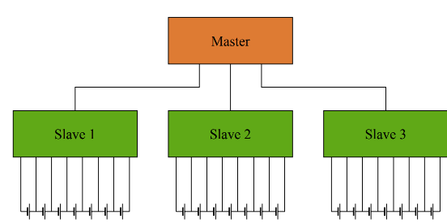
* Balancing
  + When charging, the cell voltages will vary and need to be balanced. The AMS here does it when it is nearly fully charged (when one is near max, and the others are below).
  + The cells used in Viking IX had a capacity variance of 5%.
  + We have chosen that it must be balanced within an hour, meaning that we need a balancing current of 625 mA
* LTC6820
  + Communication link between the Accumulator Master PCB and the AMS Slaves done using SPI from the AMS converted to isoSPI.
* Shutdown circuit
  + The AMS must be a part of the shutdown circuit à AMS must shut of the shutdown circuit if a critical voltage, temperature or current value appears for more than a set amount of time.
  + The AMS and IMD part of the shutdown circuit will have to be latched open, and it must only be possible to reset the latch by a person at the vehicle who is not the driver.
    - Reset buttons are placed on the actual AMS PCB, the accumulator container and the TSMS/TSMP-panel as seen in those sections at the end of this paper.
  + 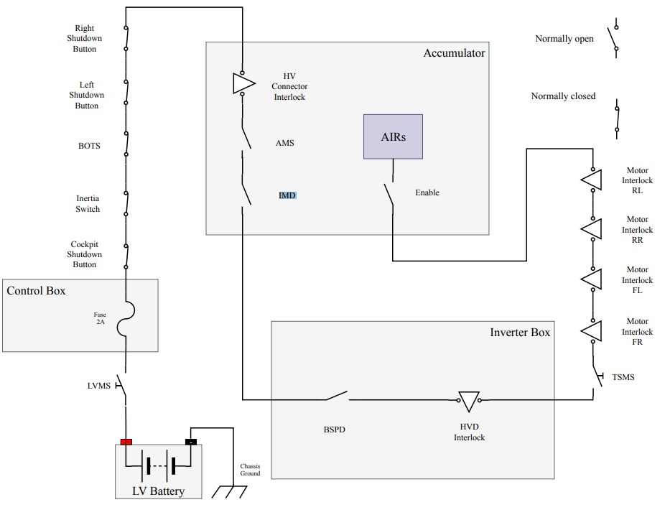
* Relay control
  + Sends signals to the TSAL
    - whether the relays are closed or not.
    - whether TS > 60 V or not.
  + Isolates relay signals to the Zynq
  + Controls if the current is allowed to flow in the relays

**Circuitry Explanation**

* (beware that component references are different between different KICAD projects!)
* Shutdown Circuit
  + If the IMD says "OK", then IMD_OK (IMD_SC) is set high, meaning that the U101A optocoupler conducts from LV to IMD_OK_ISO. The IMD saying "good" is indicated via the D109 LED. The optocoupler is used to isolate the signal used for logic-calculations from the one supplied by the IMD.
  + If the IMD has an error, then the U12A latch will be set and the K1-relay will open because the Q1-MOSFET is not conducting (notice the inverter!). This means that SC_HVDC_II_IN can't flow to SC_OUT, and the AMS is effectively "open" in the SDC and the indicator LED D6 is unlit & D13 is instead lit.
  + The D12 LED is an indicator for if the SDC is open due to the HVD not being connected. if SC_IN conducts, then the D12 LED is lit.
  + AMS_SC is a signal coming from the PicoZed to the Shutdown circuit signaling if the AMS is closed or open in the SDC. AMS_SC goes high if the PicoZed has not received voltage values within the permissible limits for more than 500 ms or cell/discharge resistor temperature values within permissible limits for more than 1 s. This may be caused by the values actually being outside the limits, faulty connections or signal corruption. If it is low, then the AMS is open and will need to be manually reset via JP9. If the AMS is "open", then U12B is set, meaning that Q2-mosfet is NOT conducting (notice inverter) and the K2-relay remains open and the indicator LED D7 is unlit & D14 is instead lit (assuming K1 is conducting). If K2 is conducting, then this is indicated via D15-LED.
  + EN_SC (= Enable shutdown circuit) is a signal given from the Picozed. If HIGH, then the SDC closes (the enable-stage part) and the Q3-MOSFET conducts meaning that K3 is closed: indicated by the D17-LED. SC_IN_AGAIN is the input to the SDC if it gets past the TSMS. This means, if K3 is closed, then TSC HV PCB's positive discharge coil is charged via the SC_IN_AGAIN.
    - In summary: if K1 and K2 are conducting then the current through the HVDC can flow. The shutdown circuit stages in the accumulator is controlled by three relays. One for the IMD-stage, one for the AMS-stage and one for the Enable-stage. The IMD-stage is controlled by the IMD itself. Both the AMS-stage and the Enable-stage is controlled by the Zynq. The AMS-stage is latched in hardware like the IMD-stage.
  + If we reach SC_END (that is, get past K1, K2, K3), then we can begin looking at precharging and the AIRs.
  + U13 is a debouncer / delay block used to remove the noise from the 3v3 input signal in order to avoid switch bounce when resetting the SDC latches.
  + U9 are AND-gates:
    - ER DER IKKE FEJL VED INPUT 5 PÅ U9B? VI SAMMENLIGNER DA HELE TIDEN MED 0 OG DERMED FÅR ALTID 0 UD?
      * The schematic depicts an OR gate but the 74HC08 is an AND gate. This should be a 74HC32 instead. The pinout of both are the same. Cutting the legs short on the previous 74LVC32 has made this one fit for use. - NRB, 23/07/14
  + U9B compares the 3v3 stable voltage with JP7 (OR).
  + U9A compares the SDC-reset button (from outside the accu container, presumably) with switch SW2
    - In summary: to be able to reset the SDC you need to have a stable 3v3, press jp7, press sw2 and press SC_Reset in order to reset and close the SDC on the AMS.
  + U19 (ADC) is used to convert the SC_END signal to I2C-compatible such that it can be sent to the picozed
* Relay control
  + Isolates the TS_indicator signal (telling if the TS is active or not) via U1-optocoupler and this becomes the TSAL_ACC_TS_ON signal.
  + D1 shows if the TSAL is properly connected to the AMS.
  + U203 is an AND gate that compares the aux_signals from precharge, AIR+ and AIR-.
    - If they are all open, then it output 5V, whereas if any of them are closed or all closed then it outputs ~0V.
    - This signal is then coupled to the "TSAL_RELAY_DETECTION" signal used in the TSAL.U2 is used to isolate the different relay signals to the ZYNQ.
  + Power selection:
    - 5V is either supplied by 5V from the charger (verify).
    - or via the TSAL (VERIFY).
  + Same story for AIR+_control ^ and AIR-_control
  + J211 needs a connection to 5V.
  + Q4, Q5, Q6 is used to pull precharge, AIR+ and AIR-'s negative terminals to GND if the control-signals are sent from the PicoZed. This is basically for activating the relays.
  + HVAD GØR DETTE????
    - If the precharge is “asked” to close, then precharge_control is HIGH and the Q4 MOSFET conducts
      * + 
    - LED D22 lights up, when the precharge relay is CLOSED, and Q4 allows for discharging to GND for activating relay????
* Charger interface
  + DAC for sending voltage values to charger interface.
* Power
  + Used to create stable non-noisy power supply. LV, 5V & 3v3. LV is supplied from the LV-battery (via X90 interface PCB) or charger. The PicoZed needs both 5V and 3.3V
* JTAG
  + USB in order to be able to program the ZYNQ without using an external JTAG programmer.
* Bluetooth
  + While the accumulator is inside the car, it is not possible to get access to the Zynq controller. A wireless link is therefore made possible.
  + primary be used to transmit data of accumulator container to monitor if everything is as it is supposed to be
  + If a boot-loader for the Zynq is made, it will also be possible to program it over Bluetooth.
  + Has not been used before.
* CAN Interface
  + Zynq will communicate with the car’s main controller through a CAN interface. The Zynq does not have a CAN transceiver built in, and it is thus necessary to implement this on the PCB. This is done by using a SN65HVD232
* LTC6820 Master
  + BMS master of the slaves.
  + converts the isoSPI into normal SPI for the Zynq, à communication link between the Accumulator Master PCB and the AMS Slaves,
  + it is recommended that the LTC6820 have to placed at least 1−2cm, away from the transformer to avoid magnetic coupling.
* nvSRAM
  + The inclusion of the nvSRAM is to be able to save configuration parameters and the likes. This could be the number of battery packs, cells and so on, so that one may change the parameter without needing to update the firmware. These components are basically a copy of the new master controller whose nvSRAM circuit has been tested. The battery is necessary so that the nvSRAM gets power to keep the data stored"
  + NOT INCLUDED

**Connections**

* + - J2(23 pins):
      * 3 Pins for charger
      * 6 pins for X90 Interface PCB
        + 3 pins for CAN
        + LV-unfiltered
        + Input to shutdown circuit.
      * 2 pins for TSC HV PCB: Discharging
      * 6 pins for TSAL (TSC LV PCB)
      * 1 pin for GND-point in the main hoop for the IMD
      * 1 pin for The output of the SDC in the AMS to the TSC
      * 1 pin for the Input of the SDC to the AMS after TSMS.
      * 1 pin for SC_END UNKOWN IF IN
      * 2 pin for SC_RESET_BUTTON (in/out)
    - J7 IVT shunt connector
    - J1 IMD connector
    - J3 Aux connectors to AIRs for monitoring. OR AUX SUPPLY?!?!?!??!
    - J8 is connected to the slave boards
    - J9 is connected to USB in order to be able to program the ZYNQ without using an external JTAG programmer.
    - J6 is the HVD
      * Don’t think so
    - J4 is connected to the precharge and AIR relays
    - J5 is connected to the HV PCB for info if the TS is active or not

## AMS Slaves

**Placement on Vehicle**

* 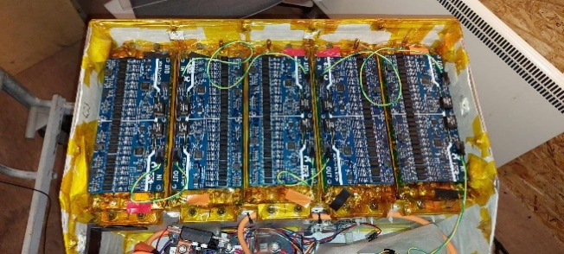
* Placed inside the accumulator container.
* 5 PCB’s handling 5 different banks
* on top of the cell connection PCBs inside the accumulator container.

**Purpose & Relevant Rules**

* Used for balancing of the cells & for communicating voltage and temperature information to the AMS.

**Circuitry Explanation**

* Powered by the LTC6813
  + Has an option to be both powered directly by the cells or via external power source. Can be configured either way according to the AMS Slave boards.
* Cell voltage measurement and temperature the LTC6813 has 3 16-bit ADC’s used to measure cell voltage. Each ADC is connected to 6 cells. Each cell is connected to a low pass filter for noise rejection (measurement error) and then connected to the LTC6813. This enables the passive balancing.
  + 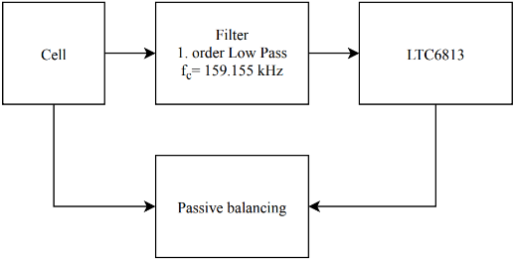
* Balancing
  + Each LTC6813 supports up to 18 cells, but since we have 28 in a bank we will only connect 14 to each of the two. The unused are connected to 100 ohm resistor in series to V+ so that I reads 0 V when measured. The unused cell inputs are 15-18.
  + The MOSFET is used to for balancing the cells: they are controlled via S14 (for the 14th cell). D501 is an LED indicating when it is balancing.
    - 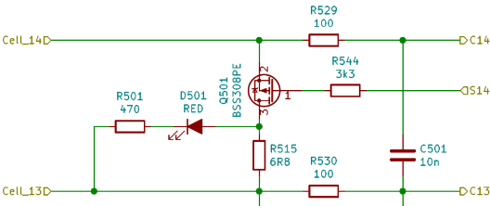**'**
  + Because the LTC6813 has an internal balancing circuit only capable of 200 mA and the rules dictate a balancing current of minimum 625 mA, an external balancing circuit is required. This is controlled via the LTC6813 via the S-pin to the “balance-control”-circuit.
* Communication
  + Temperature measurement: thermistors are placed on the cell connection boards to measure temperature. The balancing resistors are also measured by temperature sensors to ensure a safe temp.
  + All communication is controlled by a Zynq controller. This controller communicates through SPI and the LTC6813 has an internal interface isoSPI which enables it to be completely isolated via a transformer. LTC6820 is then used to convert the isoSPI to a normal SPI for the Zynq.
* Powering the multicell stack monitor (LTC6813): each bank contains 28 cells, it will be necessary to place two LTC6813 on each slave PCB, this will create a difference in ground potential, as each will be connected to different section of the cell bank. This means that each have to be isolated from each other:
  + 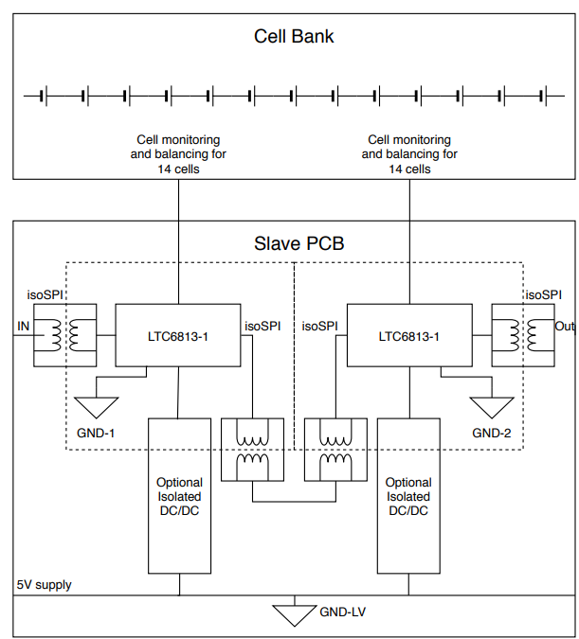

**Connections**

* J101-J106 = Cells connection PCB
* J107 = isoSPI
* J108 = ?

## Battery Cells

* LiPo pouch cells (most common used in EV vehicles). 5 Banks of 28 cells à 7.34 KWh & 11.03 Ah. Peak current 190.5 A and continuous current rating: 41.2 A.

## Cell Connection PCB

**Placement in Vehicle**



* Placed on top of the cells, but below the AMS slaves inside the accumulator container.

**Purpose & Relevant Rules**

* Used to connect all the cells in series to a total of 28 (1 bank). There are a total of 5 cell connection PCBs in the accumulator totaling 5 banks. Has safety measures such as 2A fuses and thermistors to measure the temperature of some certain cells (random sample)

**Circuitry Explanation**

**Connections**

* Cells and AMS slaves

## Cell connection addon PCB

## Accumulator Isolation Relays

* (AIR+ and AIR-) in which the TS-current flows through once closed. AIR+ is placed in series with the positive terminal of the accumulator, and AIR- is placed in series with the negative terminal. If the AIRs are open, no TS voltage may be present outside of the Accumulator container and the vehicle side of the AIRs must be galvanically isolated from the accumulator side,
* HV cables are connected to All 3 AIR. Small wires are connected to HV+ and Precharge, since these are used for the precharge circuit.
* The AIR + can only be closed once the precharge circuit has charged the vechicle-side of the AIRs to minimum 90% of the TS voltage to avoid a large inrush current.. The AIRs are opened when the shutdown circuit is opened and the TS must then drop below 60VDC. Auxiliary contacts on the relays allows us to monitor the state of the relays, and these are connected (to the AMS?) for monitoring of the state.
* Monitoring of the AIR status is done via the auxiliary contacts One side of the auxiliary contacts are connected the low voltage supply, and the other side is used to monitor the status of the contacts. The status of each individual relay is read by the Zynq controller on the AMS.
* The low-side of the AIRs is controlled by a MOSFET controlled by the Zynq controller.
* **Connections**

**Precharge Relay** is connected to the precharge circuit on the HV PCB inside the accumulator container. This relay is only opened once the vehicle side of the AIRs is charged to at least 95% of the TS voltage.

* + **Connections**
* **IMD:** From the rules: “The IMD must be a Bender A-ISOMETER R iso-F1 IR155-3203 or -3204 or equivalent..”
  + this device tests the resistance between the tractive system and the chassis of the vehicle, i.e. the ground of the low voltage system.
  + This specific device has two ground measurement lines. One line must be connected to the grounded accumulator container, the other must be connected to main hoop of the car.
  + **Connections**
    - Connection to the AMS:
      * resistance between the tractive system and the chassis of the vehicle, i.e. the ground of the low voltage system.
    - Connection to the HV PCB:
      * HV+ and HV- is supplied via the HV PCB

# Others

## **Tractive-System Master Panel (TSMP)**

### Contains the master switches (TSMS & LVMS), the measuring points on the right side of the vehicle (from driver’s POV) and the AMS and IMD reset button.

* 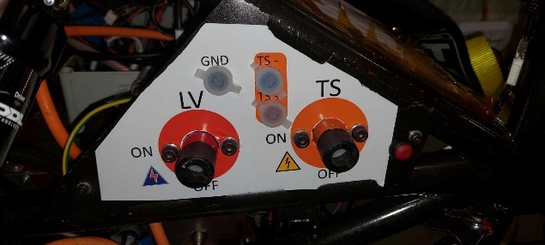
  + **Measuring Points** are used to measure the voltage of the TS and conduct IMD test. They are connected to the TSC HV PCB, where they are secured with a current-limiting resistor of 15 kΩ (R1 and R2 on the TSC HV PCB) connected to a TS+ and TS- busbar.
    - **Connections:**
      * **TSC HV** for voltage measurement
      * **TSC LV** for connector interlock in **SDC**
  + Tractive-System Master Switch (TSMS) is the “key” to enable the HV-system (which can be removed from the car). This is the last switch before the AIRs except for the precharge circuit and hardwired interlocks
    - **Connections:**
      * X90 Interface PCB (brown wire) pin number??
      * AMS (brown wire) pin number??
      * AMS (purple wire) pin number??
  + AMS and IMD reset button on panel**:**
    - **Connections**
      * Serves as one of the 2 GND for LVMS à single back wire is connected from the chassis (via a bolt) to the TSMS, where then it and a red wire go from the TSMS to the X90 interface PCB (basically LV supply).
      * 2 black wires (which then turn green?) are connected from the SDC-reset button on the panel to the AMS

### **Charger**

### Is used to charge the accumulator through the HV DC connector. The AMS connector is used to ensure safety. Blue CEE plug is 230V supply. The top container is the custom controller and bottom is an “of the shelf” PSI 9000 2U power supply.

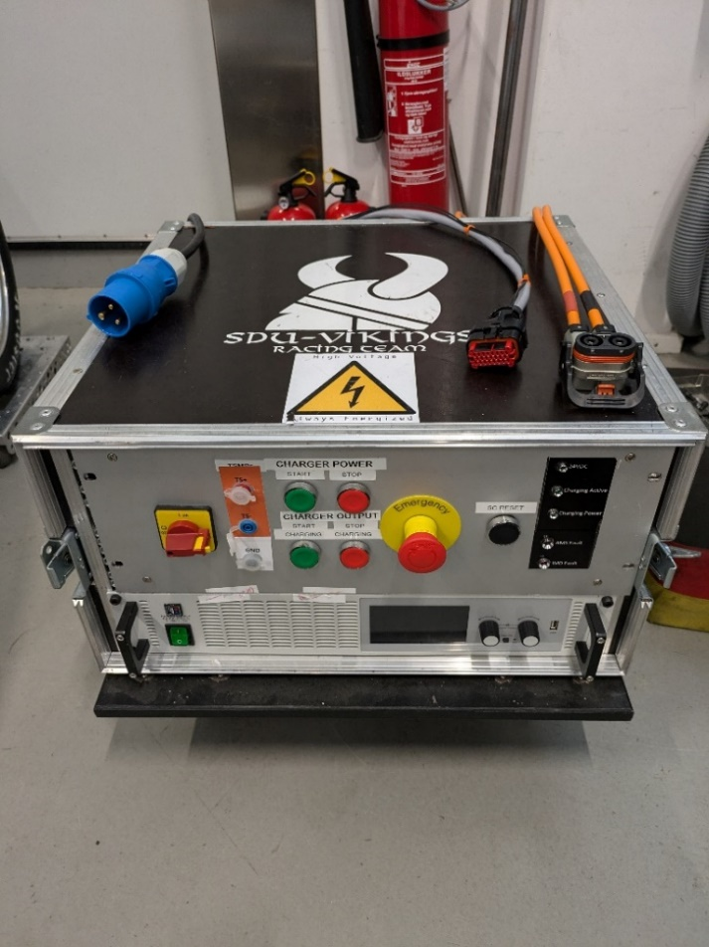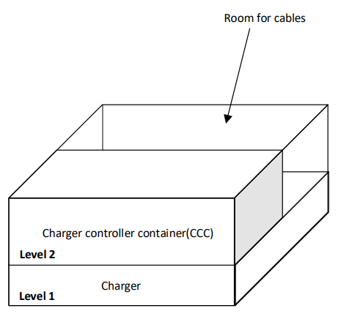

### To charge the battery the AIR relays need to be closed. Therefore, a smaller version of the SDC exists, where charger-power along with AIR’s is only enabled if the rest of SDC is ok.

* + Connections going out of Charger

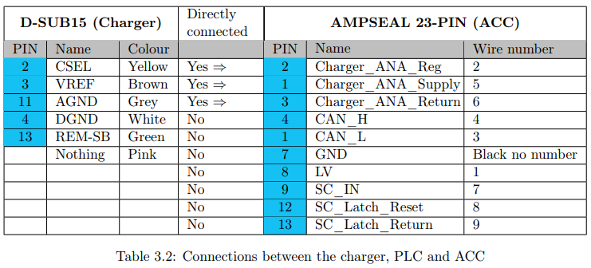

* + System Overview

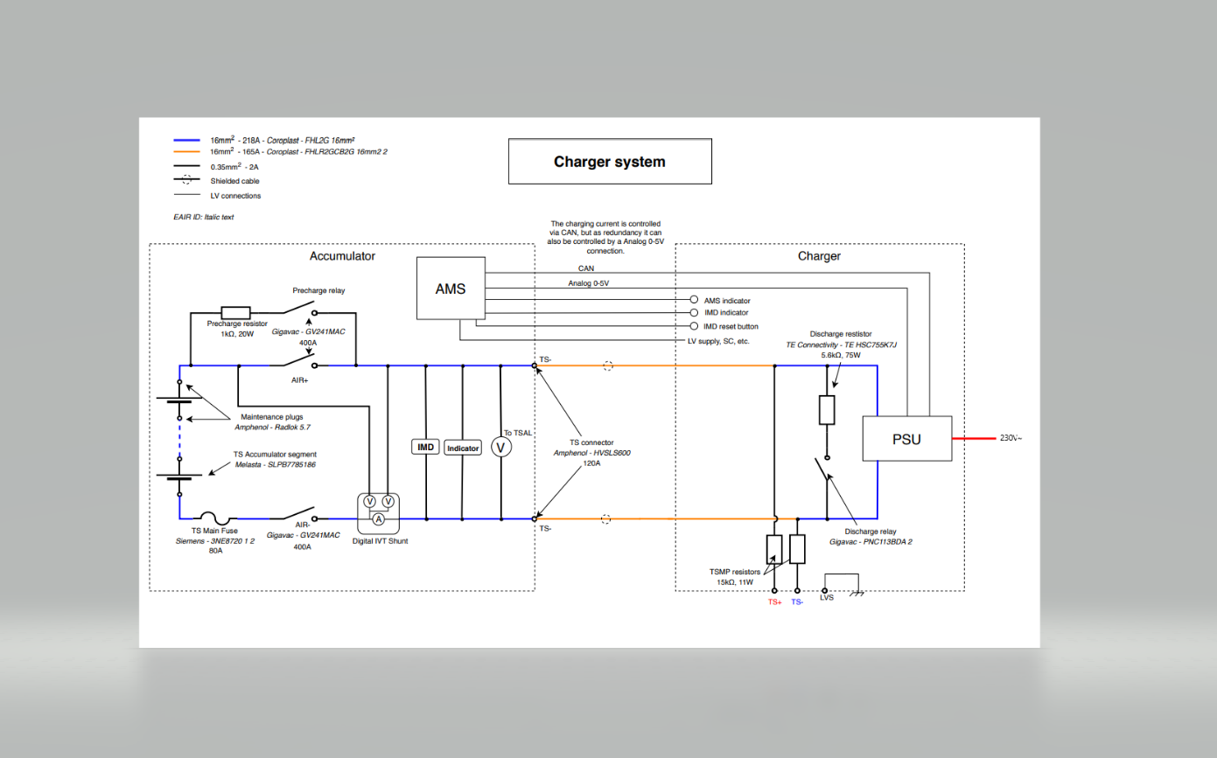

* + - Complete wiring diagram can be found here: [Charger Wiring Diagram.pdf](https://syddanskuni.sharepoint.com/:b:/r/sites/SDUVikings/Delte%20dokumenter/Electrical/1%20-%20Hardware%20%26%20Software%20Material/4%20-%20Others/3%20-%20Charger/Charger%20Wiring%20Diagram.pdf?csf=1&web=1&e=hrokex)

## Cooling Pump

### A 24 V Davies Craig EBP40 pump is used to circulate the cooling fluid. This is the main way that the motors and inverters are cooled. As of this writing, the pump is supposed to be turned on at all times when the tractive system is to be operated.

### The pump receives a constant 24 V signal from the master controller.

### The activation of the cooling pump is controlled by the X90 master controller through a connection to the X90 Interface PCB.

### Ingen tilgængelig beskrivelse.

### *Cooling pump located on the left in the area where the orange HV wire terminates.*

## **Emergency Buttons**

* There are three emergency buttons located in the car, one in the cockpit and two on each side of the vehicle.
* They are connected to the X90 interface PCB and act as part of the SDC.

[Picture of cockpit emergency button] [Picture of left side emergency button] [Picture of right side emergency button]

*Picture 1: Emergency button in the cockpit. Picture 2: Emergency button on the left side of the car. Picture 3: Emergency button on the right side of the car.*

## **Brake Light**

* The brake light fulfills the requirements of T6.3 regarding the Brake Light.
* The brake light consists of 24 LEDs which are activated when pressure is applied to the brake pedal. The signal determining when the LEDs should light up is controlled via the X90 interface PCB. The power supplied from the master controller is stepped down to 5 V on the brake light PCB using a buck converter.

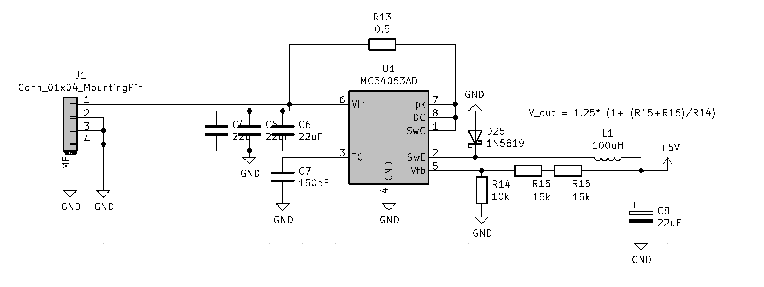

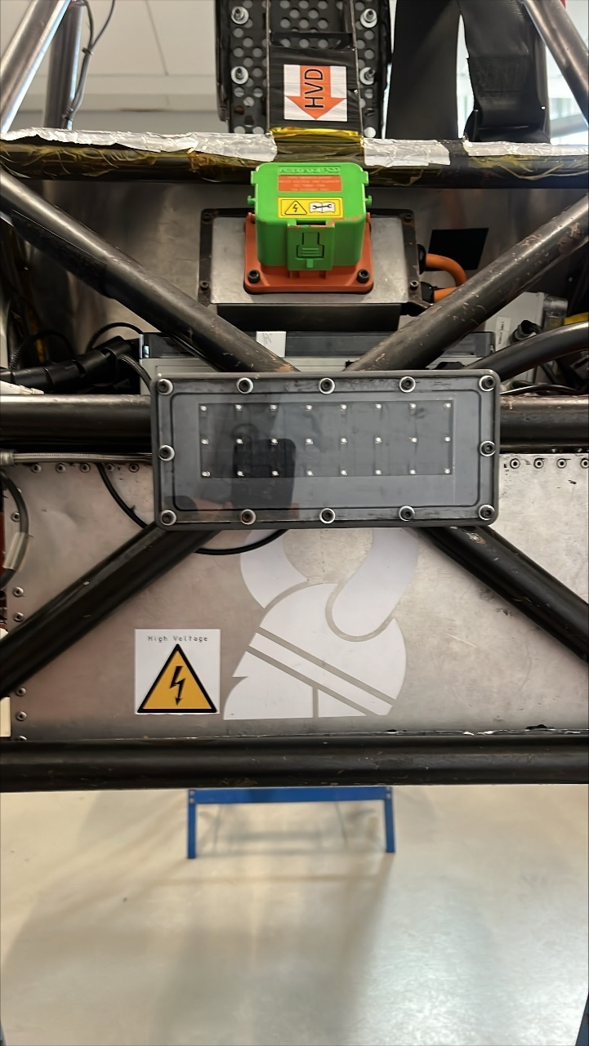

*Picture of the brake light*

## **RTDS**

### From the ESF: “To start Ready-To-Drive Mode the TS must be active and pre-charge must be complete. When this condition is met the RDY LED on the dashboard blinks. The brake pedal is pressed to sufficient pressure and the RDY LED switches to continuously be lit. Now the DRIVE button can be pressed, and the car enters Ready-To-Drive Mode. This is signaled by the RTDS.”

### The RTDS speaker is located on the left side of the cockpit above the X90 interface PCB.

### The RTDS is activated from the X90 master controller which supplies it with 24 V.

### The sound level of the RTDS must be above 90 dB according to the FS rules.

### *RTDS speaker located on the left in the cockpit.*

## **Sensor Network**

## **Low-Voltage Battery**

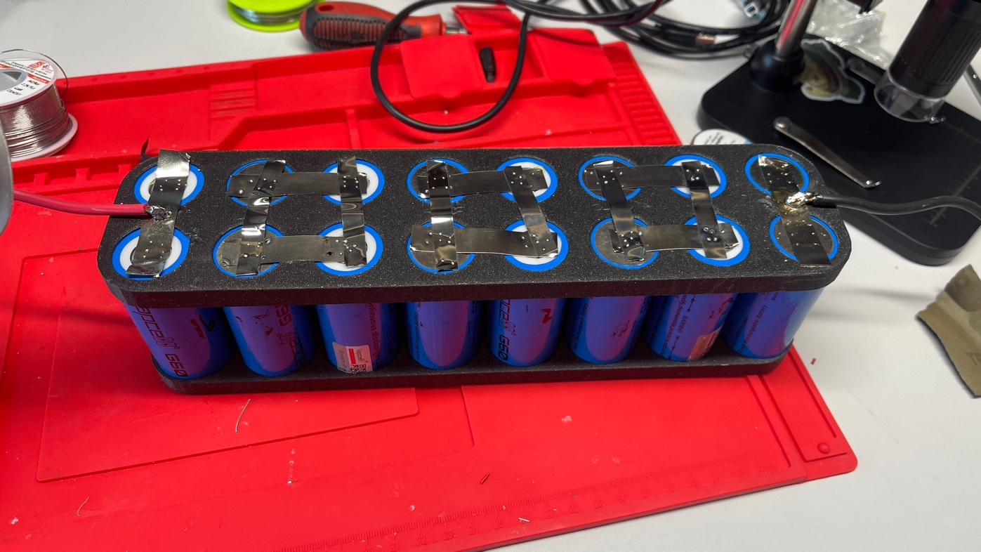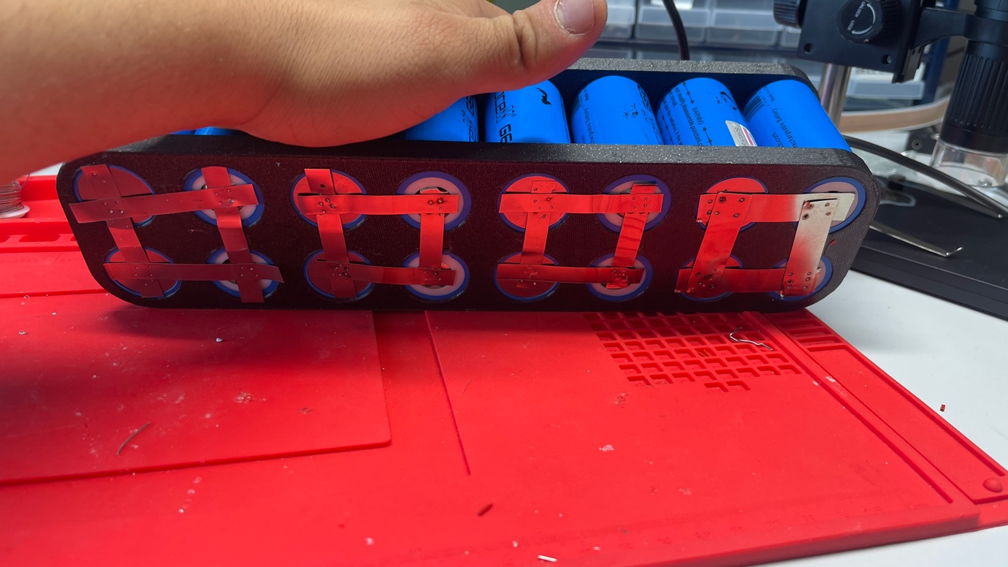

### Cell Chemistry: LiFePO4

### Model Nr.: IRF32700

### Capacity: 6000mAh

### Max Voltage: 3.65V

### Nominal Voltage: 3.20V

### Cell Type: 18650

### Connection: 8S2P with 0.15mm Nickle Strips

### Externally Fused with 20A fuse with LittleFuse fuse holder

## **BMS for Low-Voltage Battery**

***Currently not in the car.***

### PCB Description

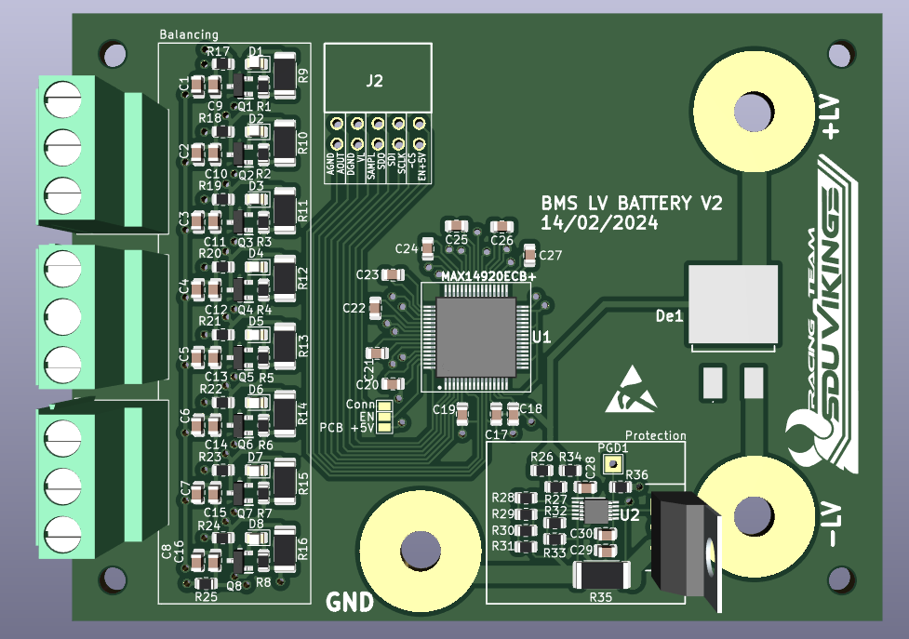The LV BMS PCB consists of 2 major parts – the balancing circuit with the **BMS IC** *(MAX14920)* and the protection circuit with a **current controller** *(LM5067)*.

### Balancing Circuit

* + - **U1** (MAX14920) balances the cell voltages by controlling the MOSFETs (Q1-Q8) via the BA1-BA8 pins (cell balancing gate driver) and samples cell voltages through the **CV** pins. When balancing this is indicated by the MOSFET conducting, and thus the LED (D1-D8) is lit.
    - **VA** is the +5V LDO output.
    - **VP** is the power supply. Connected to the highest voltage of the battery pack.

### Overcurrent protection

* + - U2 (LM5067) is an overcurrent protection IC to protect against large inrush currents.
    - D9 is a rectifier that only enables the current to flow from LV+ to LV- or to GND if Q9 is conducting and the sense-pin is HIGH.
      * Sense-pin is connected via R35 (current-sense resistor) to VEE. If the voltage across R35 is > 50mV, then the load current is limited.
    - GATE-pin switches, when VSYS exceeds the UVLO threshold. If VSYS exceeds the UVLO threshold at the end of the insertion time, Q1 is switched on at that time. If the system input voltage falls below the UVLO threshold, or rises above the OVLO threshold, the GATE pin is pulled low by the 2.2 mA pull-down current to switch off Q1.

**Software/Communication**

The programming of the BMS IC can be done by any MCU that has SPI support. Communication with the IC is done through a 24bit SPI interface.

**Configuration for SPI and BMS**

The SDO data changes on the falling edge of the SCLK signals. The device samples the SDI data on the rising edge of SCLK, that means clock polarity (CPOL) is low and clock phase (CPHA) is set to 1 Edge *(first clock transition is the first data transition)*.

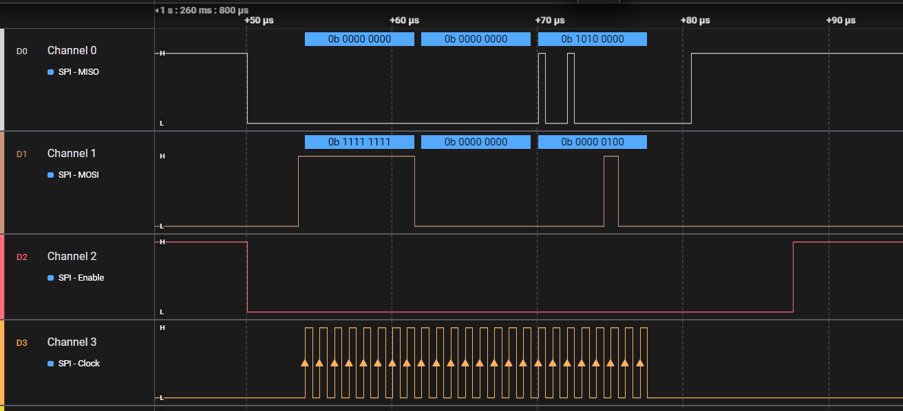When bits are being sent to the IC, it will simultaneously send back monitoring data back through the SDO line.

* + **Connections**
    - **AGND –** analog ground.
    - **AOUT –** buffered amplifier output. The AOUT output voltage is relative to CV0.
    - **DGND –** digital ground.
    - **VL –** logic voltage, determines what voltage is logic high and low.
    - **SAMPL –** sample control input. Voltages at CV inputs are tracked wgen SAMPL is logic high.
    - **SDO –** slave data out (SPI)
    - **SDI –** slave data in (SPI)
    - **SCLK –** clock signal (SPI)
    - **CS –** chip select (SPI)
    - 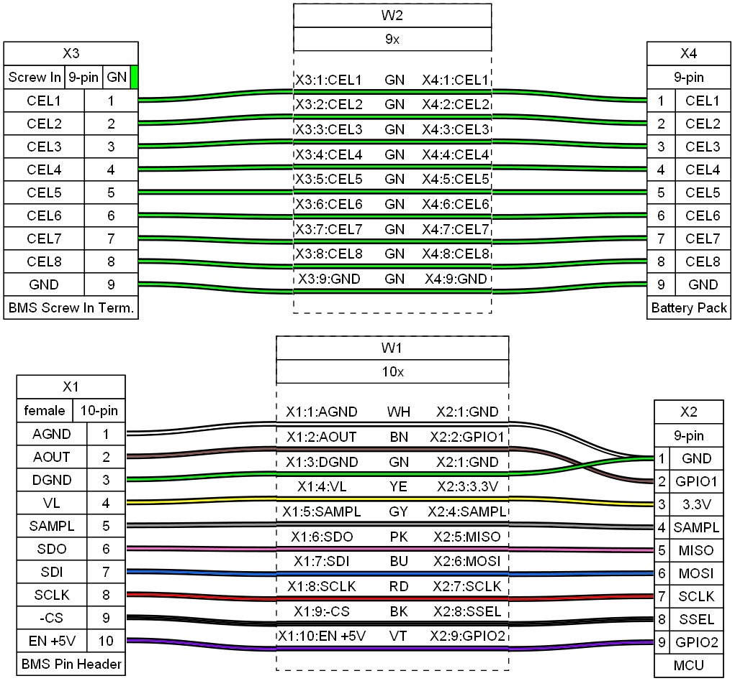**EN +5V –** 5V enable

### Problems/Issues

* Overall design is flawed.
* Requires an MCU to constantly communicate and retrieve data.
* Does not communicate with the master controller or any other ECU in the car.

# Mechanical Hardware

### Brake pressure sensors

* + **Placement in vehicle:** 
    - **BSPD**
      * The BSPD is located in the back, to the right of the TSAC. And its container and the PCB can be seen under here

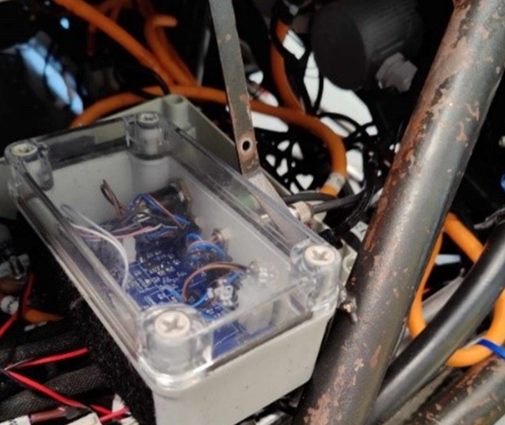

* + - **Front**
      * The VariohmEPT3100-H16000-B-5-A is located behind the brake pedal. Due to brake fluid, it is impossible to label it.

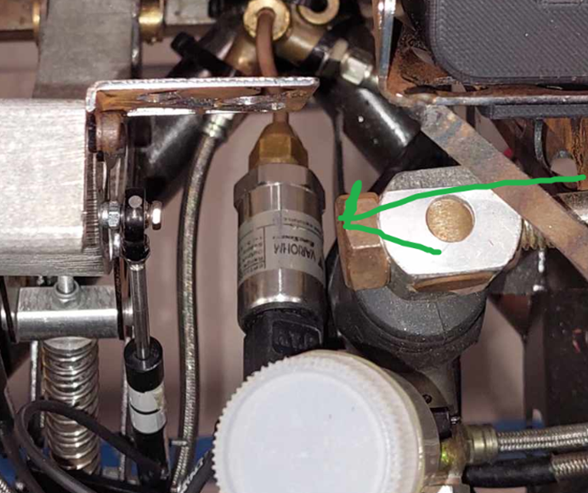

* + - **Rear**
      * The rear brake sensors are placed in the back of the car close the wheel, picture for reference.

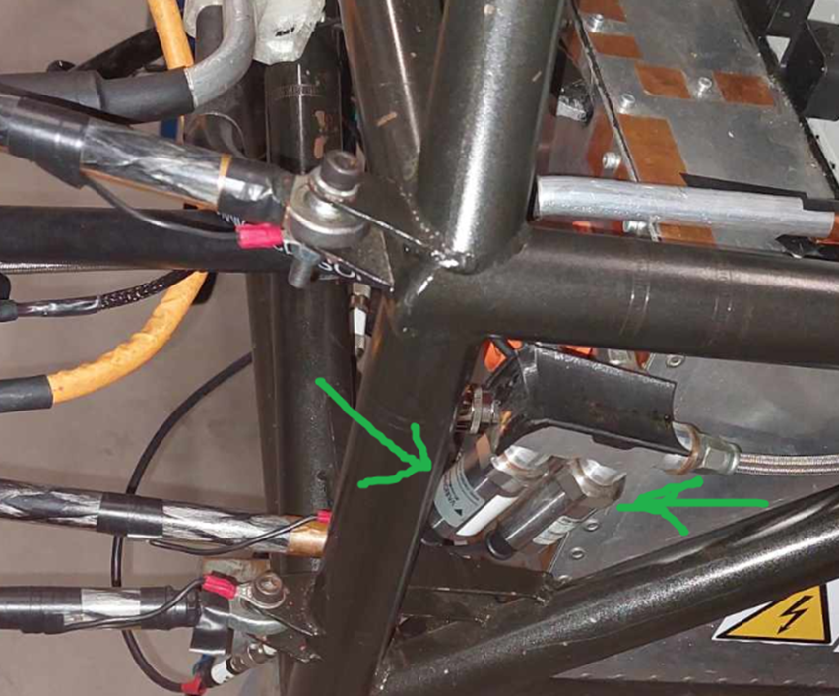

* + Purpose & relevant rules:
    - BSPD
      * The BSPD (Brake System Plausibility Device) is a circuit that must open the SDC when both the brakes and power ≥ 5kW is delivered to the motors. The BSPD is a non-programmable circuit.
      * Hard braking is defined in the rules as “The threshold must be chosen such that there are no locked wheels, and the brake pressure is ≤30 bar” and must happen with a brake systems sensor.
      * The SDC must according to the rules: “The SDC must remain open until power cycling the LVMS or the BSPD may reset itself if the opening condition is no longer present for more than 10 s.”
    - Front and rear.
      * The purpose of the front and rear brake pressure sensors is to measure the pressure when braking.
  + Circuitry Explanation:
    - BSPD
      * The BSPD is supplied with 12V and takes two signals as input. One from the current sensor and the brake pressure sensor from the back. The BSPD´s output is connected to the SDC.
  + 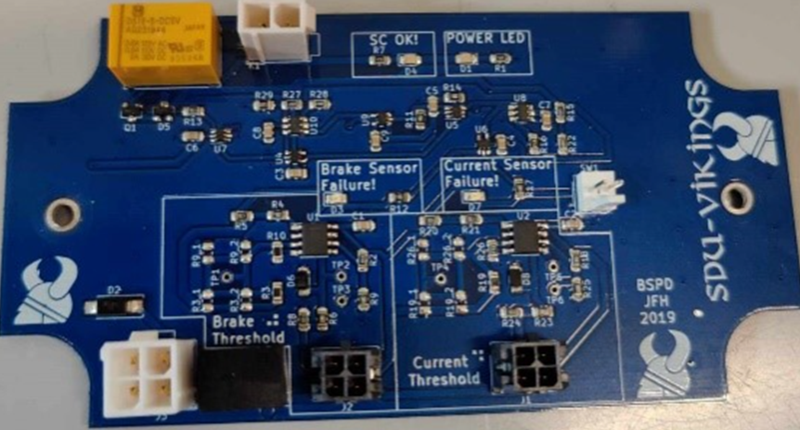
  + Connections:
    - BSPD
      * Connected to X90 interface PCB.
    - Front
      * The front brake pressure sensor is connected to the X90 interface PBC on the Z connector.
    - Rear
      * The right brake pressure sensor in the picture below is connected to the X90 interface PCB on the Z connector. The sensor consists of a positive and negative supply and has a signal wire.
      * The brake pressure sensor on the left is connected to the BSPD.

### Throttle Position Sensor

* + The Throttle Position sensors are two pistons on the side of the speeder:
  + Placement in vehicle:
    - Torque Pedal Sensor 1, when seen from the front of the car sensor 1 is on the right.
    - Torque Pedal Sensor 2, when seen from the front of the car sensor 2 is on the left.
    - 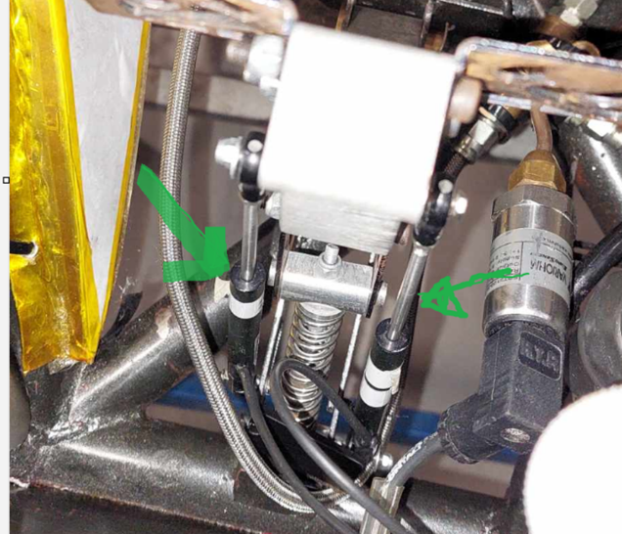
  + Purpose & relevant rules:
    - Signals the motor controller how much the driver wants to go forward
  + Connections:
    - Connects to the motor controller.

### 4x Hub Motors

* + **Placement in vehicle:**
    - Next to the wheels
  + **Purpose & relevant rules:**
    - To make the wheels turn
  + C**ircuitry Explanation**/**Connections:**

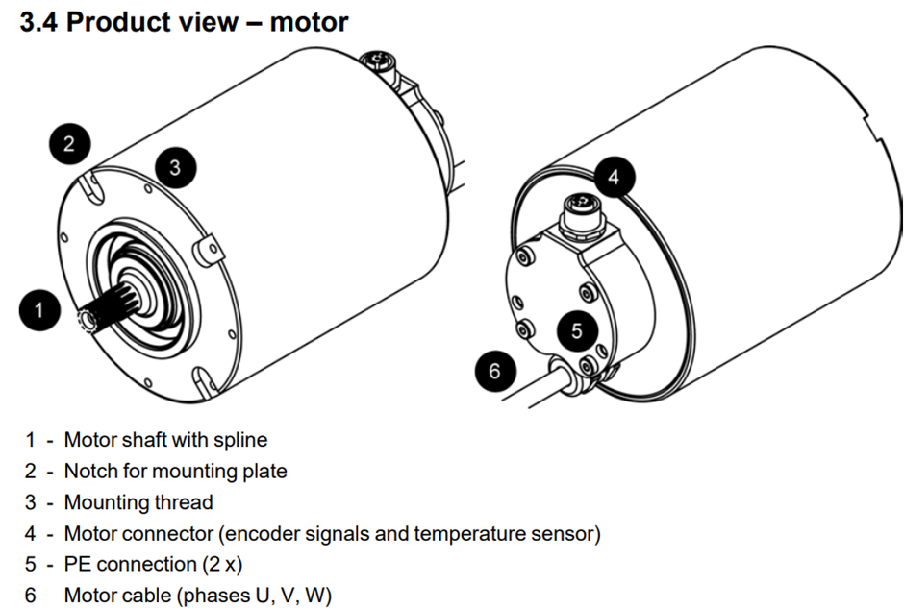

* + - The motors are connected with 4 cables.
      1. One cable for the encoder and temperature (4 on the image above).
      2. One cable for the SC circuit.
      3. The motor cable (HV cables. 6 on the image above) are the large orange cable connected to the motors. They are connected to the motor connection for the front motors. And the rear motors are connected to the inverters.
      4. The cable for the SC circuit is named after which motor they are connected to them are the motor interlock cables. The purpose of the interlock is to open the SDC when the interlock is disconnected. The interlock should disconnect if the suspension fails or the motors are disconnected.
* **Steering Angle Sensor** 
  + **Placement in vehicle:**
  + It is located under the steering column**.** 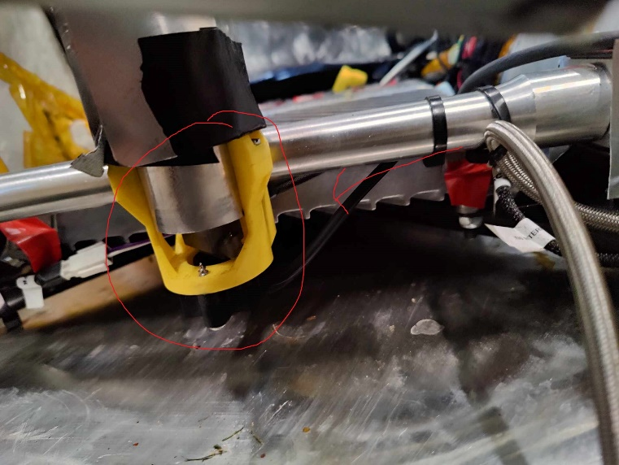
* **Purpose & relevant rules:** 
  + It measures the steering angle
* **Connections:**
  + The motors are connected with 4 cables. One cable for the encoder and temperature (4 on the image above). One cable for the SC circuit. The motor cable(HV cables. 6 on the image above) are the large orange cables connected to the motors. They are connected to the motor connection for the front motors. And the rear motors are connected to the inverters.
  + The cables for the SC circuit is named after which motor they are connected to they are the motor interlock cables.

The BSPD is supplied with LV 12V, and it takes two signals as input. One form the current sensor and the brake pressure sensor, this signal is from the brake pressure sensor from the back. The BSPD´s output is connected to the SDC.

* + The brake pressure sensor on the right is connected to the X90 interface PCB on the Z connector. The sensor consists of a positive and negative supply, and it has a signal wire.
  + The brake pressure sensor on the left is connected to the BSPD.
  + The front brake pressure sensor is connected to the X90 interface PBC on the Z connector.
  + The steering angle sensor is connected to the X90 interface board on the Z connector.
* **Cooling Temperature Sensor**
  + **Placement in vehicle:** 
    - By the cooling system
  + **Purpose & relevant rules:**
    - To measure the cooling system temperature
  + **Circuitry Explanation:** 
    - A positive and negative supply, and a signal wire.
  + **Connections:** 
    - The car has 2 cooling temperature sensors connected to the Y connector on the X90 interface.
* Motor connection box
  + Placement in vehicle:
    - The motor connection boxes are located in the front, one on each side of the car.
  + Purpose & relevant rules:
    - They facilitate the connection between the inverters and the front motors.
    - The purpose of this is to make the front motor easily removable, as the HV cable can't be removed from the motors.
  + The car has 2 cooling temperature sensors connected to the Y connector on the X90 interface.
  + They both consist of a posetive and a negative supply and a signal wire.
  + The motor connection are loacated on the front, one on each side of the car. They facilitate the connection between the inveters and the front motors. This is done to make the front motor easily removable (The HV cable cant be removed from the motors).

# Simulators, testbenches and others

* Accumulator Simulator

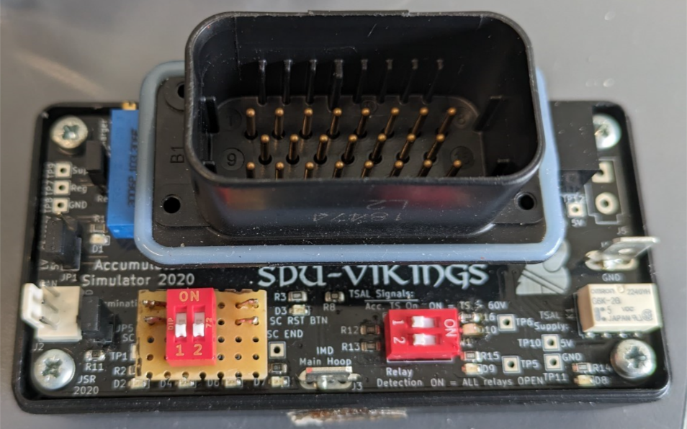

* + Purpose:
    - To simulate the accumulator so the LV-System can be tested without the accumulator present.
  + Circuitry Explanation:
    - As seen in the image above the simulator has 2 red switches with 2 switches each. They can be switched on and off to simulate different signals the accumulator can send.
    - **The switches simulate the following then they are turned on** 
      * Left side:
        + Switch 1 simulates HV DV, IMD and AMS in the shutdown circuit SDC.
        + Switch 2 simulates the relays may turn on.
      * Right side:
        + Switch 1 simulates HV contactors Open.
        + Switch 2 simulates Accumulator TS off.
  + Connections:
    - The simulator is connected the same way the accumulator would be connected.
* Steering Wheel Simulator
  + - Purpose:
      * To simulate the steering wheel
    - Circuitry Explanation:
      * It is a smaller version of the actual steering wheel, same buttons, and uses a rotary encoder with a knob for simulating the turning of the steering wheel.
    - Connections:
      * Connects to the dashboard, the same way the actual steering wheel does.
* Dashboard Programmer
  + - Purpose:
      * To flash the dashboard software on the dashboard using JTAG
    - Circuitry Explanation:
      * Breaks out the JTAG connector of the TM4C123G LaunchPad™ Evaluation Kit, to a 10-pin connector which is then connected to the dashboard via. The oddly specific connector for flashing.
      * The current dashboard programmer PCB has some leftovers that are currently not operational, however the components are usually not soldered on, to avoid further confusion.
    - Connections:
      * 12V supply
      * JTAG connector to dashboard
      * Female pin headers for TM4C123G LaunchPad™ Evaluation Kit
* Charger Interface
  + - Purpose:
      * To control the charging current
    - Circuitry Explanation:
      * By using a Zynq controller and a DAC it is possible to control the charging current through I2C communication
    - Connections:
      * I2C connection to the accumulator master PCB
      * DAC output and supply.
  + Datalogger
    - Purpose:
      * **To log data**
    - Circuitry Explanation:
      * *“The first signal connector is J3 going to the datalogger which is not implemented”* as mentioned in the TSC HV PCB circuit explanation, it is yet to be implemented.
  + Vehicle monitor??

# Major Electrical Circuits

### Discharge Circuit

* + Explained in “TSC HV PCB”

### Shutdown Circuit

* + Explained in further detail in the “AMS”-section
  + The SDC is connected throughout the car and is a “floodgate” for the LV-current to enable the tractive system to open (that is, allow the high-voltage to enter the vehicle after the AIRs).

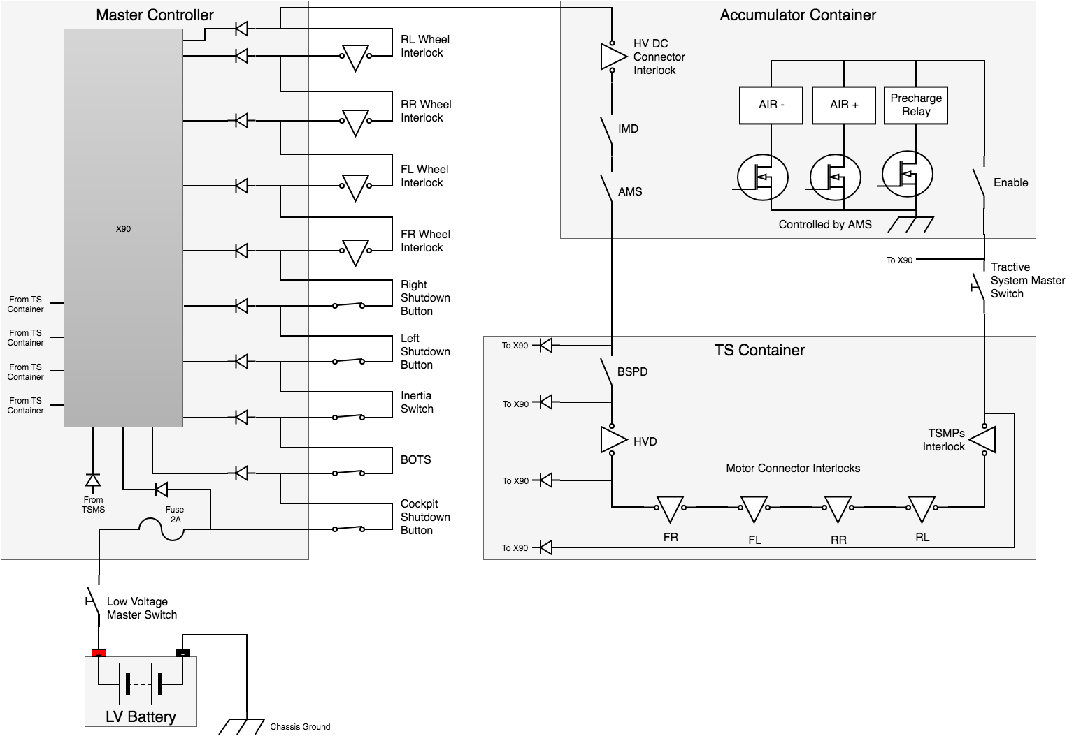

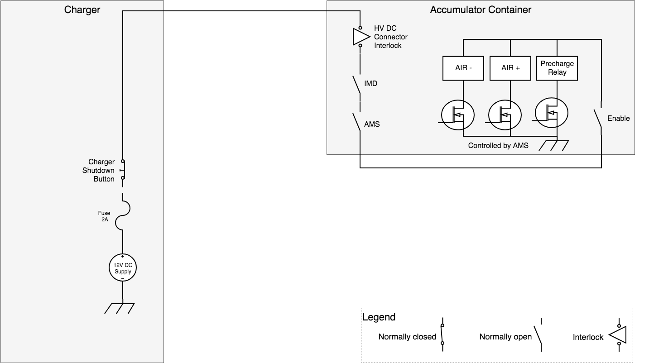

* + The AMS and IMD part of the shutdown circuit will have to be latched open, and it must only be possible to reset the latch by a person at the vehicle who is not the driver.The shutdown circuit directly carries the current driving the coils of the AIRs
  + The circuit is a series connection of switches, relays and interlocks and must be on the high-side of the AIR coils.
  + When the shutdown circuit is opened the tractive system must be shutdown by opening the AIRs, the TS must drop below 60V DC
  + Consists of the following:
    - LVMS à control box fuse à Cockpit Shutdown Button à Inertia switch à BOTS à Left shutdown button à Right Shutdown Button à HV Connector interlock à AMS à IMD à BSPD à HVD interlock à TSMS à Motor interlocks à Enable relay à AIRs.
* **Precharge Circuit**
  + Explained in further detail in TSC HV PCB.
* **CAN busses**
* **LV System**
  + The LV system is “originally” designed for only 4 LiFePO4 cells in series, meaning a voltage range of 11.2V to 14.4V . However, it was already a plan from before that it should be upgraded to 8 cells (22.4 V – 28.8V) and that all parts supplied by the LV system should be able to tolerate an input voltage from 11.2 V to 28.8V.
  + The tractive system must be galvanically isolated from the low voltage system.
* **TS System**
  + Composed of the following circuits / PCBs:
    - Everything in the accumulator container.
    - Everything in the TSC (including HVD & Inverter).
  + The drivetrain of the car à “every part that is electrically connected to the motors and TS accumulators.”